ANIMALS
Make five questions to ask your partner about animals
1.
2.
3.
4.
5.

Video: Animals in Britain

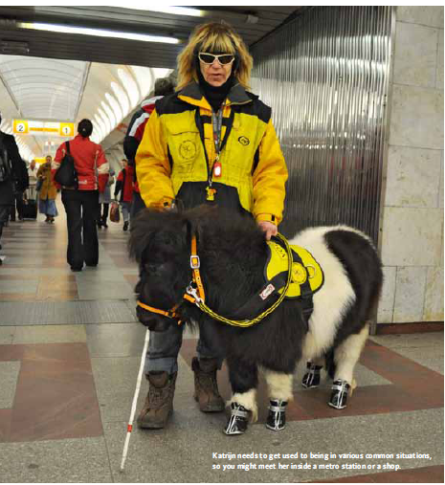
How to Train a Guide Horse
Blind and handicapped people often need specially trained dogs that help make their life easier. But what if they can’t have a dog for some reason? Now there is a solution – a horse! We interviewed Zuzana Daušová from Helppes (an organisation that trains dogs for blind or handicapped people) about Katrijn, a mini horse that has been trained for this purpose.
1.________________________________
No, it’s actually cheaper than dog food. A horse needs mainly grass. They also eat hard bread, apples and carrots. And, of course, some treats and vitamins. But most importantly, the owner has to provide hay.
2. _______________________________
It is also easier than caring for a dog. There is no danger of the horse rolling in something outside, like dogs do. You only have to brush the coat (= fur) and take care of the hooves2. It’s similar to looking after a dog’s paws. On the other hand, a horse needs a much larger space than a dog.
3. _______________________________
Mostly in the same way we train guide dogs. We use the same techniques.
4. _______________________________
American experts reported that it only takes four months to train this kind of horse, and it’s true. We got Katrijn when she was two years old and she was living as a normal horse before that. After 4 months Katrijn was able to lead a blind person.
5. ______________________________
In some ways it is similar. But it’s more difficult to get used to the horse’s behaviour. They don’t show emotions in the same way dogs do. They don’t wag their tail; they don’t jump at you when they’re happy. You have to learn to read a horse’s emotions on their face.
6. ______________________________
Yes, of course. Sometimes supermarket security guards don’t want to let us into the store, and I have to explain that she is a guide horse. Then they usually understand.
7. ______________________________
Oh yes, there’s always an interest in her if we go anywhere. People are curious and come to find out about her.
8. ______________________________
Yes, there have already been two people. Unfortunately, neither was appropriate because they didn’t fulfil the criteria. One of them had diabetes and there was a danger that he would lose his leg and the other couldn’t guarantee they would be able to stay in their house which had a garden.
9. _______________________________
No, she is a pilot project for us. We won’t give her away. Now we know it’s possible to train a guide horse. If there is someone who meets the criteria and has a special need, we will get and train another horse.

a) And what about normal day-to-day care?
b) It sounds like it’s easier to train a mini horse than a dog.
c) What does a mini horse eat?Is it more expensive than feeding a dog?
d) And any positive or funny experiences?
e) How do you train her?
f) Do you have any negative experiences?
g) If you found someone who fit your criteria, would you give him/her Katrijin?
h) How long does the training last?
i) Have you been contacted by any people who would like to use a guide horse?
Vocabulary:
a hoof –
treats
pilot (adj) –
hay –
a paw –
to wag someone’s tail –

Fables
What is a fable?

Vocabulary
Animal |  | Male |  |  |  | Female |  |  |  |  | Young |  | Home |  |  |  | Group |  |  |  | Sound
cat | tom,  tomcat |  |  |  |  |  | queen (breeding)  Pussy-cat |  |  | kitten,  kit,  kitty |  |  |  |  |  |  |  |  |  |  |  | meow,  mew,  miaow
dog |  |  | dog |  |  |  |  | bitch |  |  |  | pup,  puppy, |  |  |  | den  kennel |  |  | pack |  |  |  |  | bark,  woof,
elephant |  |  | bull |  |  |  |  | cow |  |  |  | calf |  |  |  |  |  |  | herd |  |  |  |  | trumpet
goat |  |  | billy-goat,  he-goat |  |  |  |  | nanny-goat,  she-goat |  |  |  | goatling, |  |  |  |  |  |  |  |  |  |  |  | bleat
horse |  |  | stallion |  |  |  |  | mare |  |  |  | colt m,  filly f |  |  |  | stable  stall |  |  |  |  |  |  |  | neigh,  whinny,  nicker
ox |  |  | bull u,  ox c, |  |  |  |  | cow |  |  |  | calf,  bull-calf m,  cow-calf f, |  |  |  | barn (US),  cowhouse  cowshed  cow-stable  cow-stall |  |  | herd,  drove, |  |  |  |  | bellow (bull),  moo,  roar (bull)
pig |  |  | boar u,  hog c |  |  |  |  | sow |  |  |  | hogget,  piglet,  pigling, |  |  |  | pen  pig-cote  pigpen |  |  | herd,  pig-herd,  sounder |  |  |  |  | squeal
lion |  |  |  |  |  |  |  | lioness |  |  |  | cub,  lion cub, |  |  |  |  |  |  | pride |  |  |  |  | growl,  roar
whale |  |  |  | bull | cow |  |  |  | calf |  |  |  |  | whalery |  |  |  |  |  | school

