**BEER**

**Complete the sentences about beer:**

Beer is ____________________ (popular) alcoholic drink ______ the world and ________________ (popular) drink after water and tea.

In my opinion beer _________________________________________________________________.

I ___________________________ beer because__________________________________________.

In our country you can buy beer when __________________________________________________.

I first __________beer ______________________________________________________________.

A brewery is_______________________________________________________________________.

There are _____________________kinds _______________________________________________.

__________ people ______Czech republic ______________________________________________.

**Reading:**

1. The Earliest Beer Recipe

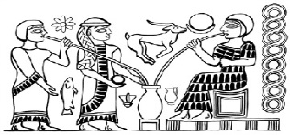Beer brewing dates to almost 6000 BC. However, it was the Sumerians around 2000 BC who really loved beer. Their pieces of art often showed people or gods drinking from large jars of beer. A **hymn** to their most important **goddess**, Ninkasi, is actually a very detailed explanation of how to make beer. This was helpful because the society was almost entirely **illiterate**. When they wanted to make some beer but couldn’t read the recipe, they just start reciting the hymn.

2. Beer is Dangerous

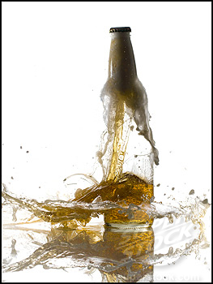For your liver, obviously. But beer brewing is also a dangerous process because bottles can explode, as today’s home brewers know. At a London brewery in 1814, a **container** with more than 100,000 gallons of beer exploded. The beer was running down the street through poor **residential** areas. It destroyed two houses and one pub and killed nine people. However, one of them died because he drank too much and died from alcohol **poisoning** the next day.

3. People will do anything for Beer

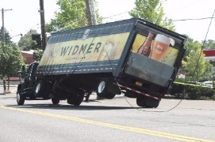In Australia on Easter weekend in 2001, a beer truck had an accident and **overturned** into a river. The driver was able to escape but his **cargo** sank to the bottom of the river. When the local people hear about the accident, they ran to the scene, some in full **scuba gear**, and spent the whole weekend getting the beer out of the river. One man managed to get 400 bottles. Did they return them to the company? Of course not. Police warned them that what they were doing was theft, but the divers escaped with the rescued bottles.

4. Brewing is Woman’s Work

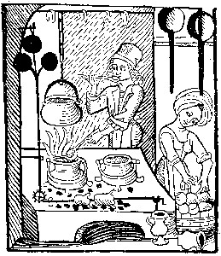In ancient and medieval times the brewing was a woman’s job. In some cultures it was such an honor that only beautiful or noble women could do it. However, in medieval Europe brewing was one of a housewife’s regular **tasks**, just like cooking and cleaning and looking after children. You never knew what you were getting because the hygiene at those times wasn’t very strict. Sometimes there were animal such as chickens sitting over the beer containers and their poo was simply **stirred** into the beer. Yummy.

5.Religious Beer

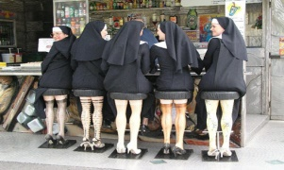The few beer producers who weren’t women were monks. Monasteries have a rich history of brewing beer **in order to** refresh tired travelers and to sell to make money to run the monastery. Today some still have active breweries, especially the Trappist Monks in Belgium and the Netherlands. Trappists make beer because they want to run their monasteries on the money they make from the brewery.

6. The World’s Oldest Brewery

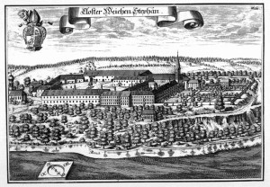 Germans are huge beer drinkers. Their country of 80 million did until just a few years ago have more breweries than the 300 million strong USA. They also have the oldest brewery which is located in Bavaria. Weihenstephan Abbey has been making beer since 1040. That’s almost 1000 years of continuous beer production.

7. Drinking Ages

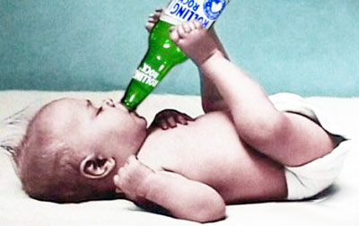In most countries the age at which you can buy alcohol falls between 16 and 21. However, parts of India have a drinking age of 25, the latest in the world. Many Muslim countries **outlaw** alcohol consumption completely while a very few countries allow anyone of any age to buy beer. The age at which you are allowed to purchase alcohol is often different from when you can legally drink

it. For example, in the UK you must be 18 to **purchase** alcohol but it is legal for you to drink it in a private home under adult supervision from the age of 5.

**Conversation questions:**

Is there anything healthy about drinking beer?

Is beer an important part of your country’s culture?

Why do you think beer is so popular around the world?

Would you like to go to the Munich Beer Festival or any other beer festival in your country?

Which country produces the best beer?

Do you like alcohol-free beer?

Is beer a man’s drink or a woman’s drink?

Do you mix anything with beer?

What’s the best thing to eat with beer?

Do you know how beer is made?Have you ever been to a brewery?

What beers are produced in your country?

How would you describe the taste of beer?

What do you think of people who drink too much beer?

Would you like to try making your own beer?

Do you think there is a difference between beers from different countries?

What do you think of beer bellies and ‘lager louts’ – young men who behave offensively after drinking beer?

How many beers would you normally drink a week?

BEER QUIZ

1. Beer is the world's best-selling ___ drink.  
   a. alcohol b. alcoholic c. alcohols
2. The process of making beer is called ___ .  
   a. beering b. brewsing c. brewing
3. The first recorded recipe ( ___ on clay tablets) seems to be one for making beer.  
   a. write b. written c. wrote
4. The ___ ingredients used in making beer are malted grains, water, hops, and yeast.  
   a. principal b. principle c. principles
5. The most common grain ___ for beer-making is barley, but sometimes wheat, corn, or rice are also added.  
   a. use b. uses c. used
6. Grain is malted by first soaking it in water, then allowing it to sprout, and finally drying it ___ stop the sprouting.  
   a. in order to b. to order to c. into order to
7. Hop cones add both flavour and aroma to beer; they are also good ___ .  
   a. preserves b. preservatives c. preservations
8. In a process ___ fermentation, yeast changes sugar from the malted grain into alcohol.  
   a. call b. calling c. called
9. Although the alcohol level in beer ___ ranges from 4-7%, it can go as high as 15%.  
   a. usual b. unusual c. usually
10. The two most ___ styles of beer are lager and ale.  
    a. common b. commons c. commonly
11. Lager ___ about 150 years ago, and it is now the most popular style of beer.  
    a. has developed b. was developed c. has been developed
12. However, in recent years, ale has been regaining ___ .  
    a. popular b. population c. popularity
13. One difference between lager and ale ___ the kinds of yeast used in the fermentation process.  
    a. lies in b. lies at c. lies on
14. Another difference between these two ___ of beer is the temperature of the fermentation process.  
    a. type b. types c. typicals
15. In addition, lager ___ lighter in colour and body than ale.  
    a. tends to be b. tend to be c. tends to have
16. Most beer in the United States is made by big breweries, such as Anheuser-Busch and Miller; microbrew or "craft" beer ___ only 5-10% of all beer produced.  
    a. account for b. accounts for c. count for
17. However, the rapid ___ in the number of microbreweries in the past 20 years means that the United States has a wider selection of beer styles than any other country.  
    a. increasing b. increases c. increase
18. In Europe, one of the smallest countries, Belgium, produces the ___ variety of beer styles of all and is sometimes thought of as a "Disneyland" for beer drinkers.  
    a. great b. greatest c. greater