**BEER**

What do the following words and phrases mean?

keg -

It’s on me. –

pint /half pint –

stout -

lager -

brewery –

on tap –

pitcher –

1. The Earliest Beer Recipe

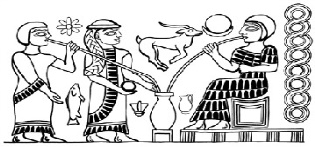Beer brewing dates to almost 6000 BC. However, it was the Sumerians around 2000 BC who really loved the stuff. Their plaques and carvings often center on people or gods drinking from large jars of beer. A hymn to one of their most important goddesses, Ninkasi, is actually a very detailed explanation of how to make beer; this was helpful in a society that was almost entirely illiterate. Want to make some beer but can’t read the recipe? Just start reciting the hymn and you’re set.

2. Beer is Dangerous

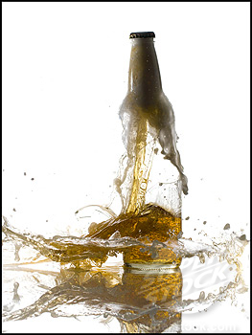For your liver, obviously. But beer brewing is also a dangerous process due to the chances of bottles exploding, as today’s home brewers know. Sometimes, however, you get beer destruction on an even larger scale. At a London brewery in 1814, a container with more than 100,000 gallons of ale exploded, sending the beer rushing down the street through poor residential areas. It destroyed two houses and one pub, killing nine people in the process. However, one of those people only had himself to blame. When the beer was flowing through the streets, people rushed to drink it. A gentleman drank a little too much and died from alcohol poisoning the next day.

3. People will do anything for Beer

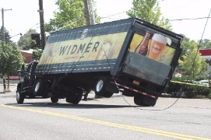Seriously, they will. In Australia on Easter weekend in 2001, a beer truck blew a tire and overturned into a river. The driver was able to escape but his cargo sank to the bottom of the river. Hearing about the accident, people gathered at the scene, some in full scuba gear, and spent the entire weekend recovering the beer. One man managed to get 400 bottles. Did they return them to the company? Of course not. Despite a warning from police that what they were doing was theft, the divers escaped with the whole lot.

4. Brewing is Woman’s Work

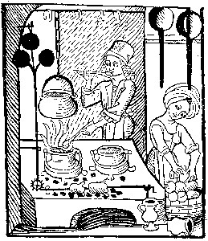In ancient and medieval times the job of making beer fell to women. In some cultures it was considered such an honor that only beautiful or noble women could do it. In medieval Europe brewing was one of a housewife’s regular tasks, just like cooking and cleaning and baby making. Some of these women became famous for being exceptional brewers and started supplying people other than their own families. You never knew what you were getting though. One brewer let her chickens sit over her beer containers and when they defecated she would simply stir the refuse into the beer. Yummy.

5.Religious Beer

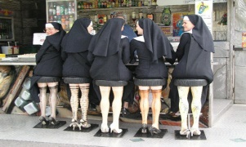The few beer producers who weren’t women tended to be monks. Monasteries have a rich history of brewing beer in order to refresh tired travelers and to sell to make money to run the monastery. Today some still have active breweries, especially the Trappist Monks in Belgium and the Netherlands. Trappists make beer in order to remain entirely self-sufficient, allowing them to run their monasteries on the money they make from the brewery.

6. The World’s Oldest Brewery

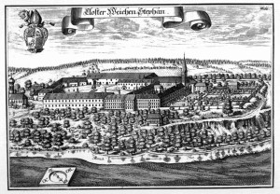It’s a terrible stereotype that Germans are all huge beer drinkers. However, their country of 80 million did until just a few years ago have more breweries than the 300 million strong USA. They also lay claim to the oldest brewery. Located in Bavaria, Weihenstephan Abbey has been making beer since 1040. That’s almost 1000 years of continuous beer production.

7. Drinking Ages

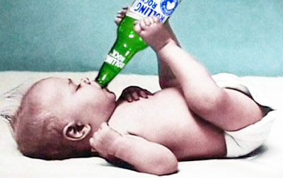The age at which you are allowed to buy alcohol varies surprisingly little from country to country, usually falling between 16 and 21. However, parts of India have a drinking age of 25, the latest in the world. Many Muslim countries outlaw alcohol consumption altogether while a very few countries allow anyone of any age to buy beer. The age at which you are allowed to purchase alcohol is often different from when you can legally drink it. For example, in the UK you must be 18 to purchase alcohol but it is legal for you to drink it in a private home under adult supervision from the age of 5.

Is there anything healthy about drinking beer?

Is beer an important part of your country’s culture?

Why do you think beer is so popular around the world?

Would you like to go to the Munich Beer Festival?

Which country produces the best beer?

Do you like alcohol-free beer?

Is beer a man’s drink or a woman’s drink?

Do you mix anything with beer?

What’s the best thing to eat with beer?

Do you know how beer is made?

What beers are produced in your country?

How would you describe the taste of beer?

What do you think of people who drink too much beer?

Would you like to try making your own beer?

Do you think there is a difference between beers from different countries?

What do you think of beer bellies and ‘lager louts’ – young men who behave offensively after drinking beer?

How many beers would you normally drink a week?

**Listening: Beer 0:14 – 1:20**

1: According to the article, roughly how old is beer?

2: Who brewed beer in ancient times?

3: Why was it so common to brew beer?

**BEER QUIZ**

1. Beer is the world's best-selling ___ drink.  
   a. alcohol b. alcoholic c. alcohols
2. The process of making beer is called ___ .  
   a. beering b. brewsing c. brewing
3. The first recorded recipe ( ___ on clay tablets) seems to be one for making beer.  
   a. write b. written c. wrote
4. The ___ ingredients used in making beer are malted grains, water, hops, and yeast.  
   a. principal b. principle c. principles
5. The most common grain ___ for beer-making is barley, but sometimes wheat, corn, or rice are also added.  
   a. use b. uses c. used
6. Grain is malted by first soaking it in water, then allowing it to sprout, and finally drying it ___ stop the sprouting.  
   a. in order to b. to order to c. into order to
7. Hop cones add both flavour and aroma to beer; they are also good ___ .  
   a. preserves b. preservatives c. preservations
8. In a process ___ fermentation, yeast changes sugar from the malted grain into alcohol.  
   a. call b. calling c. called
9. Although the alcohol level in beer ___ ranges from 4-7%, it can go as high as 15%.  
   a. usual b. unusual c. usually
10. The two most ___ styles of beer are lager and ale.  
    a. common b. commons c. commonly
11. Lager ___ about 150 years ago, and it is now the most popular style of beer.  
    a. has developed b. was developed c. has been developed
12. However, in recent years, ale has been regaining ___ .  
    a. popular b. population c. popularity
13. One difference between lager and ale ___ the kinds of yeast used in the fermentation process.  
    a. lies in b. lies at c. lies on
14. Another difference between these two ___ of beer is the temperature of the fermentation process.  
    a. type b. types c. typicals
15. In addition, lager ___ lighter in colour and body than ale.  
    a. tends to be b. tend to be c. tends to have
16. Most beer in the United States is made by big breweries, such as Anheuser-Busch and Miller; microbrew or "craft" beer ___ only 5-10% of all beer produced.  
    a. account for b. accounts for c. count for
17. However, the rapid ___ in the number of microbreweries in the past 20 years means that the United States has a wider selection of beer styles than any other country.  
    a. increasing b. increases c. increase
18. In Europe, one of the smallest countries, Belgium, produces the ___ variety of beer styles of all and is sometimes thought of as a "Disneyland" for beer drinkers.  
    a. great b. greatest c. greater