Shhh… Someone might be listening!
Ever find yourself watching the clock at work? Be careful, it might be watching you. A recent American survey reveals that 32 per cent of major American firms record and keep track employees’ communication and activities while working. Today’s high-tech cameras make it easy to keep an eye on you. They can be put in a fan, a smoke detector, a light switch and so on.
What’s the benefit? “It keeps people honest,” said the director of security in a shop in Los Angeles. ‘And if a company finds employees cheating on them and they take action, they may save money.’
It doesn’t stop at video cameras. Monitoring employees’ use of the internet and e-mail is now common practice. The fact is that our personal privacy is decreasing all the time. Credit rating companies keep tabs on your personal financial history since the day you get your first credit card. Anyone who has ever used the internet knows that their surfing habits are constantly being traced by ‘cookies’. Even when you are at any particular time will soon be easy to find out. Already, employee security cards record when people enter and leave buildings. Cell phones, car navigation systems will soon have detailed tracking abilities, if they do not already have them. “It all seems like an infringement of our privacy,”said a representative of the American Right to Privacy League. “But in a way, we are the ones who open the doors and let these people in.”
- What is the writer’s attitude towards decreasing personal privacy?
- angry
- enthusiastic
- warning
- neutral
- Look at the text again and find words and expressions that mean ‘to monitor’.

- Is your country similar? Better or worse?
- Would your employer get more work from you if you knew they were watching you?

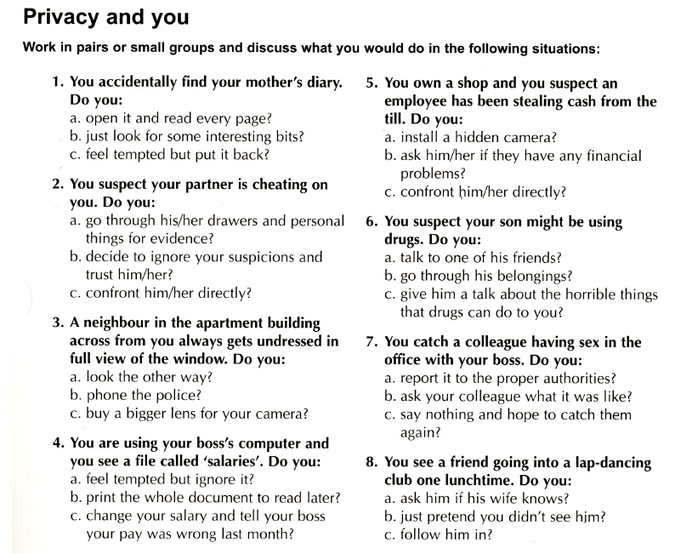

nedávný
záznam; sledovat
výhoda, užitek
jednat, podniknout
společnost ověřující důvěryhodnost/úvěruschopnost
hlídat, sledovat
narušení soukromí

