**Body Language**

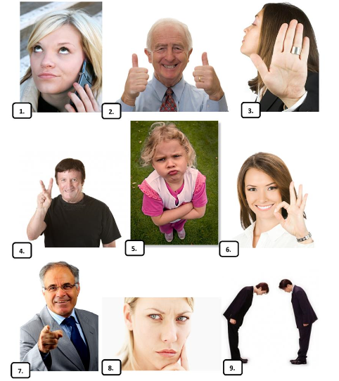[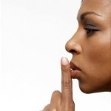](http://www.englishwithjo.com/wp-content/uploads/2013/07/gesture.jpg) Body language is a form of non-verbal communication used between animals and humans and consists of postures, gestures, facial expressions, and eye movements.  Body language can tell us about the attitude or state of mind of a person. For example, it may indicate anger, depression, pleasure, confidence or nervousness. Learning about body language is helpful in relationships, business, in family settings and parenting.  Although it is non-verbal, it can reveal a lot about your feelings and meaning to others and also how others reveal their feelings toward you.

1. thumbs up
2. bowing
3. frowning
4. rolling eyes
5. palm
6. crossed arms
7. pointing
8. fingers

What do the gestures in the picture mean?

**Vocabulary**

|  |  |  |
| --- | --- | --- |
| Nouns | Adjectives | Verbs |
| Non-verbal communication  Body language  Eye contact  Gesture  Handshake  Posture  Reaction | Relaxed  Nervous  Confident  Bored  Vulgar | Nod  Stare  Slouch  Fidget  Shake hands  Gesticulate  Insult |

**Idioms**

* To make the first move – to be the first to try to start a romantic relationship with someone
* To keep one’s fingers crossed – to wish for luck for someone or something, sometimes by actually crossing one’s fingers.
* Actions speak louder than words – What you do is more significant than what you say

**Conversation Questions**

1. Do you think body language is important?
2. How does body language help communication?
3. Are you aware of your own body language?
4. Do you notice other people’s body language?
5. What are some typical hand gestures in your culture?
6. Can you think of any gestures that are common across all cultures?
7. Can you understand something about a person’s personality by looking at their body language?
8. What do you think it means when a person fidgets?
9. What does it say about a person when they cross their arms?
10. What do you think it means when a person stands with their hands on their hips?
11. Do you have any body language you would like to change?
12. Some people say “you can know a person by their handshake”. Do you agree?
13. Do you think body language is different in other cultures?
14. What type of eye contact do you think is good?
15. Does your eye contact change according to the situation?
16. How do you feel if someone doesn’t give you eye contact?
17. How do you feel if someone stares at you?
18. What body language does a person who is bored show?
19. What body language does a person who is nervous show?
20. Is body language different between men and women?
21. Do you try to use body language when you communicate in English?
22. Do you agree that actions speak louder than words?

**Vocabulary revision:**

1. _____________ - the way in which somebody usually holds their shoulders, neck, and back.

e.g. Yoga improves the ____________.

2. ____________ – to move your head down and then up sometimes repeatedly to show agreement or approval.

e.g. She _________ to show that she understood.

3. ____________- a movement of the hands, arms, head etc. to express an idea or a feeling.

e.g. He made a very rude ________at the other driver.

4. ____________- a kind of feelings, worried or slightly frightened

e.g. Do you feel ________ during exams?

5. ___________- a greeting or expression of agreement in which two people face each other and hold a part of each other’s body.

e.g. I can tell a lot about a person from their _________.

6. _________- rude because referring to sex.

e.g. It was an extremely ______joke.

7. __________- to stand, walk or sit with shoulders hanging forward so that you look tired or bored.

e.g. Straighten your back. Try not to slouch.