BORN THIS WAY
Explain the following words or write their synonyms:
- a goal
- unofficial
- to encourage
- to stamp out
- revolutionary
- autographs
- iniciatives
- to reach out to
- to adopt
- bullying
- to pose
LADY GAGA LAUNCHES ANTI-BULLYING FOUNDATION
Pop diva Lady Gaga launched her Born This Way Foundation (BTWF) at Harvard University on February 29. She _______________________ of the foundation is to empower youth, inspire bravery, increase tolerance of others and _______________________. The singer told her audience that she hoped to use her fame to change the _______________________. She said: “If you have__________________, you must make the world a better place and use it….This is about transformative change in culture.” Gaga explained how important the foundation was to her, saying: “The culture of love is not going _______________________ but youth are the answer to creating a braver, kinder world…This _______________________ best days of my life.”
Lady Gaga arrived at Harvard with her mother, and her friend Oprah Winfrey. She _______________________ for students and _______________________. The Harvard event was the first of a _______________________ for the foundation. The Born Brave Bus was at the university and will travel around America to _______________________ get more involved in their communities. The bus will also accompany Lady Gaga's next concert tour in the U.S. Gaga hopes her foundation will also _______________________ help gay and lesbian youth. It is named after her global hit song “Born This Way” and has been _______________________ anthem for lesbians and gays. Lady Gaga has contributed $1.2 million of her own money to the BTWF.
a. | Lady Gaga has recorded a new song about bullying. | T / F
b. | Lady Gaga has started an initiative to try and stop bullying. | T / F
c. | Lady Gaga says she wants to use her fame to change the world. | T / F
d. | The pop diva said her visit to Harvard was the very best of her life. | T / F
e. | Harvard was the first of many events for Lady Gaga’s foundation. | T / F
f. | Youth can get to Lady Gaga’s concerts on a special bus. | T / F
g. | Gaga’s new foundation is named after one of her big hits. | T / F
h. | Gaga has not yet given any money to her foundation. | T / F
EMPOWER YOUTH: How? Complete this table with your partner(s)
 | How? | Problems with this?
empower youth
inspire bravery
increase tolerance
stamp out bullying
get involved
culture of love
CHANGE: How do today’s youth most need to change? Rank them and share your rankings with your partner. Put the biggest changes at the top.

- fashion
- getting involved in local community
- study habits
- manners
- tolerance
- selflessness
- drinking
- respect for the aged

TEST EACH OTHER: Look at the words below. With your partner, try to recall how they were used in the text:
- told  - bravery  - fame  - better  - answer  - best | - signed  - posed  - more  - next  - reach  - own
- What do you think of Lady Gaga’s Born This Way Foundation?
- What do you think of Lady Gaga?
- How do you inspire bravery?
- What’s the best way to stamp out bullying?
- Do you think you have “revolutionary potential”?
- Do you think it’s possible for a pop star to create a “culture of love”?
- Do you think “youth are the answer to creating a braver, kinder world”?
- What was one of the best days of your life?
- Why do you think Lady Gaga chose to launch her Born This Way Foundation at Harvard University?
- What do you think of the name Born This Way Foundation?
- How good a role model is Lady Gaga to youth?
- What can you do to help today’s youth?
- How do the youth in your country need to change?
- What different types of bullying are there?
- Was (Is) bullying a big problem at your school?
- Is it worse for children or adults to get bullied?
- Why do people bully each other?
- Do you think bullying should be made a crime or is it part of growing up?
- Is cyber-bullying (online bullying) worse than face-to-face bullying?
- What experiences of bullying do you have?
- How bad is bullying in your country?
- What kind of person is a bully?
- Do bullies need help? What kind?
- What can people who are bullied do to stop the bullying?
- If bullying involves violence, should someone call the police?
- What damage does bullying do to people?
- Should someone who is bullied make the name of the bully public – put it on the Internet?
- Is it always best to stand up to a bully?
- Do you think bullying will disappear one day, or is it getting worse?
- What advice would you give to someone who is bullied (a) online and (b) physically or emotionally?

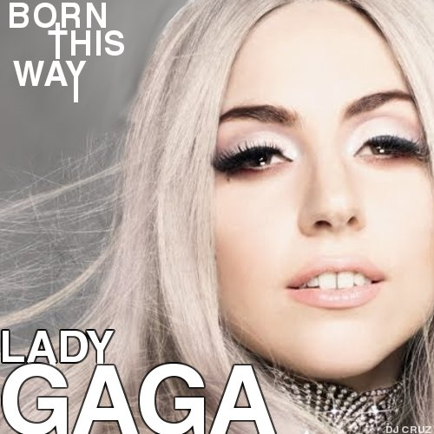
BORN THIS WAY by LADY GAGA
It doesn't matter if you love him, or capital H-I-M
Just put your paws up
'cause you were Born This Way, Baby
My mama told me, when I was young
we are all born superstars.
She rolled my hair and put my lipstick on
in the glass of her boudoir.
"There's nothing wrong with lovin' who you are,"
she said, "'cause he made you perfect babe.
So hold your head up, girl and you'll go far,
listen to me when I say."
I'm beautiful in my way,
'cause god makes no mistakes
I'm on the right track baby
I was born this way
Don't hide yourself in regret
Just love youself and you're set
I'm on the right track baby
I was born this way
Ooo there ain't no other way
Baby I was born this way
Baby I was born this way
Ooo there ain't no other way
Baby I was born -
I'm on the right track baby
I was born this way
Don't be a drag - just be a queen
Don't be a drag - just be a queen
Don't be a drag - just be a queen
Don't be!
…

