How the angel came up on top of the Christmas tree.

When four of Santa’s [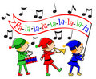](http://www.dreamstime.com/stock-photography-christmas-elves-musical-parade-image22082852) got , the trainee [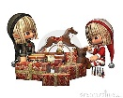](http://www.dreamstime.com/register?jump_to=http%3A%2F%2Fwww.dreamstime.com%2Fstock-photography-christmas-elves-wrapping-presents-image7342782) did not produce 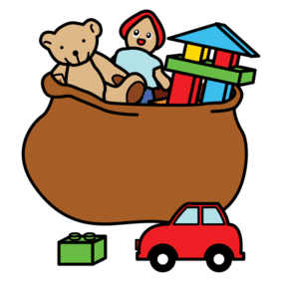 as fast as the regular ones, and Santa began to feel the Pre-

Christmas pressure. Then Mrs. [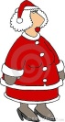](http://www.dreamstime.com/register?jump_to=http%3A%2F%2Fwww.dreamstime.com%2Froyalty-free-stock-photography-mrs-claus-image41327) told 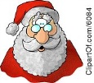 her Mother was coming to

visit, which stressed Santa even more.

When he went to harness the [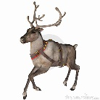](http://www.dreamstime.com/register?jump_to=http%3A%2F%2Fwww.dreamstime.com%2Fstock-images-reindeer-3-image3532724), he found that [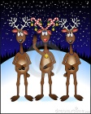](http://www.dreamstime.com/register?jump_to=http%3A%2F%2Fwww.dreamstime.com%2Fstock-photo-3-reindeer_candy-cane_2-image11666680) of them were

about to give birth and 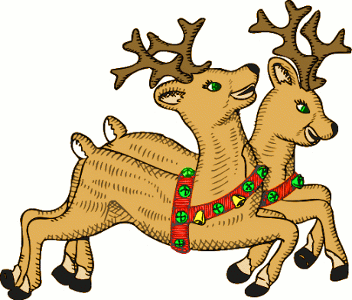 others had jumped the 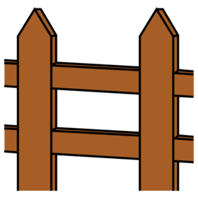 and were out,

Heaven knows where.

Then when he began to load the [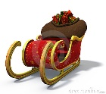](http://www.dreamstime.com/register?jump_to=http%3A%2F%2Fwww.dreamstime.com%2Froyalty-free-stock-photo-santa-s-sleigh-image11806155), one of the floorboards cracked, the

[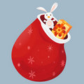](http://www.dreamstime.com/royalty-free-stock-photography-present-bag-image16382647) fell to the ground and all the toys were [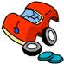](http://www.google.dk/imgres?q=broken+toys&um=1&hl=da&sa=N&biw=1280&bih=899&tbm=isch&tbnid=lll1lDsQX6eGeM:&imgrefurl=http://www.sunnyneo.com/toyrepairshop.php&docid=WbdzudjDd2KErM&imgurl=http://images.neopets.com/items/broken_redtoycar.gif&w=80&h=80&ei=CNrcTsCNOuTk4QT2tvnrDQ&zoom=1).

Frustrated, 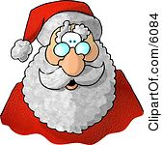 went in the [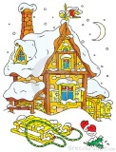](http://www.dreamstime.com/register?jump_to=http%3A%2F%2Fwww.dreamstime.com%2Froyalty-free-stock-images-house-of-santa-clause-image2974199) for a glass of  cider and a shot of [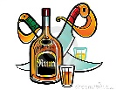](http://www.dreamstime.com/register?jump_to=http%3A%2F%2Fwww.dreamstime.com%2Fstock-photo-rum-image7676710). When he went to the 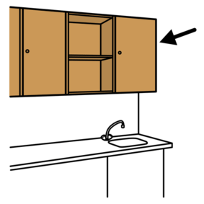, he discovered the[](http://www.dreamstime.com/stock-photography-christmas-elves-musical-parade-image22082852)had drunk

all the cider and hidden the liquor.

In his frustration, he accidentally dropped the cider 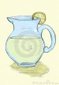, and it broke into hundreds of little  pieces all over the [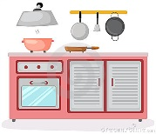](http://www.dreamstime.com/register?jump_to=http%3A%2F%2Fwww.dreamstime.com%2Froyalty-free-stock-photos-kitchen-room-image14385158) floor. He went to get the  and found the [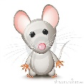](http://www.dreamstime.com/register?jump_to=http%3A%2F%2Fwww.dreamstime.com%2Fstock-photo-little-gray-mouse-image11830280) had eaten all the [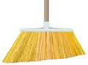](http://www.dreamstime.com/stock-photography-broom-image11565302) off the end of the broom.

Just then the [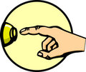](http://www.dreamstime.com/stock-photography-doorbell-image2325552)rang, and irritated 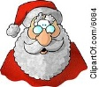 marched to the 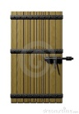, yanked

it open, and there stood a little 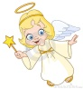 with a great big [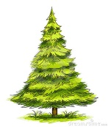](http://www.dreamstime.com/register?jump_to=http%3A%2F%2Fwww.dreamstime.com%2Froyalty-free-stock-photography-green-christmas-tree--image16703657). The 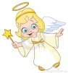said

very cheerfully, 'Merry Christmas, Santa. Isn't this a lovely day? I have a

beautiful [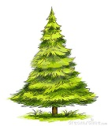](http://www.dreamstime.com/register?jump_to=http%3A%2F%2Fwww.dreamstime.com%2Froyalty-free-stock-photography-green-christmas-tree--image16703657) for you. Where would you like me to stick it?'

And so began the tradition of the little 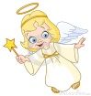 on top of the Christmas tree.

Video:

What does Crimbo mean?

How are the following things different in the UK and the USA?

1.Letters

2.Hanging stockings

3.Crackers

4.Christmas hats

5.Dinner

6.Pudding

7.Royal Christmas Message

8.Boxing Day

9.Pantomime

10.Taking down the Christmas tree