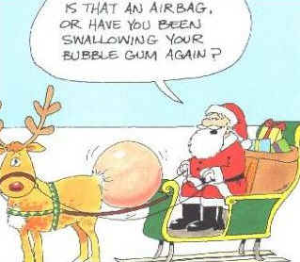
CHRISTMAS
Brainstorming:

Vocabulary game:
BOXING DAY
I think Boxing Day is confused / confusing for people who don’t know much about Christmas. It is a strange name for a holiday. I bet / better many people think it is a time when people have a fight and punch each other. Well, it’s quiet / quite a bit different than that. Boxing Day started hundreds of years ago as a way of helping poorer people at Christmas. Shopkeepers and craftsmen used / use to put a special Christmas box in their store or workshop. Customers and visitors would put money into the box. On the day after Christmas Day, when / which is December 26th, the shopkeeper emptied the box and shared the money with his workers. So that’s how Boxing Day started. This tradition kind of continues / continuing today. Many companies give their workers a Christmas bonus.
I’ve always liking / liked Boxing Day. It’s kind of the same as Christmas Day. It has a nice feel / felt about it and we get to eat Christmas dinner all over again. There are also load / lots of good programmes and movies on TV. For children, it’s another day to play with all their new toys; and for adults, it’s another / other day off work – at least in countries where Boxing Day is a national holiday. The biggest difference for me between the two days is that there are no more presents to open on Boxing Day. There is / are a lot of sport on Boxing Day so many people go to watch a football match or game of rugby. And if you don’t like sport, there are always the Boxing Day sales. You can go shopping and buy all of the things you wanted for Christmas but didn’t give / get!
Why is the 26th December called BOXING DAY?
What do people usually do on Boxing Day?
What do you think about the following statements:
- Christmas is too commercial nowadays.
- Santa doesn’t exist.
- I strictly observe Christmas traditions.
- Nobody should be alone at Christmas.
- Everybody loves Christmas.
- Christmas is a big problem for the environment.

Which is better – a white Xmas or a golden Xmas (on the beach in a hot country).
What makes Christmas magical to you?
What makes Christmas a nightmare to you?

Interview your partner about Xmas. Prepare 5 questions you want to ask.

1.
2.
3.
4.
5.

Christmas story
Picasso dictation

