MERRY CHRISTMAS
Make as many words as possible containing only the letters M E R R Y C H R I S T M A S

Wordle: How are the words in the wordle connected with Christmas?
Christmas tree word search:
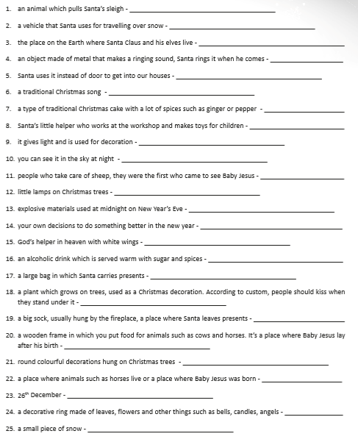
Make four interesting qustions to ask your partner about Christmas:
1.
2.
3.
4.

Christmas quiz:
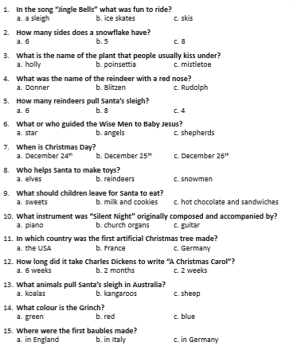
Christmas story A and B

