Colours

Which of the following are not colours?

red blue green azure white pink brown puce rainbow black turquoise navy khaki beige orange stripe purple violet indigo scarlet magenta grey burgundy
Match the words on the left with the words on the right to make common colour phrases

green tape
white fingers
black lie
red card
green jack
black company
blue-chip blood(ed)
blue market

Put the phrases into the sentences
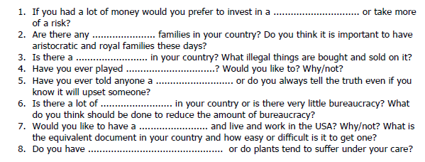
Listening: VOA
Red:
Pink:
Blue:
Green:
Black:
Brown:
Conversation:

What colours are in fashion at the moment?
What are the main colours in your house or flat? Who chose them?
What are your favourite coloours?
What colours suit you? What colours do you never wear?
What colours have special significance in our country?
What are the colours of the rainbow?
What do you think is the strangest colour for a car?
What colour ink do you like using the most?
Do favourite colours change throughout life?
Do you dream in colours?

Reading: Colour
How important is colour in our lives? According to various studies colour has a major influence on how we feel emotionally and even on our day-to-day performance. For instance, the colour you paint your living room could have an effect on how often you lose your temper in it! (What colour is your living room?) The colour of food packaging is vitally important too. It is carefully considered before marketing the product as certain colours are appetite stimulants whereas others may give the impression that the food tastes bad or is poisonous.
So, which colours should we avoid in our living rooms? Well, surprising as it may seem, yellow is not a good choice for the domestic environment. Usually yellow is associated with sunlight and is traditionally a happy, optimistic colour. It can also help you to think clearly. However, according to recent studies, people become irritable and even angry more often in rooms which are yellow than in rooms of other colours. It can also be upsetting for babies, who will cry more often in rooms with yellow colour schemes.
Orange is less risky. It can make you feel better by reducing depression. Red, however, traditionally associated with anger, can make us feel irritated and overstimulated if we are exposed to too much of it. Meeting rooms with red colour schemes may promote more argument than agreement! Red is also recognised as being effective in making you hungry which is why restaurants often include red in their colour schemes.
Pink might be a good choice for the walls of your living space if you want a calm colour that makes you feel loved and protected, but beware, it can also make you feel lethargic. Some sports teams have been known to paint the walls of the opposing team's dressing room pink in order to drain them of their energy prior to the competition or match.
Blue could be a good choice for the walls of your living room if you want a peaceful colour. People perform better in rooms with blue colour schemes so it is a good colour for offices. Believe it or not, weightlifters have been shown to lift heavier weights in blue rooms than rooms of other colours. But the shade of blue is important too – certain shades can seem cold. Dark blue is not recommended if you are prone to depression. As far as food is concerned, blue is an appetite suppressant. Scientists suspect that when hunter-gatherers searched for food they discovered that blue (or blue-ish) foods, such as berries, were poisonous.
Perhaps the easiest colour for interior walls is white. It is neutral, it doesn’t clash with anything, it is a good background colour, and it is always in fashion!
Quick Quiz:
1. According to various studies, colour has a major influence on how we feel __________.
2. Certain colours are appetite stimulants whereas others may __________ the impression that the food tastes bad or is poisonous.
3. __________, however, traditionally associated with anger, can make us feel irritated and overstimulated.
4. Some sports teams have been known to paint the walls of the __________ team's dressing room pink.
5. As far as food is concerned, blue is an __________ suppressant.
6. White is __________, it doesn’t clash with anything, it is a good background colour, and it is always in fashion!

Why shouldn’t you have a yellow colour scheme in your living room?
Which colour should be avoided in meeting rooms and why?
Why do restaurants often include red in their colour schemes?
According to scientists, why is blue coloured food unappealing?

