CRIME
What are the following words? redurm stinglea hefit onsipr

Match:
1. Murder a)To use force to take control of a plane, ship, train etc.
2. Kidnapping b)Killing someone by accident through a careless or dangerous act
3. Burglary c)Stealing - usually secretly and without violence
4. Mugging d)Taking somebody by and demanding money or conditions to free that person
5. Pickpocketing e)To steal things while pretending to shop
6. Arson f)To violently attack a person sexually
7. Rape g)To deceive or cheat someone to get money
8. Hijacking h)To set fire to a building illegally.
9. Fraud i)To enter a building, often while no one is in it, and steal money or objects
10. Theft j)Unlawfully and deliberately killing someone
11. Manslaughter k)To steal from someone’s pocket etc., without them realizing
12. Smuggling l)To take something by force from someone, often in the street
13. Shoplifting m)To bring illegal goods, like drugs, into a country or to bring goods into a country without paying taxes.

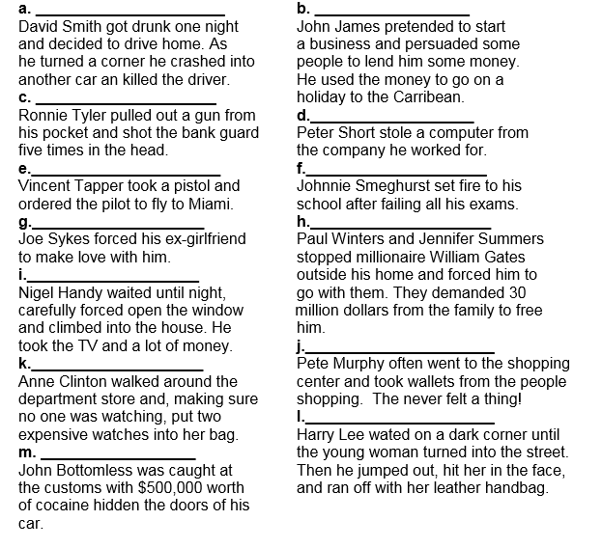

Listen to this interview with a couple who have been the victims of repeated crime and a police officer. Are the following statements True or False according to the interview?
1. The Saunders have been burgled eight times.
2. They bought the house for its views.
3. They thought they might have problems when they bought the house.
4. They think they know who the burglars are.
5. The burglars haven't stolen anything valuable from the Saunders.
6. They do not lock the door.
7. The Crime Prevention Officer doesn't think there is anything they can do to stop the burglars.
8. The Saunders do not have a burglar alarm.
9. The Crime Prevention Officer thinks it's always the same burglars who break into the Saunders' house.
10. Burglars like to steal things which have been bought recently.

Grammar Complete the short newspaper stories on the left with a suitable verb in the passive voice
arrest injure rob damage break shoot kill find guilty destroy steal handcuff rescue sentence

POLICE THEFT A Television set (1)________ from a Liverpool police station while officers were out fighting a crime.

PLANE DRAMA A drunk who tried to open an airplane door at 30,000 feet (2)_____________ for the rest of a Denmark to Thailand flight.

CAMPER DIES Camper John Barnes, 23, (3)__________ after a 200-meter fall into a rocky ravine with only a broken foot. Sadly he (4)_____________ when he fell out of the ambulance on the way to the hospital in Perth, Scotland.

UNLUCKY BURGLAR Burglar Frank Gort broke down and sobbed when he (5)_______________ to seven years in jail, claiming it was his unlucky number. An understanding judge in San Antonio, Texas, took pity and game him eight years instead.

WANTED MAN JAILED Fugitive James Sanders, who escaped from jail in 1975 (6)____________ in Texas after ringing the FBI to check if he was still on the wanted list.

STABBED IN THE BACK Mr. Clarence Ramsey (7)___________ seriously ______________ yesterday when a man came up behind him and stabbed him in the back. Turning around to face his attacker, Mr. Ramsey was surprised to hear him say, “Sorry I thought you were somebody else.”

Reading comprehension:

Picasso Painting is stolen in 35-second gallery raid by John Steele and Godfrey Barker

A PONY-TAILED robber with a shotgun walked into a West-End art gallery yesterday and stole $650,000 Picasso painting before escaping in a taxi he had ordered to wait outside. The raid which took only 35 seconds, was described by police as “most unusual” the man made no attempt to disguise himself from security cameras in the Lefevre gallery, one of London’s leading dealers in Impressionist works. Loss adjusters offered up to $50,000 for information leading to the return of Tete la Femme, a 1939 oil portrait by Pablo Picasso of his then lover, Dora Maar. The man, described as white and in his 30s, entered the gallery in midmorning and approached an assistant, Jacquie Cartwright, to ask the price of the work, which was hanging on a wall visible from the street. During their brief conversation he opened a hold-all to show what appeared to be a sawn-off shotgun. Mrs. Cartwright, who has worked at the Bruton Street Gallery for 13 years said, “He asked only for that one picture. “Then he told me he had a shotgun and he wanted the painting. He said: ‘Get it off the wall for me.’ I said, I couldn’t and told him to get it himself. So he did and then he ran out.” A security guard and another member of staff, Camille Bois, 28, chased the robber but lost him in a nearby side street where the unwitting taxi driver, who had originally picked him up was waiting. Martin Summers, managing director of the gallery, said the man threatened staff at a nearby restaurant. He then brandished the gun at the taxi driver and forced him to drive to Park Lane and then Battersea, where, according to Mr. Summers, he tried to use a telephone at a branch of Halfords. The cab went on to Wimbledon, where the robber fled after removing the plywood painting from its frame and leaving $10 for the driver. Mr. Summers declined to say whether the gallery owned the painting or was selling it for a client. Mark Dalrymple, a loss adjuster, said, “No one is going to be able to sell it at a serious price.”

What did the robber look like?
What weapon did he have?
Who was painted in the stolen picture?
What did the thief ask Mrs. Cartwright to do?
What did the thief do in Battersea?
What did the robber give the taxi driver?

Conversation:
- Do you always lock your house? What about your car?
- Do you think that men and women are punished the same for the same crimes? Why or why not? How should it be?
- Do you think it's possible to prevent certain kinds of crimes? If so, which ones and how?
- Should users of illegal drugs be put in prison? Why or why not? What about the people who sell them?
- How have science and technology changed what crimes are committed? How about the way we solve them?
- How much do the media cover crime in your country? Do you think that they should spend less time or more time on it?
- What do you think are reasonable penalties for people who commit environmental crimes?
- Are prison sentences an effective punishment for criminals? Why?
- What would you do if you heard a burglar in your house?
- Who decides what is and isn't a crime?
- What do you think the most common crime in our country is?
- Should police in our country be stricter or less strict?
- Do you think criminals can change?
- What kind of people shoplift and what kinds of things do they steal?
- Have you ever met someone from the mafia?
- Can you tell if a kid will grow up to be a criminal?

