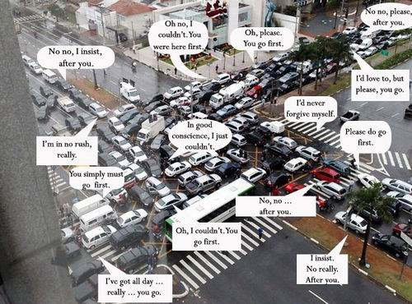
Etiquette
1) Are the people of your country well mannered compared to other nationalities?
2) What customs or social rules does your country have that a foreigner might not know?
3) What examples of bad manners do you often see?
4) Do you have any customer service horror stories? 5) Is it old fashioned to think a lot about the rules of etiquette?
6) Why are manners important?
7) What rules of etiquette would you like to change?

8) White Lies: Is it okay to lie in order to avoid hurting someone’s feelings?
9) Do you say "hi" to people even if they are strangers? Why? Why not?
10) Do you think it is good manners to hug or kiss another person in greeting?
11) Do you let people pass you when you are driving in your car? Is it considered a good manner?
12) Do you honk your horn to people when you drive?
13) Do people have more manners now or in earlier times?
14) Can manners affect your success in life? How?
15) What's the best way to teach manners to children?
16) When you walk, what side should you be on?
17) When you are entering an elevator, what should you, do if there are people getting out?
18) How closely do you think good manners are related to income and social status?

Listening:
What kind of school did Callum ask whether Jennifer had visited?
Which fork and knife should you use first in a restaurant?
Whose idea was the etiquette lessons?
What special event are they preparing for?
Who is helping with the lessons?
What are the boys learning?
How can the lessons help students in their lives?

Match:
a finishing school | a formal party often held to celebrate a special event
etiquette | to want to be involved with or take part in something
to come about | a place where young women are taught how to behave in high society
a ball | to happen, to begin
to want a piece of something | the accepted rules for behaviour in particular situations
to go down well | to be confident and proud
to hold your head up high | to be successful and popular

What is your Etiquette IQ?
1) How would you eat corn on the cob at a formal dinner?
a) Carefully pick up with two hands and eat from left to right.
b) Cut kernels from cob and eat with a knife and fork.
c) Don't worry about it. Corn on the cob is never served at formal dinners.
d) Butter the corn liberally, eat with relish and lick your fingers when done.
2) When walking through the outside door leading to the mall, who holds the door for whom?
a) A young man holds the door for an older woman.
b) A young woman holds the door for an older man.
c) Whoever goes in first holds the door.
d) All of the above.
3) You receive a cell phone call while you're in an important meeting. What do you do?
a) Answer it and excuse yourself to have the conversation in the hall.
b) Let it ring until it stops.
c) Answer the phone and turn your back for conversation privacy.
d) Turn off the phone before the meeting and check for messages when the meeting is over.
4) There are unusual utensils at your place setting. What do you do?
a) Discreetly ask your neighbor what they are for.
b) Observe which utensils others are using and follow his or her example.
c) Guess which to use and hope for the best.
d) Ignore the questionable utensils and eat the way you are comfortable.
5) Where do you place your purse while dining at a restaurant?
a) On the table to the right of your place setting.
b) Hanging over the back or arm of your chair.
c) On the floor.
d) On your lap or between your back and the chair.
6) A customer walks into your office. How do you greet her/him?
a) Stand up, step from behind the desk, greet the person, shake hands, introduce yourself and offer them a seat.
b) Smile warmly and gesture for them to sit.
c) Wrap up the telephone call you were involved in and greet them when you hang up.
d) Greet them and wait for them to be seated before asking them how you can help them.
7) What is the difference between the American and Continental styles of dining?
a) Continental is used only at French restaurants.
b) Place settings are different for American style eating.
c) Continental requires use of both left and right hands simultaneously to manipulate food.
d) Once you pick up your silverware you never put it down in the Continental style.
8) What is the best way to dress for a job interview?
a) Wear what you wear to the mall.
b) Expose all tattoos and piercings so the prospective employer will know what they can expect to see each day.
c) Wear conservative, business style clothes so the interviewer can pay attention to what you are saying, not what you are wearing.
d) Dress in the latest fashions so everyone will know how cool you are.
9) What is the maximum appropriate number of people in a receiving line?
a) As many as there are.
b) No more than six.
c) Twelve.
d) Two.
10) Why are small bites of food better to take than large ones?
a) It is better for the digestion.
b) So that you can respond when spoken to.
c) So here is less chance to lose your food on its way to your mouth.
d) All of the above.

Answers: 1) c, 2) d, 3) d, 4) b, 5) d, 6) a, 7) c, 8) c, 9) b, 10) d

