Pros and Cons of 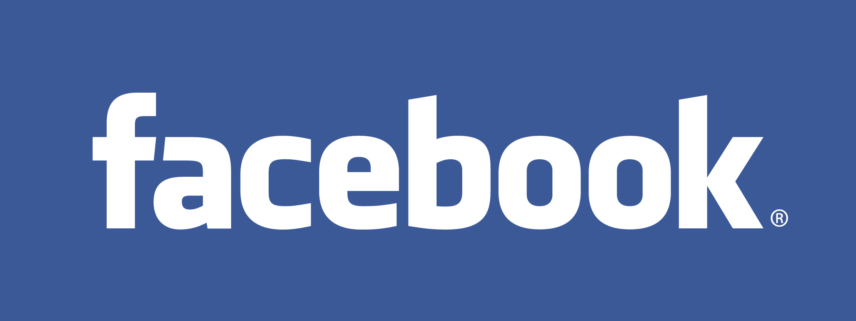
This article will tell you about the pros and cons of using Facebook. This is a tool that can be used or misused, and the choice ultimately resides in your hands.

When Mark Zuckerberg formed Facebook in February 2004, he had no idea how big it would actually become, and how big a debate the pros and cons of Facebook would spark. Along with a few of his friends at Harvard University, Zuckerberg created Facebook to fulfill the purpose of a college yearbook. Within a few months more and more people joined the community, and today Facebook has more than 750 million users all over the world. In January 2011, Facebook also became the second most visited website in the United States.
In simple terms, Facebook is a social networking website where each user joins the community and connects with their friends virtually. Connected members can share information, pictures, videos and also use the Facebook instant messenger facility. A member creates a profile for himself and uploads anything he/she wants, and all his connected friends can view this data at any time.
The Privacy Issue
All this information sharing has brought the privacy issue to the fore, with many people vehemently claiming that Facebook is a gross violation of an individuals privacy. Though this is true to a certain extent, it is also true that one is a member of Facebook by choice. The basic premise of Facebook will show us that this is a matter that can violate some people's sense of privacy, but at the end of the day, it is entirely in your hands. The information displayed there is of your own choosing, and each individual deserves the right to decide what they want to share. You should also learn more about what is Facebook and how does it work.
One should accept that once such data has been uploaded on Facebook, it is in the public domain, and there will be people who will be viewing your profile. This is a conscious choice you are making, and therefore a Facebook member should not complain about privacy violation. If you are uncomfortable with this violation, you are free to delete your Facebook account as and when you like.
Pros and Cons of Facebook for Individuals
There are obviously two sides to this argument, and it all depends on what your opinions are. People who like Facebook can spend hours on it browsing through other people's profiles, whereas some people cannot even stand the sight of it, even though they know how to use Facebook wisely. Here are some of the well-known pros of Facebook.
You have the ability to find old friends and reconnect with them.
You can keep in touch with your friends, no matter how far apart you'll are physically.
You can keep your friends and family members updated about what is happening in your life.
You can promote yourself and any other work that you do.
You can make many new like-minded friends by joining various groups and communities.
You can share your favorite music and videos with your friends.
You can play many different games and use many different applications.
You can communicate with your friends at any time you want.
To balance out these advantages, there are bound to be some cons of Facebook as well, and these are what deter many people from joining Facebook.
You will get bombarded with unwanted friend requests from many unknown people.
Your friends and family members will be able to snoop around and know what is happening in your life at all times.
Your pictures could be misused.
You might mistakenly befriend an individual with dishonorable intentions.
You will get unwanted newsfeeds about every single activity that your friends perform on Facebook.
Your friends will get newsfeeds about every single activity that you perform as well.
You will get bombared by spam and annoying advertisements from time to time.
You will witness unnecessary dramatization of unimportant occurrences in your friends lives.
Anyone on Facebook will be able to see your information and pictures, if you do not update your privacy settings regularly.
Your friends may tag you in a picture that you do not want others to see.
Applications will ask you for many details that you would not normally give out.
You will waste many hours because Facebook is addictive for most people.
You can also learn about pros and cons of Facebook for business purposes, as many people like to advertise their work on this medium, in the hope that a potential client or employer may see it. Many advertisers and companies also use Facebook as an advertising medium since there is a large base of people to target here.
These qualities and features of Facebook for kids and adults mean that this is double edged sword, and you have to make a decision about joining Facebook. Even if you are a member, there is no compulsion to share information every single day, and you can also choose to share only selected information. All this means that Facebook is synonymous with the Internet, in the sense that it can be useful or disruptive, only if you allow it to be.
By Rahul Thadani
Last Updated: 9/29/2011

What springs to mind when you hear the word ‘Facebook’?
Do you like the Facebook logo?
What do you think of the name ‘Facebook’?
Can you remember when you first heard of Facebook?
Facebook or Twitter?
What are the best things about Facebook?
Do you think it’s dangerous putting information on Facebook?
What are your favourite Facebook applications or games?
How would you sell someone to Facebook who didn’t want to open an account?
What is the purpose of Facebook?
Would you ever pay to use Facebook?
Have you ever put anything on Facebook that you regretted?
What do you think Facebook will be like a decade from now?
What would you like Facebook to do differently?
Is Facebook a good place to meet new people?
Would you let your 14-year-old child open a Facebook account?
Is Facebook here to stay or will something else come along and make it history?
What do you think of people who are addicted to Facebook?
What questions would you like to ask Facebook’s owner?

