FAIRY TALES
"A fairy tale is a story featuring folkloric characters such as fairies, goblins, elves, trolls, giants, and others. The fairy tale is a sub-class of the folktale. These stories often involve princes and princesses, and modern versions usually have a happy ending."
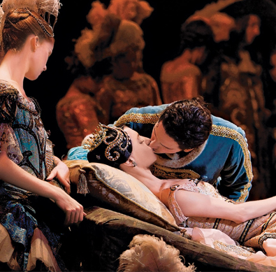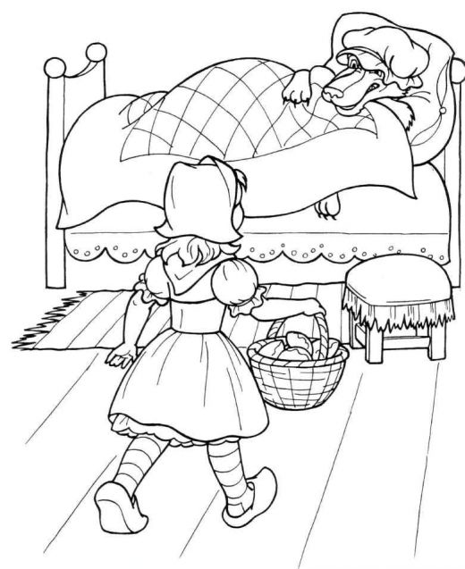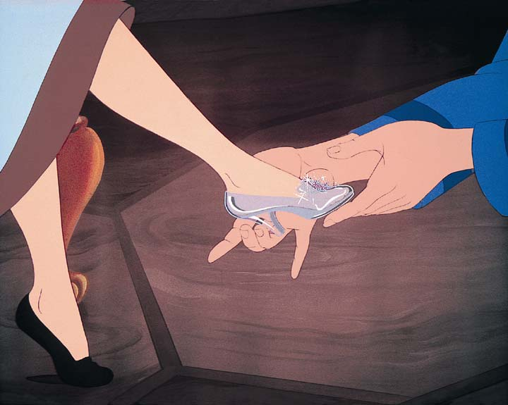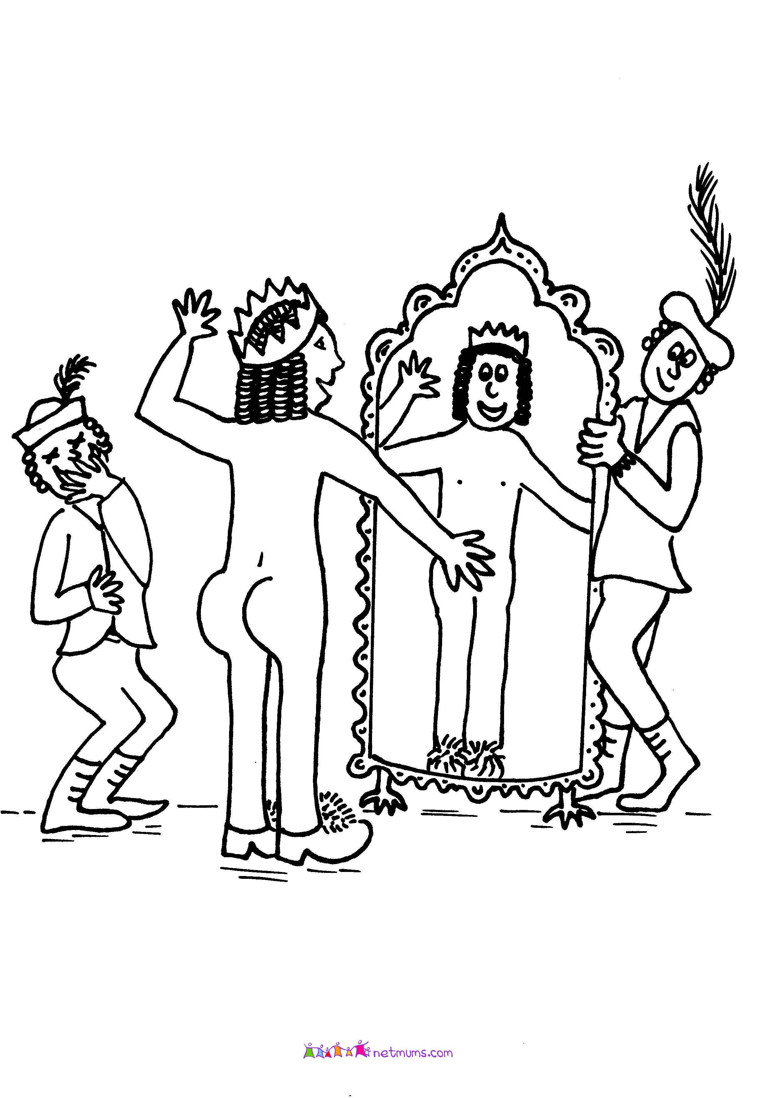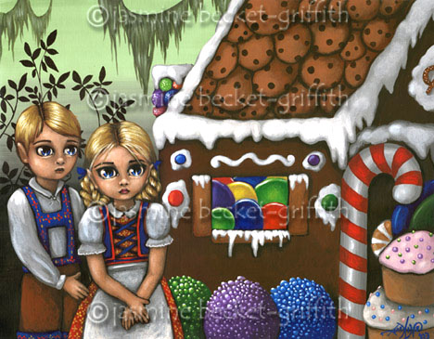

Which stories do the pictures belong to?
What was your favourite story when you were a child?
What are fairy tales good for?

How much do you know about fairy tales?

How many dwarfs are there in Snowhite?
How much money do Hansel and Gretel’s parents have?
How long does Sleeping Beauty sleep?
Who does Cinderella marry?
Who created Mickey Mouse?
Who are Bashful, Doc, Happy or Sleepy?
Where did Hans Christian Andersen come from?
Whose lamp is magic?
What kind of animal is Walt Disney’s Dumbo?
How old is Harry Potter in the first story Harry Potter and the Philosopher’s Stone?
What did Goldilocks eat in the house of the three bears?
How did Little Red Riding Hood get her name?
What did Snow White take from the wicked Queen?
What did Cinderella lose on the way home from the ball?
In the story of the three little pigs which house didn’t blow down?
Which musical instrument did the Pied Piper play to charm the rats?
In the story of Hansel and Gretel what was the house in the forest made of?
Why did Sleeping Beauty go to sleep?

THE REAL PRINCESS
There was once a Prince who wished to marry a Princess; but then she must be a real Princess. He ________ all over the world in hopes of finding such a lady; but there was always something ________. Princesses he found in plenty; but whether they were real Princesses it was impossible for him to ________, for now one thing, now another, seemed to him not quite right about the ladies. At last he returned to his palace quite cast down, ________ he wished so much to have a real Princess for his wife.
One evening a fearful tempest arose, it thundered and lightened, and the rain poured down from the sky in torrents: besides, it was as dark as pitch. All at once there was heard a violent knocking at the_______, and the old King, the Prince's father, went out himself to _______ it.
It was a Princess who was standing outside the door. What with the rain and the wind, she was in a sad condition; the water trickled down from her hair, and her clothes clung to her _______. She said she was a real Princess.
"Ah! we shall soon see that!" thought the old Queen-mother; ________, she said not a word of what she was going to do; but went quietly into the bedroom, took all the bed-clothes off the bed, and put three little peas on the bedstead. She then laid _______ mattresses one upon another over the three peas, and put twenty feather beds over the mattresses.
Upon this bed the Princess was to pass the night.
The next morning she was asked how she had ________. "Oh, very badly indeed!" she replied. "I have scarcely closed my eyes the whole night through. I do not know what was in my _______, but I had something hard under me, and am all over black and blue. It has hurt me so ________!"
Now it was plain that the lady must be a real Princess, since she had been able to feel the three little peas through the twenty mattresses and twenty feather beds. None but a real Princess could have had such a delicate sense of _________.
The Prince accordingly made her his wife; being now convinced that he had found a real Princess. The three peas were however put into the cabinet of curiosities, where they are still to be seen, _______ they are not lost.
Wasn't this a lady of real delicacy?
Jack and the Bean Stalk
Jack lived with his mother and they were very poor. Jack went to market to sell their cow, but exchanged it for some magic beans. His mother was angry and threw them out the window. Next morning a giant plant was growing up into the sky.
Jack climbed up into the clouds where there was a magic land. He saw a huge castle and so went there. The castle belonged to a giant, who was out hunting. The giant’s wife let Jack come in, and when the giant came home she hid Jack. After dinner the giant brought out a hen that laid a golden egg. When the giant fell asleep Jack stole the hen and went back home.
For a while Jack and his mother were happy as they had money, but then Jack decided to go back up the beanstalk. He returned to the giant’s castle and this time when the giant fell asleep Jack stole two bags of money. When he got home his mother was ill, but cheered up when she saw him.
Again they were happy for a while and again Jack decided to go back up the beanstalk. This time the giant got out a magic harp after dinner, which played beautiful music all by itself. When the giant fell asleep Jack stole the harp, but the harp woke the giant, who started chasing Jack.
Jack raced back down the beanstalk, took an axe, and as the giant was climbing down he chopped it down. The giant fell all the way to the ground and was killed. And Jack and his mother lived happily ever after.

The Boy Who Cried “Wolf!“

He didn’t enjoy looking after sheep and he got very bored. So one day he decided to play a trick on the people in the village. He shouted “Help! There is a wolf coming to eat me.“

The people in the village heard him shouting again, but this time they didn’t stop to go and help him. “He’s hoping to trick us for a third time,“ they said,“but this time it is not going to work.“

Once there was a boy who looked after sheep. Every morning he left the village and took his sheep into the hills. All day he watched the sheep eating grass.

A week later, the boy was looking after his sheep as usual when he heard something moving in the forest. When he looked round, he saw a big grey wolf coming out of the trees. “Help!“ he shouted. “Wolf!“

The villagers were all working , but when they heard the boy shouting, they stopped working and ran out to the hills to save the boy.

And so the villagers decided to stay in the village. They didn’t go to help the boy and the wolf ate him. A few days later someone found some bones lying on the ground. It was all that was left of the boy who cried “Wolf!“.

When the boy saw them approaching, he started to laugh. But the villagers didn’t think it was funny and they were angry with the boy and he promised not to do it again.

A few days later, however, the boy played the trick again. “Wolf! Wolf!“ he shouted and once again the villagers stopped to go and help. Again they expected to find the boy in danger, but, as before, they found him sitting on the ground and laughing. They were very angry with the boy.

