*FEAR AND HALLOWEEN*

*Match words and definitions:*

spooky - scary

frightened - bones

ghost - a woman thought to have evil magic powers

haunted - an apparition of a dead person

witch - a place visited by a ghost

pumpkin - when children go from door to door in fancy dress asking for sweets

trick or treat - a big orange vegetable which is hollowed out and made to look like a face

skeleton - afraid

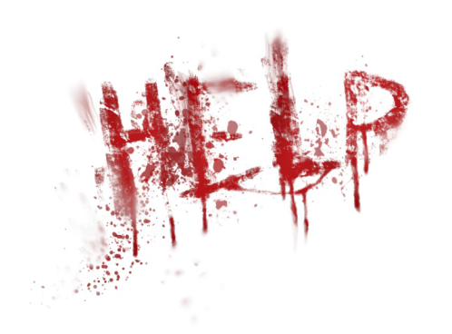

Is fear a good thing?

What would happen if we were fearless?

How do you react to fear?

Do you like being scared?

Do you like watching horrors?

When were you last afraid of something?

What were you afraid of as a child?

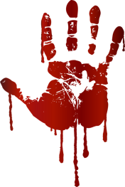Do you think that people live in fear?

What do you know about Halloween?

Video: NUMBERS

How many American celebrate it?

How much money is spent on this holiday?

How many kilograms of candy are eaten?

How long has it been celebrated?

When was ancient pre-Christian holiday SAMHAIN celebrated?

When is ALL HALLOW’S DAY?

How much money is spent on sweet stuff on Halloween?

How many pieces of candy can you buy for this money?

How many people wear the witch costume?

Which are the second and third popular costumes?

How many people in the US dress up their pets?

What is the most popular costume for pets?

How many tons of pumpkins are grown for Halloween?

**The Yellow Ribbon**

Once upon a time, there was a boy named Johnny and a girl named Jenny. Jenny was a very nice girl, but she was also very quiet. More importantly, she always wore a yellow ribbon around her neck.

Johnny didn't know why she wore a yellow ribbon, and he was very curious. Every day, Johnny asked Jenny, "Why do you wear that yellow ribbon?"

Jenny would say, "I can't tell you that now, maybe later."

Johnny and Jenny grew up together, but he never saw her without that yellow ribbon. When they were teenagers, he asked her every day, "Why do you wear that yellow ribbon?"

And Jenny would say, "I can't tell you that now, maybe later."

When they were all grown up, Johnny and Jenny fell in love and got married. On their wedding day, Jenny wore a beautiful white dress, and a yellow ribbon around her neck. Johnny asked her, "Why do you wear that yellow ribbon?"

Jenny said, "I can't tell you that now, maybe later."

Jenny and Johnny lived together for a very long time and had a very happy life. They had children together and they were always happy, but Johnny never saw his wife without her ribbon around her neck. He was still curious. One day, when they were both very, very old, he asked Jenny, "Why do you wear that yellow ribbon?"

Jenny sighed and said, "I guess it's time to show you. If you want to, you can untie it." Johnny's hands trembled as he reached for the ends of the yellow ribbon and sloooowly untied it. Carefully, he pulled the ends of the ribbon away from Jenny's neck…

…and her head fell off!

Where did Jenny wear her ribbon?

Why did Johnny ask Jenny about her ribbon?

When did Jenny answer Johnny's question?

Why did Jenny wear a yellow ribbon around her neck?

What do you think the "moral" of this story is?