*FEAR AND HALLOWEEN*

*Match words and definitions:*

spooky - scary

frightened - bones

ghost - a woman thought to have evil magic powers

haunted - an apparition of a dead person

witch - a place visited by a ghost

pumpkin - when children go from door to door in fancy dress asking for sweets

trick or treat - a big orange vegetable which is hollowed out and made to look like a face

skeleton - afraid

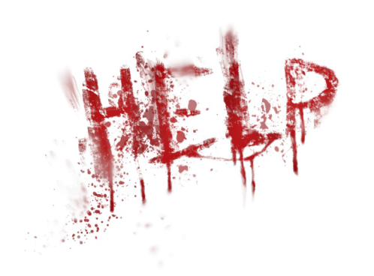

Is fear a good thing?

What would happen if we were fearless?

How do you react to fear?

Do you like being scared?

Do you like watching horrors?

When were you last afraid of something?

What were you afraid of as a child?

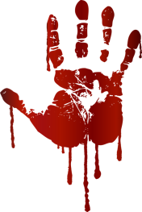Do you think that people live in fear?

What do you know about Halloween?

Video: NUMBERS

How many American celebrate it?

How much money is spent on this holiday?

How many kilograms of candy are eaten?

How long has it been celebrated?

When was ancient pre-Christian holiday SAMHAIN celebrated?

When is ALL HALLOW’S DAY?

How much money is spent on sweet stuff on Halloween?

How many pieces of candy can you buy for this money?

How many people wear the witch costume?

Which are the second and third popular costumes?

How many people in the US dress up their pets?

What is the most popular costume for pets?

How many tons of pumpkins are grown for Halloween?

**The Yellow Ribbon**

Once upon a time, there was a boy named Johnny and a girl named Jenny. Jenny was a very nice girl, but she was also very quiet. More importantly, she always wore a yellow ribbon around her neck.

Johnny didn't know why she wore a yellow ribbon, and he was very curious. Every day, Johnny asked Jenny, "Why do you wear that yellow ribbon?"

Jenny would say, "I can't tell you that now, maybe later."

Johnny and Jenny grew up together, but he never saw her without that yellow ribbon. When they were teenagers, he asked her every day, "Why do you wear that yellow ribbon?"

And Jenny would say, "I can't tell you that now, maybe later."

When they were all grown up, Johnny and Jenny fell in love and got married. On their wedding day, Jenny wore a beautiful white dress, and a yellow ribbon around her neck. Johnny asked her, "Why do you wear that yellow ribbon?"

Jenny said, "I can't tell you that now, maybe later."

Jenny and Johnny lived together for a very long time and had a very happy life. They had children together and they were always happy, but Johnny never saw his wife without her ribbon around her neck. He was still curious. One day, when they were both very, very old, he asked Jenny, "Why do you wear that yellow ribbon?"

Jenny sighed and said, "I guess it's time to show you. If you want to, you can untie it." Johnny's hands trembled as he reached for the ends of the yellow ribbon and sloooowly untied it. Carefully, he pulled the ends of the ribbon away from Jenny's neck…

…and her head fell off!

Where did Jenny wear her ribbon?

Why did Johnny ask Jenny about her ribbon?

When did Jenny answer Johnny's question?

Why did Jenny wear a yellow ribbon around her neck?

What do you think the "moral" of this story is?

**The White Dress**

It was the night before the high school graduation party, and Clara didn't have a dress to wear. Her father was dead and her mother was a waitress, so they didn’t have much money. Life for Clara was difficult.

Today, Clara went to a funeral home to say goodbye to an elderly neighbour who had died a few days ago. Inside the funeral home, Clara saw a young girl, about her age, in a casket. Clara noticed the dead girl’s dress was very pretty and brand new.

While looking at the dress, the manager came in the room and said it was time to leave. He told Clara this girl would be buried tomorrow morning. After the manager left, Clara walked down the hall to the room and found her dead neighbour.

A few minutes later, she heard a lot of crying. Someone had fainted in one of the rooms, and everyone, including the manager, ran to help. Suddenly, Clara had an idea. She went into the room with the body of the young girl, opened the casket, removed the white dress from the girl’s body. She put the white dress in her school bag and walked out of the funeral home. Nobody had seen her steal the dress.

As she was walking home, Clara was thinking about her actions. Was it wrong to steal from a dead person? Especially a dead person who would never be seen again. She decided the world was not fair. Why was it okay for some people to have anything they wanted while others could not buy a nice dress? She thought there is no right or wrong, no good or evil. There was only money and poverty. The next night, she put on the white dress and went to the graduation party.

Clara was having a good time at the party. She danced a lot and many friends said she looked nice in the white dress. Suddenly, Clara’s knees and elbows began to hurt. Later in the evening, her muscles became stiff. She couldn’t walk or move very well. She thought there was something wrong with the dress, so she went into the bathroom and looked at it. She couldn't find anything wrong. So she put it back on.

As Clara danced, her body became cold and stiff. She fell down on the floor and couldn’t move. The ambulance was called, and she was taken to the hospital. The doctors said she was dead - but she was alive! She could hear every word that was said. She just couldn't move or speak.

The next day, she was lying in a funeral home wearing the white dress. Her family and friends visited her coffin. They were crying. She tried to move and shout, but she couldn't.

The manager in the funeral home came in and closed the casket. The next day, the casket was taken to the graveyard. Clara could hear the gravediggers working.

"Did you hear what happened at the funeral home yesterday?" said one of them.

"No, what?" said the other as they threw shovels of dirt onto Clara’s casket.

"A worker in the funeral home heard a knocking sound in one of the caskets. She opened the casket, and a young girl climbed out. She said someone tried to hurt her with voodoo magic. Someone gave her a dress covered with zombie powder, so she looked dead but she wasn't."

"Huh," said the first gravedigger. "I wonder what happened to that dress."

And then Clara couldn't hear anything else…