**Food and cooking**

**Complete the table with at least five words for each category. Try to be original.**

|  |  |  |  |  |  |  |  |
| --- | --- | --- | --- | --- | --- | --- | --- |
| **fruit** | **vegetable** | **meat** | **dairy** | **other food** | **ways of cooking** | **dishes** | **restaurant** |

What have you eaten today? Did you prepare the meals yourself?

Can you cook? Are you a good cook? When did you learn to cook?

Do you cook? If yes, what food do you cook the most often? What food can you cook the best?

Do you enjoy cooking? Do you like cooking alone or with your partner or friends?

Do you use cookery books? How many have you got?

Is it OK for men to cook? Are men better cooks than women?

Do you watch programs about cookery? Which ones?

Are there any meals that you didn’t use to eat as a child that you eat now?

Do you like eating? Why or why not?

Do you often eat out?

What kind of cuisine do you like?

How long do you eat lunch?

How much do you eat when you are sad or happy?

Is there any food that you really dislike? What is you favourite food, fruit, vegetable, drink or dessert?

What food have you tasted which you will never forget for the rest of your life?

What is a typical meal from your country?

What is the most unusual thing you've ever eaten. Did it taste good or bad?

Why do you think obesity is becoming such a problem in the United States and throughout the world?

Do you believe that "we are what we eat?"

Have you ever had pot-luck?

Does your family have any special recipes that are passed down from generation to generation?

Do you like brunch?

Have you ever found something disgusting in your food?

Have you ever sent food back in a restaurant?

Do you like trying new food?

Do you have any food allergies?

Are there any foods that bring back special memories for you? What are they?

[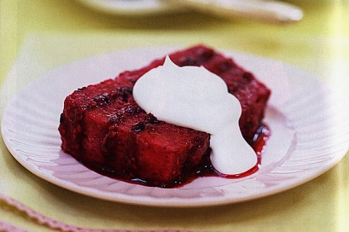](http://www.bakepedia.com/emily-luchetti-summer-pudding-recipe/)

**Listening: SUMMER PUDDING RECIPE (E4L – pre2, 33/35)**

Today I am going to make Summer Pudding. It’s an easy recipe. You don’t need _____ things for it and it doesn’t take ______ time. You need _____ soft fruit. I’ve got some raspberries, some blueberries, and _______ strawberries. You also need _________ slices of white bread, _______grams of sugar, and _______ water.

So, we’re going to make Summer Pudding. We’ve got ______ nice soft fruit. First, wash the fruit and put it in _____saucepan with _______sugar. Add ______water. Then cook the fruit and add ______ more sugar, if you need it. Now, take ______ slices of white bread. Put the bread in _____bowl. Put _____ more bread on top of the fruit. Put _______ plate on top and put the bowl in the fridge for _______ hours. Serve the summer pudding with ______ cream or _______milk.

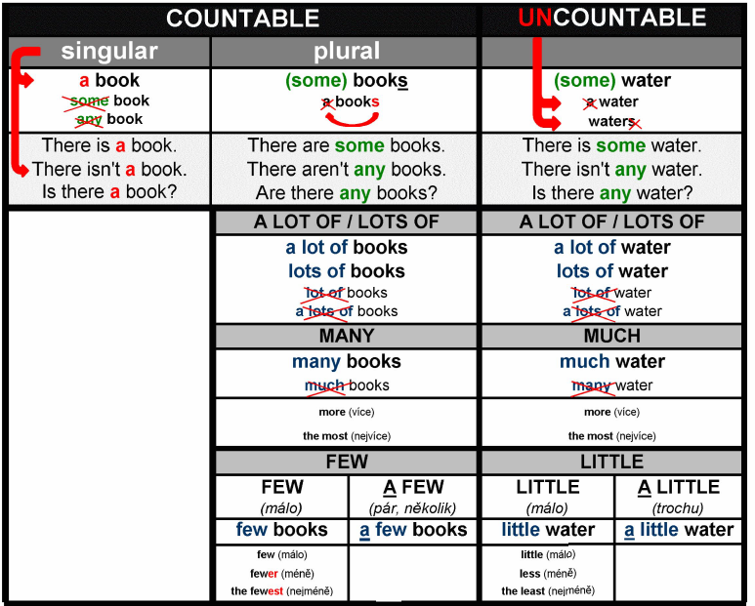

**MUCH, MANY, A LOT (OF)**

1) I'd like to have ____________ money.

2) How _________ money do you earn?

3) Peter, do you like milk? -- Yes, _________.

4) We spent so _________ time together.   
5) I like skirts very _________.

6) I don't have _________ books.

7) Thanks for walking me home, but I have to go now. I have so _________ work.

8) How _________ people did you see there?

9) I want to have _________ friends.

10) You're my best friend. I like you very _________!

**FEW, LITTLE, A FEW, A LITTLE**

1) I don't think she will pass the exam. She has too _________ knowledge of the subject.

2) This job is so boring! There is so _________ work to do!

*3) I know this city quite well. I have visited it _________ times.   
4) There is _________ sugar left. Could you buy some?

5) There are still _________ apples left. You don’t have to buy any.

6) Could I have _________ cream in my coffee?   
7) The Irish alphabet has _________ letters in comparison to the English one.   
8) I can buy you a drink. I still have _________ money on me.   
9) Last year our country was not successful in the Olympics. We won _________ medals. We should have done better!

10) Could you give me _________ help? I won’t manage it by myself.

**Translate:**

méně čokolády

hodně chleba

několik plátků sýra

méně polévky

ne mnoho jablek

málo cukru

ne mnoho smetany

trošku vody

více jahod

mnoho cibule

málo masa

**HW: Finish the sentences**

• British food is _______________________.

• The best cuisine in the world is _______________________.

• The most delicious dessert is _______________________.

• Egg and bacon ice cream sounds _______________________.

• Microwave dinners are _______________________.

• Vegetarian fare is _______________________.

• The best drink to accompany a meal is _______________________.

• Dining out is _______________________.

• McDonalds’ hamburgers are _______________________.

• Life without restaurants would be _______________________.

**Restaurant – at the restaurant –role play**

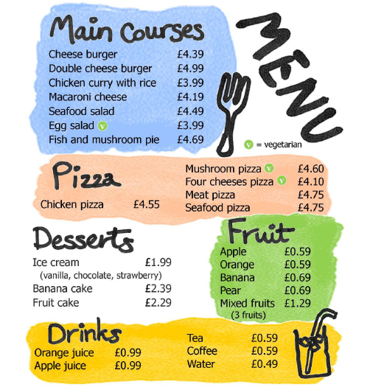

**Restaurant language: Make a conversation. Use the sentences below. Add some more.**

Are you ready to order?

Can I have a seafood salad, please?

Do you have a reservation?

I would like to pay.

Would you like anything else?

Is everything alright?

Can I pay by credit card?

How do you like the meal?

I would like another glass of wine, please?