**Globalisation**

**Define:** What is globalisation?

**Listening:**

What does the speaker say the world is like?

Why is it easier to do business?

What examples of globalisation does he mention?

**Think!** What are the advantages and disadvantages of globalisation? Look at the following words and phrases and write them down in the right column. Can you add some more?

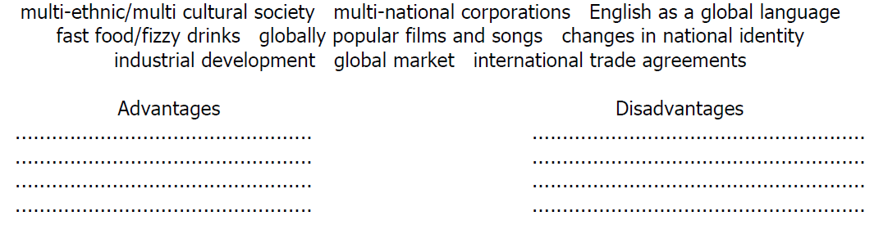

**Reading - What is globalisation?**

Globalisation is the process that makes economies and societies from all around the world become more and more connected. This means that people, ideas, technology, money, services, and many other things are moving between countries and changing the way people think and act.

**Good or Bad?** Not everyone thinks the same way about globalisation. Some people think it is good, some people think it is bad. Some believe that globalisation helps rich people get richer and makes poor people poorer. These people say that globalisation helps big companies like Coca-Cola and McDonald's destroy local businesses. The people who think globalisation is a good thing argue that globalisation helps poorer people to become richer. They also think that it doesn't damage local cultures. These people also believe globalisation helps prevent conflicts like wars. This is because countries that have economic connections will try hard to maintain good relationships with each other so their economies aren't damaged.

**Effects** Despite whether you think globalisation is good or bad, it affects the world in two important areas: jobs and culture. Globalisation has had a very strong effect on employment and jobs throughout the world. For some workers, such as engineers, lawyers, and bankers, globalisation has been a good development. These workers are able to successfully compete globally and have seen an increase in their salaries. But for those who work in factories or in the service industry (at hotels, shops and restaurants), it has not been good. These types of jobs have been exposed to increasing competition from workers from poorer countries. A worker from a poorer country will do the same job for less money. This decreases the salaries for that job, so people get paid less to do it.

Cultures have also been affected by globalisation. Foods such as Japanese noodles, Indian curry and French cheeses have spread around the world. We can also see an increase in the use of Chinese characters in tattoos. Some people get these tattoos without actually knowing what the characters mean. Another area affected by globalisation is the film industry. Most people have seen American movies. But due to globalisation, Korean, Indian and Japanese movies have become more popular worldwide.

No one knows the future of globalisation. Most experts agree that it will continue to grow and have an increasingly larger impact on people's lives in the future.

______________- joined together in some type of relationship (line 2)

*______________-* disagreements between two or more groups that can lead to fighting or war. (line 9)

______________- the beliefs, customs, traditions, and arts of a group of people (line 14)

______________- to try and be better than someone such as in sports (line 16)

______________- people who have a lot of knowledge about a particular thing (line 25)

**Choose two of the words above and make a sentence:**

**Discussion:**

Would you support a one-world government? Why/not?

Would you support English as the official language of Earth? Why/not?

What would happen if the world had one government, one language, and one culture?

Should young people live abroad for a year as part of their education? Why/not?

What do you think about the fact that a lot of young people after finishing their university studies want to live abroad?

How has globalisation influenced your life?

Could globalisation have happened without the Internet?

Have you ever worked for a multinational company? If yes, did you enjoy it?

If no, would you like to work for a multinational company? Why / why not?

How has globalisation impacted on language learning?

What does globalisation mean to a consumer?

What does globalisation mean to a business?

What does globalisation mean to countries?

How would life be different if countries did not trade with their neighbours?

What is your opinion about outsourcing labour to third world countries?

What problems might occur as a result of a small number of companies having a lot of power?

How has globalisation affected the environment?

What will happen to the tribes in Africa and the Amazon, as well as other indigenous people around the world, in the next 25 year? 50 years? 100 years? Why?

**Video:** **Globalisation easily explained.**

What is the background of globalisation?

What does the word GLOBALISATION mean?

What do the companies mentioned in the video produce?

What else is exchanged except for the goods?

Why do people in industrialized countries lose their jobs?

What ecological problems are mentioned?

Is globalisation good based on the video?