**Good Bye 2016, Welcome 2017**

|  |  |  |
| --- | --- | --- |
| **Find someone who…** | Name | More information |
| ate little during Christmas. |  |  |
| got a present they didn’t like. |  |  |
| talked to somebody who lives far away during Christmas. |  |  |
| went shopping on 27th Dec. |  |  |
| was ill during Christmas. |  |  |
| did sport during the break. |  |  |
| worked between Xmas and New Year. |  |  |
| got very drunk on New Year’s Eve. |  |  |
| spent New Year’s Eve with a lot of people. |  |  |
| has ever set off fireworks |  |  |

Do you usually look at the upcoming year with optimism or pessimism?

Will next year be better or worse than this year? Why do you think so?

On a scale of ten, with ten points the highest possible score, how would you rate this past year? Did you make new friends?

What fun things did you do?

What was the best time of 2016?

What important lessons did you learn?

If you could make three wishes for the next year which would definitely come true, what would you wish for?

**Good year, bad year**

Some years are better or more enjoyable/successful than others. We remember these years and the special things that happened.

Choose a good year for you. Tell the class why the year was special: What happened? What did you do? Who did you meet? Where did you go?

**New Year’s Resolutions**

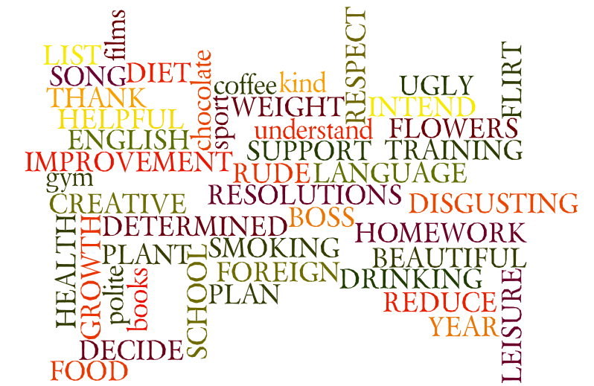Can you make any typical resolutions from the words in the cloud?

***Australian New Year***

In Australia they celebrate the New Year on January 1. This day is a public holiday and many people have picnics and camp out on the beach. They have parties that start on December 31 and at midnight they start to make noise with whistles and rattles, car horns and church bells to ring in the New Year.

In Australia New Year is a day for outdoor activities such as rodeos, picnic races and surf carnivals.

***English New Year***

In England crowds of people gather in Trafalgar square, and Piccadilly Circus as well as stand around to hear the chimes of London's Big Ben announces the arrival of the New Year. Everyone stands around with arms linked to sing [Auld Lang Syne.](http://www.fathertimes.net/auldlangsyne.htm)

In England the custom of first-footing is important. The reason is that it is supposed to ensure good luck for the inhabitants of the house. The first-footer must be male, young, healthy and good looking. He must be dark-haired and he should be carrying a small piece of coal, money, bread, and salt. These are the symbols of wealth.

On New Year's Day children from Great Britain get up early to make the rounds to their neighbours singing songs. They are given coins, mince pies, apples and other sweets for singing. This must be done by noon or the singer will be called fools.

In England girls would drop egg whites into water. They thought it would form the first letter of the name of the man they would marry.

***United States of America New Year***

American New Year’s Customs such as Dance parties are thrown on New Year's Eve to see in the year. Times Square in New York City has a ball drop hosted by the television celebrity Dick Clark. This is broadcast all over the United States. At the stroke of midnight on New Year's Eve people will kiss or honk car horns. Paper blowers and whistles are blown. A typical food eaten on New Year’s Day is black-eyed beans and rice called Hoppin' John.In the US they believe that black-eyed beans are lucky.

They also watch the Championship football games in stadiums or on their televisions. They also in New York's Time Square they watch for the moment when a giant brightly coloured electric apple is lowered to the ground at which time they start saying Happy New Year.