**Habits**

a thing done often and therefore easily

a pattern of action that is acquired and has become so automatic that it is difficult to break

Can you identify the bad habits from the pictures?

[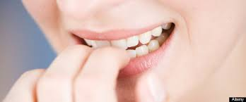](https://www.google.cz/imgres?imgurl=http://www.dumblittleman.com/wp-content/uploads/2015/06/r-HOW-TO-BREAK-BAD-HABITS-large570.jpg&imgrefurl=http://www.dumblittleman.com/2015/06/hard-break-habit-easily.html&h=238&w=570&tbnid=MVMqtkJaq8nzdM:&docid=6uR8qr-Mm0-zjM&hl=cs&ei=-pOXVsTfBoHyUJbBuNAD&tbm=isch&ved=0ahUKEwjExMytpqnKAhUBORQKHZYgDjoQMwhcKDMwMw)[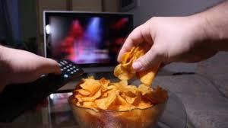](https://www.google.cz/imgres?imgurl=http://www.foodnavigator-usa.com/var/plain_site/storage/images/publications/food-beverage-nutrition/foodnavigator-usa.com/markets/americans-eating-habits-worst-since-2008-systemic-change-needed-rd-says/8621526-11-eng-GB/Americans-eating-habits-worst-since-2008-systemic-change-needed-RD-says_strict_xxl.jpg&imgrefurl=http://www.foodnavigator-usa.com/Markets/Americans-eating-habits-worst-since-2008-systemic-change-needed-RD-says&h=343&w=610&tbnid=mzJILhDZA1fBkM:&docid=V3wqjPMDqCgn2M&hl=cs&ei=ipSXVraxNIiaU-H3pJgB&tbm=isch&ved=0ahUKEwi2ns_ypqnKAhUIzRQKHeE7CRM4yAEQMwgFKAIwAg)[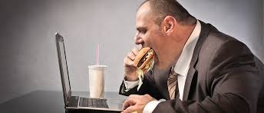](https://www.google.cz/imgres?imgurl=http://vennli.com/wp-content/uploads/2014/11/iStock_000018543896_BadHabit.jpg&imgrefurl=http://vennli.com/3-bad-habits-you-can-break-immediately-to-become-more-productive/&h=461&w=1080&tbnid=JLEPbAFrGmkx3M:&docid=EWASqRxtKhQ0sM&hl=cs&ei=4JWXVoP4DontUpP7vagO&tbm=isch&ved=0ahUKEwiD6LOVqKnKAhWJthQKHZN9D-UQMwg9KBQwFA)[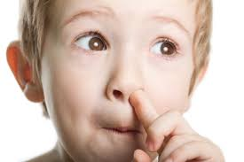](https://www.google.cz/imgres?imgurl=http://blog.15five.com/wp-content/uploads/2013/09/Hypnosis_for_bad_habits_nyc.jpg&imgrefurl=http://www.grassrootsy.com/2013/12/19/10-bad-music-habits-to-break-in-the-new-year-part-1/&h=2600&w=3900&tbnid=_-9sV_d_X_k6PM:&docid=icDWP006GTAK9M&hl=cs&ei=-pOXVsTfBoHyUJbBuNAD&tbm=isch&ved=0ahUKEwjExMytpqnKAhUBORQKHZYgDjoQMwhYKC8wLw)[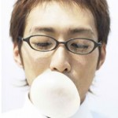](http://www.englishwithjo.com/wp-content/uploads/2011/09/habits.jpg)[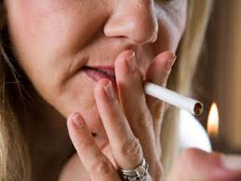](https://www.google.cz/imgres?imgurl=http://www.rd.com/wp-content/uploads/2012/06/break-bad-health-habits-03-smoking-sl.jpg&imgrefurl=http://www.rd.com/health/wellness/10-bad-habits-and-the-best-ways-to-quit-them/&h=285&w=380&tbnid=1yjuXcMSYPSbkM:&docid=i92qHOlx8hg7qM&hl=cs&ei=4JWXVoP4DontUpP7vagO&tbm=isch&ved=0ahUKEwiD6LOVqKnKAhWJthQKHZN9D-UQMwhBKBgwGA)[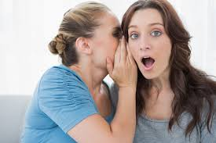](https://www.google.cz/imgres?imgurl=http://www.careerealism.com/wp-content/uploads/2013/03/10-bad-habits-that-can-harm-your-career.jpg&imgrefurl=http://www.careerealism.com/10-bad-habits-that-can-harm-your-career/&h=667&w=1000&tbnid=ytF6SykijoEWOM:&docid=TnMMmC9bcYEdMM&hl=cs&ei=4JWXVoP4DontUpP7vagO&tbm=isch&ved=0ahUKEwiD6LOVqKnKAhWJthQKHZN9D-UQMwhOKCUwJQ)

Other bad habits are e.g.:

swearing

being always late

sniffing

cracking knuckles

clicking a pen

slurping

eating loudly

Which of the above mentioned bad habit do you find the worst?

**Idioms and collocations**

***Old habits die hard* –** People find it difficult to change their accustomed behavior

***Break a habit / Kick a habit* –** to end a habit

**Listening:** What ______________________ habits? I think everyone has bad habits. Not everyone ______________________ what bad habits are. Some smokers don’t think smoking is a bad habit. Young people don’t think listening ______________________ on the train is a bad habit. In Japan, slurping your noodles ______________________ that you enjoy your food, but making a noise while eating in England ______________________ . Have you ever tried to break your bad habits? I ______________________ smoking and have stopped leaving things laying ______________________ house. I wish other people would stop their bad habits. I get annoyed when people ______________________ meetings or talk loudly on their phones in public. I also think ______________________ need to think about their driving habits. Perhaps I should ______________________ their bad habits.

**Discussion:**

Do you have any bad habits?

Do you think all habits are bad? If not, what do you think are some good habits to have?

Do you think bad habits lead to personal and professional problems?

Are there habits that apply to whole societies?

Finish the sentence: It drives me crazy when people ….

Where do you think we learn our habits from?

If you were on the train and the person next to you had an irritating habit, would you say something, move to a different seat, or do nothing? Why?

Think of some bad habits that children form (such as chewing their nails). How do mothers in your country stop their children from doing these habits? Are they effective?

Are you aware of any habits that are considered bad manners in one country but not in another?

Is drinking coffee a bad habit?

Situation: You always watch TV on Friday nights. A friend suddenly calls and wants to meet. Would you turn them down because you don't want to change your schedule or would you go out?

Which habit is the most important for parents to set as an example of for their children?

What are your sleeping habits?

What are your eating habits?

What are your exercise habits?

Do your family members have any bad habits?

Is it easy or difficult to get rid of a bad habit?

Do other people's bad habits get on your nerves?

Have you been successful in getting rid of a bad habit?

What good habits do you most admire?

Would you break up with a boy/girlfriend (or have you) because of a bad habit?

Some people walk to work the same way, sit at the same table in the coffee shop, and order the same thing every day. Are you the kind of person who always has a very fixed routine? Why/not?

**Survey reveals management pet hates** (something that is disliked intensely and is a constant or repeated annoyance)

A survey of over 2,000 British managers has revealed which habits irritate them most while at work. One of the most annoying things for today's managers is the current crop of jargon, or "management speak". Others high on the list include people who sit opposite you sending you emails, when they could simply tell you their message; people arriving late for work and for meetings; and people who take regular cigarette breaks. Report author Charles Elvin explained why it is important for us to know what annoys people. He said: "When office-based teams work in close proximity for long periods of time, we see that seemingly trivial issues can grow disproportionately. If left unchecked, they can begin to cause upset and resentment."

Management jargon proved to be an emotive issue for those participating in the research. Many managers described it as a "pointless irritation" which few people understand. They wondered why people used it when there are "normal" ways to express the same thing. Cited examples included 'thinking outside the box', 'going forward' and 'let's touch base'. The "real-world equivalents" of these are 'looking at things differently', 'in the future' and 'contact me'. The Plain English Campaign stated overused jargon damages the economy. The group said: "Management speak…gets in the way of business….It isolates newcomers who feel they have to learn the lingo….It acts as a barrier to procuring new business."

SYNONYM MATCH: Match the following synonyms from the article.

|  |  |  |  |
| --- | --- | --- | --- |
| 1. | Revealed | a. | quoted |
| 2 | Irritate | b. | unimportant |
| 3. | Simply | c. | nearness |
| 4. | Proximity | d. | annoy |
| 5. | Trivial | e. | keeps apart |
| 6. | Emotive | f. | counterparts |
| 7. | Cited | g. | shown |
| 8. | Equivalents | h. | obstacle |
| 9. | Isolates | i. | sensitive |
| 10. | Barrier | j. | easily |

|  |  |
| --- | --- |
| 1. | How many managers took part in the survey? |
| 2. | What thing was mentioned that some people do frequently? |
| 3. | Who do people get annoyed with for sending e-mails? |
| 4. | What did the researcher say can happen to the size of trivial issues? |
| 5. | What can trivial issues lead to? |
| 6. | What did many people wonder about? |
| 7. | How does jargon make newer people feel outside of things? |