In a city

1. Name the buildings and navigate each other:

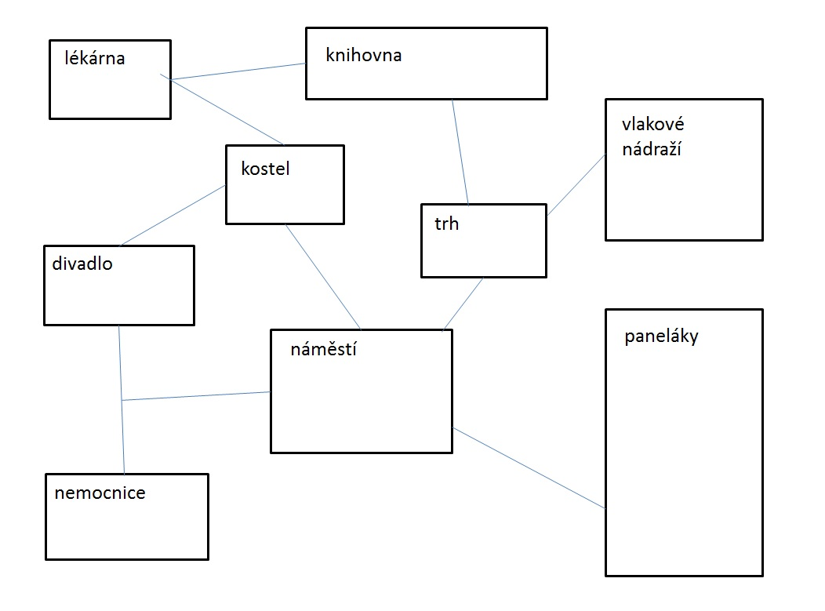

1. Fill in appropriate phrases:

Tourist: ………….. me, sir. I am looking for the complex Dolní oblast Vítkovice.

Local: That is very ………. away. You’ll need to ………… the tram.

Tourist: ………… tram should I take?

Local: ………………. either number eight or nine.

Tourist: Where should I ……….. off?

Local: At the station Náměstí republiky. …………… for the number two there.

Tourist: Ok. And ……… should I get off?

Local: After about five minutes. I don’t ……………… the name of the stop.

Tourist: Ok, thank you.

1. Match the pictures and directions:

