**HAPPINESS**

**Write five things that make you happy:**

**1.  
2.  
3.**

**4.  
5.**

**What do you think of the following statements?**

Money makes me happy.

The older you become, the happier you are.

You can take lessons on how to be happy.

Men are happier than women.

Married people are happier than single people.

People in warmer climates are happier than people in colder climates.

It’s hard to be happy in today’s world.

Every country should have a Minister of Happiness.

[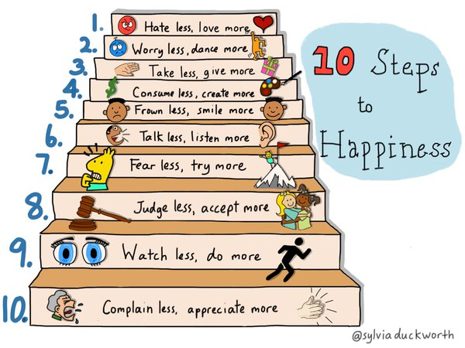](https://www.google.cz/url?sa=i&rct=j&q=&esrc=s&source=images&cd=&cad=rja&uact=8&ved=0ahUKEwiS4tfm9MPRAhWoJ5oKHTNcCKUQjRwIBw&url=https://twitter.com/sylviaduckworth/status/592820464390668288&psig=AFQjCNGydHaqs5GxNw9WaQMXJpXx0dtssQ&ust=1484561474721271)

1. Are people in our country generally very happy?
2. Are you very happy most of the time?
3. When did you last feel happy?
4. What makes you unhappy?
5. Does your job make you happy?
6. Are there any films that make you happy?
7. Do you enjoy making other people happy? How?
8. Do you wake up happy every morning?
9. What is there to be happy about in the world today?
10. Does your happiness change during different times of the day, week, month or year?
11. What is or was the happiest time of your life?
12. Do you think some nations are happier than others?
13. Do you think that everyone wans to be happy?
14. Is it difficult to be happy? Why? / Why not?

**The Key to Happiness**

50 people were asked to enter a room filled with balloons. They had an unexpected surprise.

Once a group of 50 people was attending a seminar. Suddenly the speaker stopped and decided to do a group activity. He started giving each one a balloon. Each one was asked to write their names on it using a marker pen. Then all the balloons were collected and put in another room.

Now the delegates were let into the room and asked to find the balloon which had their name, within 5 minutes. Everyone was frantically searching for their name, colliding with each other, pushing around other and there was utter chaos.

At the end of five minutes nobody could find their own balloon. Now each one was asked to randomly collect a balloon and give it to the person whose name was written on it. Within minutes everyone had their own balloon.

The speaker began – exactly this is happening in our lives. Everyone is frantically looking for happiness all around, not knowing where it is.

Our happiness lies in the happiness of other people. Give them their happiness and you will get your own happiness. And this is the purpose of human life.

**SONG**: **HAPPY - by ALEXIA**

You know what I'm ____________ ... ?  
**Chorus:** Happy (sha la la)  
It's so nice to be happy (sha la la)  
­­­­­­­­­­­­­­­_____________ should be happy (sha la la)  
It's so nice to be happy (sha la la)  
  
Happy (sha la la)  
3x It's so nice to be happy (sha la la)  
  
I wanna_________ you to my world to be happy  
Cause I can't live ________ your love, Yes you know  
  
I've never needed ________ to be happy  
But that's the way the things go wrong, ________ you know  
  
I was afraid to __________ my eyes  
__________even know how many tears that I've cried  
Now that I've found the love of my__________  
I don't get down,down,down,down,down  
  
**Chorus:** Happy (sha la la)

I've never been in love _____________ and I'm happy  
Cause you're the one I'm _____________for, yes you know  
  
You __________ the sunshine into my life  
Your lips are burning and the _________ is right  
I can't believe it's true that your mine  
Don't ________ me down,down,down,down,down  
  
**Chorus:** Happy (sha la la)  
  
Hey DJ !  
I just pray  
You'll never run ________  
Can't wait another day to hold you tight  
To hold you tight

**Chorus:** Happy (sha la la)