**PINK HELLO KITTY CHRISTMAS TREE**

How do you like it?

What is wrong with it?

Would you like to have it at home or at work?

Did you have a Christmas tree at your workplace?

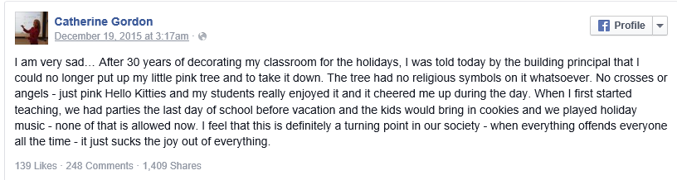

Why is Ms Gordon so upset?

What does the sentence “It just sucks the joy out of everything” mean?



How do you think the Congressman find out about the problem?

What is his opinion?

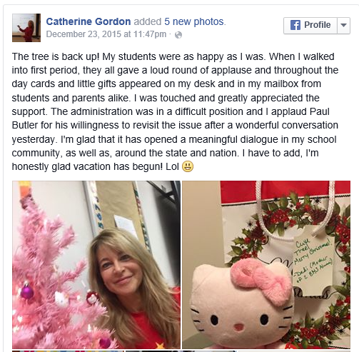

A teacher at a school in the USA has been allowed to keep her pink Hello Kitty Christmas tree in her classroom. The teacher, Catherine Gordon, was ordered by the school principal Paul Butler to remove it from her classroom. Mr Butler decided it was an "inappropriate" Christmas decoration. He explained to ABC News that the tree did not fit with the way the school celebrated the different religious events happening at this time of the year. He said: "A concern was shared with me regarding an inconsistency with our balanced approach to holiday observances."

Ms Gordon said she didn’t think her tree was offensive. She said it had no religious symbols such as crosses or angels on it. Her story went viral on Facebook. Ms Gordon wrote that she thought society was becoming too worried about upsetting people. She said she thought her experience with her tree was "definitely a turning point in our society when everything offends everyone all the time". She added that: "It just sucks the joy out of everything." She told a newspaper that: "It just seems that in our quest to be tolerant of everything, we've become intolerant to everything."

Do you agree that it is a turning point in our society?

Are we becoming intolerant to everything too?

Can you see similar tendencies to be politically and religiously correct in Europe or even in the Czech republic?



And what do you think about this Christmas tree?

Does your Christmas tree look similar?