**HISTORY**

Is history important to you?

Did you like studying history at school?

What period of history interests you most?

What do you think of the recent history of your country – the past fifty years?

What do you think of the overall history of your country?

Do you think history repeats itself?

What period of history would you like to go back and live in?

Which historic figure would you most like to meet?

Why do people like history?

What do you know about your family history?

Would you like to be a historian?

In his book 1984, George Orwell says: “He who controls the past, controls the future; and he who controls the present, controls the past.” Do you agree?

Do you think History school books tell the same all over the world? Why or why not?

Do you think history comes back to haunt us?

Which historical films have you seen?

Have you read any historical novels?

How would the world change if schools stopped teaching history to children and all history books were destroyed?

‘Studying history is useless. Why waste time on things we cannot change anyway?’ Do you agree?

Sir Winston Churchill said: “Those that fail to learn from history, are doomed to repeat it.” Do you agree with him?

**Listening:** My favourite ___________________ school was history. I don’t know why. I loved reading the __________________________ famous people and famous events. When I was little, history ___________________________ stories. As I got older, I _______________________________ is the study of how _______________________ today. It’s a long journey that describes ___________________________ great people, inventions, disasters, etc. that have brought us _________________________ in time. I now love any kind of history. It’s fascinating ____________________________ new country and learn about its history. Watching the news today is like seeing history unfold. Lots __________________________ I learnt at school now make the news more interesting. History provides us with the perfect background information _______________________.

**A brief history of English**

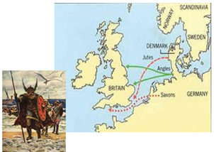The English language belongs to the **West Germanic** branch of the **Indo-European** family of languages. The history of the English language can be divided into three main periods: Old English (450-1100 AD), Middle English (1100-circa 1500 AD) and Modern English (since 1500). Over the centuries, the English language has been influenced by a number of other languages.  
***Old English (450 - 1100 AD):*** During the 5th Century AD three Germanic tribes (Saxons, Angles, and Jutes) came to the British Isles from various parts of northwest Germany as well as Denmark. These tribes liked fighting and pushed out most of the original, Celtic-speaking inhabitants from England into Scotland, Wales, and Cornwall.

Through the years, **the Saxons, Angles and Jutes** mixed their different Germanic dialects. This group of dialects forms what linguists refer to as Old English or **Anglo-Saxon**. The word "English" was in Old English "Englisc", and that comes from the name of the Angles.

Before the Saxons the language spoken in what is now England was a mixture of Latin and various Celtic languages which were spoken before the **Romans** came to Britain (54-5BC). The Romans brought **Latin** to Britain, which was part of the Roman Empire for over 400 years. Many of the words passed on from this era are those created by Roman merchants and soldiers. These include *win* (*wine*), *candel* (*candle*), *belt* (*belt*), *weall* (*wall*).  
The influence of Celtic on Old English was small. In fact, very few Celtic words now exist in the English language. But many of **place and river names** have Celtic origins: *Kent*, *York*, *Dover*, *Thames*, *Avon*, *Trent*, *Severn*.  
The arrival of **St. Augustine** in 597 and the introduction of Christianity into Saxon England brought more **Latin** words into the English language. They were mostly concerned with the naming of **Church** dignitaries, ceremonies, etc. Some, such as *church*, *bishop*, *baptism*, *monk*, and *eucharist* came indirectly through Latin from the Greek.  
Around 878 AD Danes and Norsemen, also called **Vikings**, invaded the country and English got many **Norse** words into the language, especially in the north of England. The Vikings, being Scandinavian, spoke a language (*Old Norse*) which, in origin at least, was just as Germanic as Old English.  
Words derived from Norse include: *sky*, *egg*, *cake*, *skin*, *leg*, *window* *(wind eye)*, *husband*, *fellow*, *skill*, *anger*, *flat*, *odd*, *ugly*, *get*, *give*, *take*, *raise*, *call*, *die*, *they*, *their*, *them*.

Several written works have survived from the Old English period. The most famous is a heroic epic poem called [***"Beowulf"***](http://www.lone-star.net/literature/beowulf/). It is the oldest known English poem which is 3,183 lines long. Experts say *"Beowulf"* was written in Britain more than one thousand years ago. The name of the person who wrote it is unknown.  
  
***Middle English (1100-circa 1500 AD):*** After William the Conqueror, the Duke of **Normandy**, invaded and conquered England in **1066** with his armies and became king, he brought his nobles, who spoke **French**, to be the new government. The Old French took over as the language of the **court, administration, and culture**. Latin was mostly used for written language, especially that of the Church. Meanwhile, the English language, as the language of the **lower class**, was considered a **vulgar** tongue.  
**By about 1200**, England and France had split. English changed a lot, because it was mostly spoken, not written for about 300 years. The use of Old English came back, but with many French words added. This language is called **Middle English**. Most of the words in the English vocabulary are words of power, such as *crown*, *castle*, *court*, *parliament*, *army*, *mansion*, *beauty*, *banquet*, *art*, *poet*, *romance*, *duke*, *servant*, *traitor* and *governor*.   
Because the English underclass cooked for the Norman upper class, the words for most domestic animals are English (*ox*, *cow*, *calf*, *sheep*, *swine*, *deer*) while the words for the meats derived from them are French (*beef*, *veal*, *mutton*, *pork*, *bacon*).   
The most famous example of Middle English is **Chaucer's** [***"The Canterbury Tales"***](http://www.librarius.com/), a collection of stories about a group of thirty people who travel as pilgrims to Canterbury, England. The portraits that he paints in his Tales give us an idea of what life was like in fourteenth century England.  
  
***Modern English (1500 to the present):*** Modern English developed after William Caxton established his **printing press** at Westminster Abbey in 1476. Johann Gutenberg invented the printing press in Germany around 1450, but Caxton set up England's first press. The Bible and some valuable manuscripts were printed. The invention of the printing press made books available to more people. The books became cheaper and more people learned to read. Printing also brought **standardization** to English.  
There were three big developments in the world at the beginning of Modern English period: 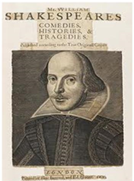**the Renaissance, the Industrial Revolution, and the British Colonialism.**It was during the [English Renaissance](http://en.wikipedia.org/wiki/English_Renaissance) that most of the words from **Greek** and **Latin** entered English. This period in English cultural history (early 16th century to the early 17th century) is sometimes called *"the age of* ***Shakespeare****"* or *"the Elizabethan era”.* During the reign of **Queen Elizabeth I** there was an explosion of culture in the form of support of the arts, popularization of the printing press, and massive sea travelling.  
England began the **Industrial Revolution** (18th century) and this had also an effect on the development of the language as new words had to be invented or existing ones modified to cope with the rapid changes in technology. New **technical words** were added to the vocabulary as inventors designed various products and machinery. These words were named after the inventor or given the name of their choice (*trains*, *engine*, *pulleys*, *combustion*, *electricity*, *telephone*, *telegraph*, *camera* etc).  
Britain was an **Empire** for 200 years between the 18th and 20th centuries and English language continued to change as the British Empire moved across the world - to **the** **USA, Australia, New Zealand, India, Asia and Africa.** They sent people to settle and live in their conquered places and as settlers interacted with natives, new words were added to the English vocabulary, e.g. '*kangaroo*' and '*boomerang*' are native Australian Aborigine words, '*juggernaut*' and '*turban*' came from India.   
English continues to change and develop, with hundreds of new words arriving every year. But even with all the borrowings from many other languages the heart of the English language remains the Anglo-Saxon of Old English. The grammar of English is also distinctly Germanic - three genders (he, she and it) and a simple set of verb tenses.

What happened to the original Celtic inhabitants after the invasion of Saxons, Angles, and Jutes?

Where can you still find old Celtic words?

Who wrote Beowulf?

Why was French a language of nobility in the 11th and 12th century?

Why was printing press so important?

What was significant about the Elizabethan era ?

**History of English – overview**

_____________________branch of __________________family

*(before 54BC) - Celtic languages – names of ___________ and rivers*

*(54 – 5BC) – Romans – Latin - words:_________________________________________________________________*

**1.____________________or _________________ (450 – 1100 AD)**

- Saxons, ________, _________ - mix of different Germanic dialects

- St. Augustine – Latin influence – church vocabulary: ______________________________________

- Vikings (_____ AD) – Old Norse influence – words: _______________________________________

Important written work: Beowulf - _____________________________________________________

**2. ______________________ (1100 – 1500AD)**

- Norman Conquest (______) – French influence – language of court, administration, and _________

- Latin – written – language of church

- English - __________class

Important written work: __________________________________________________

by 1200 – Middle English = Old English + ___________

**3. Modern English (______________)**

printing – standardized spelling

Renaissance – William ________________ (died in _______)

Industrial revolution – new inventions = new words: _______________________________________

Colonialism – influence of colonies: ____________________________________________________

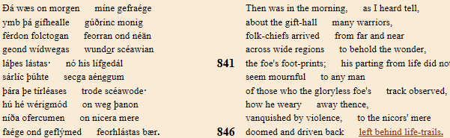

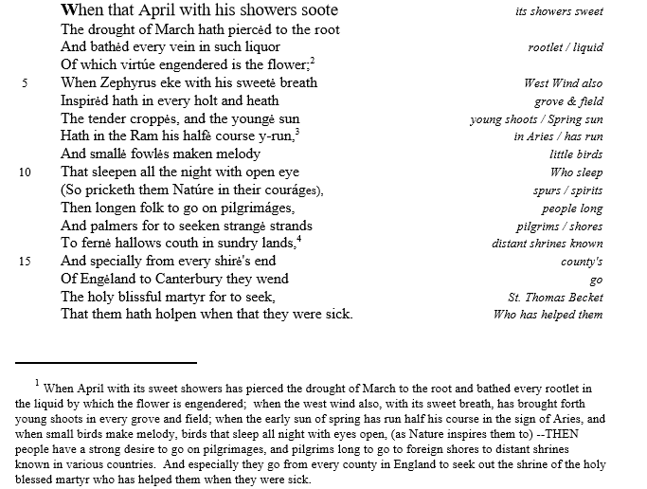

SONNET 77

Thy glass will show thee how thy beauties wear,  
Thy dial how thy precious minutes waste;  
The vacant leaves thy mind's imprint will bear,  
And of this book this learning mayst thou taste.  
The wrinkles which thy glass will truly show  
Of mouthed graves will give thee memory;  
Thou by thy dial's shady stealth mayst know  
Time's thievish progress to eternity.  
Look, what thy memory can not contain  
Commit to these waste blanks, and thou shalt find  
Those children nursed, deliver'd from thy brain,  
To take a new acquaintance of thy mind.  
   These offices, so oft as thou wilt look,  
   Shall profit thee and much enrich thy book.