HOUSEHOLD CHORES
What springs to your mind when you hear the word housework?
What do you think about housework?
Do you think doing housework is good exercise?
What would you rather do housework or homework?
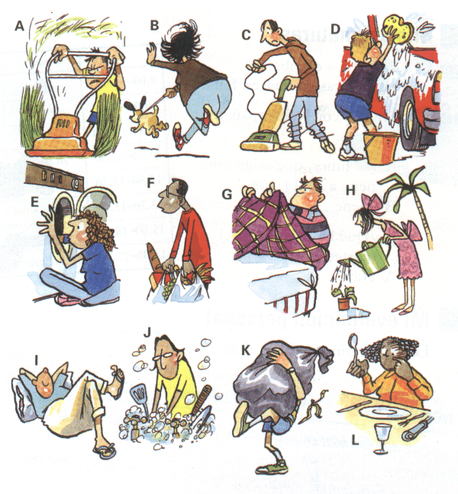
Vocabulary:

A:
B:
C:
D:
E:
F:
G:
H:
I:
J:
K:
L:

How does your family decide who does various chores around the house?
What chores are your responsibility?
What is your favourite and most hated chore?
What do you think about getting money for doing chores?
If you could buy only one of this two things, would you choose a dishwasher or a washing machine?
Which housework do you think helps you burn most calories?
What do you do after doing housework?

HOUSEWORK NOT GOOD EXERCISE

A new study suggests housework is not the quality form of exercise many people consider it to be. The report even went as far as saying that those who did the most housework were usually those most overweight. The study is called, "Does doing housework keep you healthy? The contribution of domestic physical activity to meeting current recommendations for health". It questions whether physical activities such as do-it-yourself, gardening and housework are such good exercise. It acknowledges that any activity is better than none, but says, "there is a danger that those undertaking domestic 'chores' may assume that this activity is moderate intensity" and wrongly count it as proper exercise.

A total of 4,563 adults participated in the survey, which was based on participants' weekly physical activity. The analysis from this research showed that people who included housework as part of their weekly exercise tended to be heavier. Research leader professor Marie Murphy said: "Housework is physical activity and any physical activity should theoretically increase the amount of calories [burnt]. But we found that housework was inversely related to leanness, which suggests that either people are overestimating the amount of moderate intensity physical activity they do through housework, or are eating too much to compensate for the amount of activity undertaken."

1. | Who did the study say were the most overweight?
2. | What question is asked in the study's title?
3. | Apart from housework, what other activities are mentioned?
4. | What does the study acknowledge?
5. | What might people be doing wrong?
6. | What was the survey about?
7. | Who is Maria Murphy?
8. | What did Maria Murphy say physical activity should increase?
9. | What was housework inversely related to?
10. | What do some people do after housework?
Finish the sentences:
I like …
I don’t mind…
I dislike …
I hate …

MAKE OR DO
1 | Karin doesn't like ______ housework.
2 | However, she _____ most of the cooking.
3 | Last night, she ______ a very good dinner.
4 | She also _____ dessert.
5 | Her roommate, Leslie, usually ______ the dishes.
6 | Karin doesn't have a washer or dryer, so she has to go to the laundromat to _____ her laundry.
7 | Karin tries to ______ her bed every morning.
8 | When Karin has friends over, they often _____ a mess .

