HOUSEHOLD CHORES
What springs to your mind when you hear the word housework?
What do you think about housework?
Do you think doing housework is good exercise?
What would you rather do housework or homework?
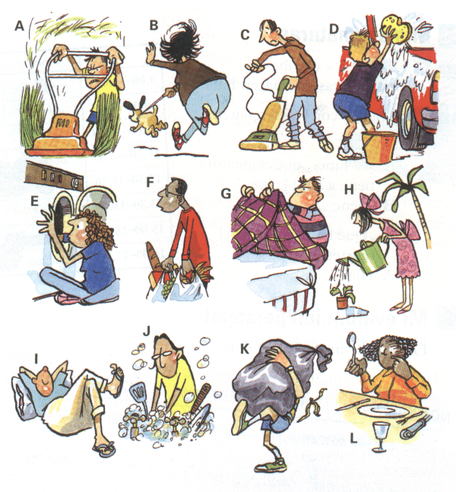
Vocabulary:

A:
B:
C:
D:
E:
F:
G:
H:
I:
J:
K:
L:

How does your family decide who does various chores around the house?
What chores are your responsibility?
What is your favourite and most hated chore?
What do you think about getting money for doing chores?
If you could buy only one of this two things, would you choose a dishwasher or a washing machine?
Which housework do you think helps you burn most calories?
What do you do after doing housework?

MEN, WOMEN, AND HOUSEHOLD CHORES

The data has been examined, and the conclusions reached: Men create more housework for women. Although he may mow the lawn, shovel snow, or fix things around the house, a husband adds seven hours per week to the load of chores. The information comes via the analysis of time diaries and questionnaires from men and women from regions all across the US between 1996 and 2005.
Of the people surveyed, single women in their twenties and thirties did the least amount of housework, which was roughly twelve hours per week. On the other hand, married women had about seventeen hours on average, which was the most. These numbers are down significantly compared with similar surveys in the past. In 1976, for example, the same demographic of married women clocked in twenty-six hours of labor each week. It seems men pitch in more now.
There were some differences between households, as well as some unusual cases. But the results of the diaries and questionnaires clearly demonstrated the following: Marriage means more work for women and less work for men. In addition, the situation worsens when children come on the scene. With three kids, the wives took on twenty-eight hours of work around the house per week, while hubbies did only ten.
There were some surprises, too. Older men were more likely than younger men to help out, even though surveys from thirty years ago showed that men contributed only six hours per week to household tasks. Women in their sixties and seventies still did the most amount of work. Single women did the least, or about twelve hours each week.
So what does it all mean? Women have traditionally taken on more responsibility around the house, as men focused on the world of work and careers. Despite equal rights and better career opportunities for women, traditional patterns remain taken for granted by both sexes.

TRUE or FALSE
Men make women busier with housework.
Single women did the most amount of housework.
According to the article, men now help at home more than thirty years ago.
Younger men help around the house more than older men.
Because of traditional patterns, women assume more responsibility for household chores.

Why do you think men do fewer chores than women? Please explain.
Why do women have more housework when there are children? Why don't men help more?
Which is more difficult, work in a career or work in the home for the family? Why do you think so?
If housework were a job that paid money, what would be a fair hourly wage? Please explain.

Finish the sentences:
I like …
I don’t mind…
I dislike …
I hate …

MAKE OR DO
1 | Karin doesn't like ______ housework.
2 | However, she _____ most of the cooking.
3 | Last night, she ______ a very good dinner.
4 | She also _____ dessert.
5 | Her roommate, Leslie, usually ______ the dishes.
6 | Karin doesn't have a washer or dryer, so she has to go to the laundromat to _____ her laundry.
7 | Karin tries to ______ her bed every morning.
8 | When Karin has friends over, they often _____ a mess .

