**Housing**

**1) Vocabulary**

Some people buy a flat or a house (= they **own** it/it **belong**s to them). When they do not have enough money, they may **borrow** money from a bank. This money is called **mortgage** and it is paid back over several years. Other people **rent** a house or flat and they pay money to the person who **own**s the house/flat (= the rent paid to the **landlord**).

**Adjectives**

dark x light

noisy x quiet

spacious/roomy x cramped

leaky

huge/enormous x tiny/ very small

draughty

tidy x messy

airy

cosy

**Verbs**

to maintain

to estimate

to mend = to fix

to take out a mortgage

to move in(to) x move out (of)

to rebuild

to rent out

to furnish

to decorate

to refurbish = to renovate

to do up = decorate and repair

**Nouns**

attic

banister

basement

bathtub

bricklayer

shutter

fireplace

pelmet

condo(minium)

caretaker/janitor

faucet/tap

lighting rod

house-warming party

flatlet

wonderful view of ..

plumber

log cabin

**2) Match the sentences:**

1. I live in the country. a) It has 20,000 inhabitants.
2. I live in the city centre. b) It’s very small, only with 800 inhabitants.
3. I live in the suburbs. c) There are a lot of houses but no offices or big shops.
4. I live in the village. d) It’s right in the middle of the city.
5. I live in a small town. e) It’s the area outside the central part of town.
6. I live in a residential area. f) It’s the historic part of a town.
7. I live in the (financial) district. g) There are two floors below me.
8. I live on the second floor. h) There are fields and trees around me.
9. I live in the old town. i) It’s an area where e.g. all the banks, theatres etc. are.

**3) Match the words with numbers:**

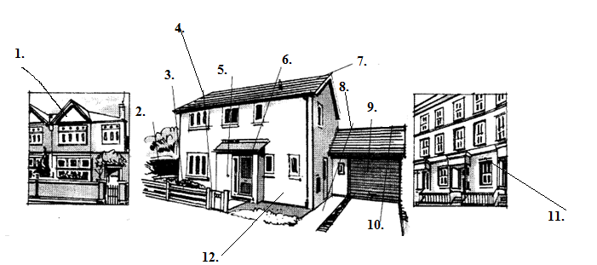

front garden

fence

detached house

terraced house

roof

gate

garage

front door

path

semi-detached house

front door bell

drive

**4) Reading - Homework**

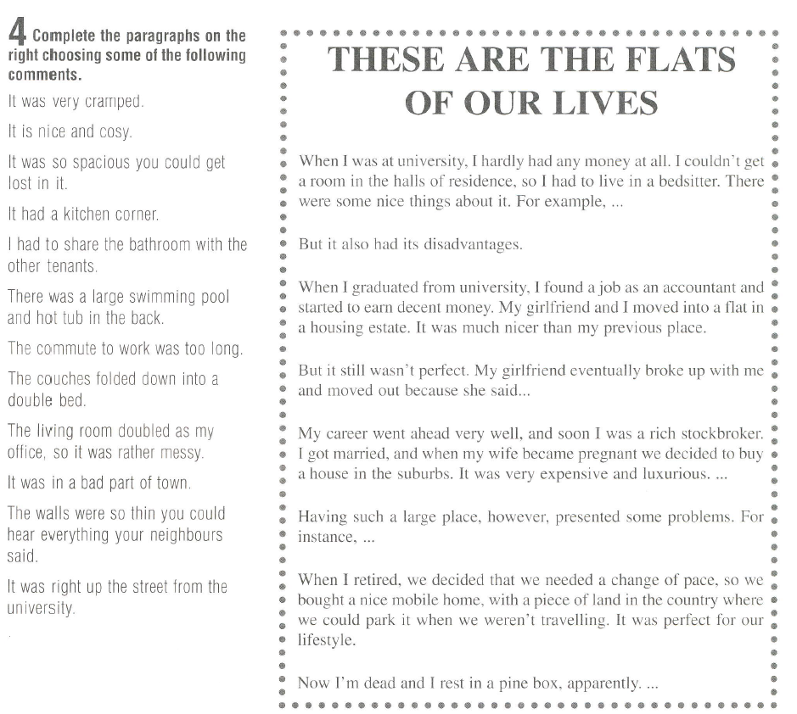

**5) Homework – complete the missing words**

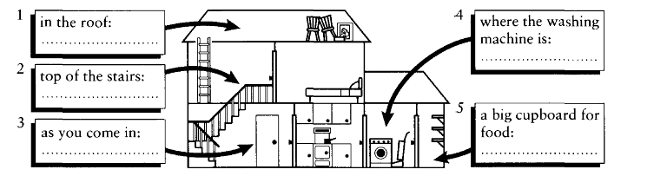

**6) Reading**

**Look at the following advertisements and match them to the people they are best suited for:**

