Learning languages
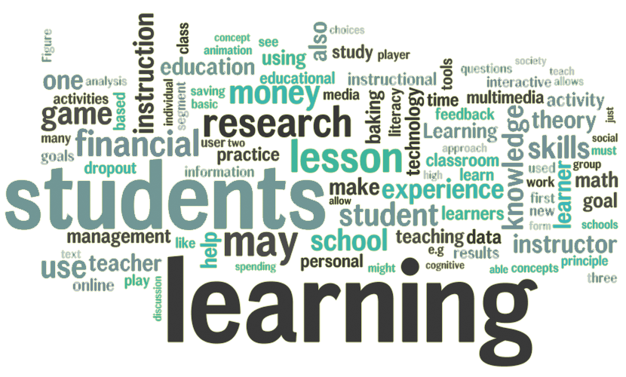
- Have a look at the word cloud about learning. Are there any words you don’t understand? Look them up.
- Look at these questions and think of an answer. We will discuss them together in a class.
• How did you learn your mother tongue?
• What methods do you use to remember vocabulary better?
• Is it necessary to write words down?
• Is it possible to understand and write well but not be able to have a conversation?
• Why do some people have more difficulty than others when learning a language?
• To what extent do you agree that it's better to learn language as a child? Why or why not?
• To speak its language well, how important is it to know something about the culture of a country?
• As a beginner, what are the first things that you need to be able to say?
• How can the Internet be a helpful tool when learning a foreign language?
• What do you know about IELTS and TOEFL?
• Can a teacher influence how well you enjoy learning a language?
• What languages would you like to learn in future?
• What different techniques do you have for learning vocabulary?
• Do you know how large your vocabulary is in your foreign language?
• Could you teach your mother tongue to someone else?
• What personal qualities do you need to be an effective language learner?
• What tools can help you learn a foreign language?
• Is knowing grammar more important than knowing vocabulary?
• How old should a child be when a school introduces the first foreign language?

