TO ADVISE OR NOT TO GIVE ADVICE?
L
I
F
E
ALL I REALLY NEED TO KNOW I LEARNED IN KINDERGARTEN by Robert Fulghum
Most of what I really need to know about how to live and what to do and how to be I learned in kindergarten. Wisdom was not at the top of the graduate-school mountain, but there in the sandpile at Sunday School. These are the things I learned:
Share everything.
Play fair.
Don’t hit people.
Put things back where you found them.
Clean up your own mess.
Don’t take things that aren’t yours.
Say you’re sorry when you hurt somebody.
Wash your hands before you eat.
Flush.
Warm cookies and cold milk are good for you.
Live a balanced life – learn some and think some and draw and paint and sing and dance and play and work every day some.
Take a nap every afternoon.
When you go out into the world, watch out for traffic, hold hands, and stick together.
Be aware of wonder. Remember the little seed in the Styrofoam cup: The roots go down and the plant goes up and nobody really knows how and why, but we are all like that.
Goldfish and hamsters and white mice and even the little seed in the Styrofoam cup – they all die. So do we.
And then remember the Dick-and-Jane books and the first word you learned – the biggest word of all – LOOK.
Everything you need to know is in there somewhere. The Golden Rule and love and basic sanitation. Ecology and politics and equality and sane living.
Take any of those items and apply it to your family life or your work or your government or your world and it holds true and clear and firm. Think what a better world it would be if we all – the whole world – had cookies and milk about three o’clock every afternoon and then lay down with our blankies for a nap. Or if all governments had as a basic policy to always put thing back where they found them and to clean their own mess. And it is still there, no matter how old you are - when you go out into the world, it is best to hold hands and stick together.

GIVE ADVICE using the expressions bellow

If I were you I would …
I think you should …
Why don’t you …?
How about ...?
It is usually a good idea to ...
Have you tried ...?
It's a good idea to...

1. My dog jumps up on people. Have you tried taking your dog to obedience school?
2. I always get headaches. I think you should relax more.
3. My cell phone battery runs out every day.
4. My feet are always cold.
5. I'm bored of the meals we eat.
6. I hate winter.
7. The back wheel on my car is making a strange noise.
8. My fingernails always break.
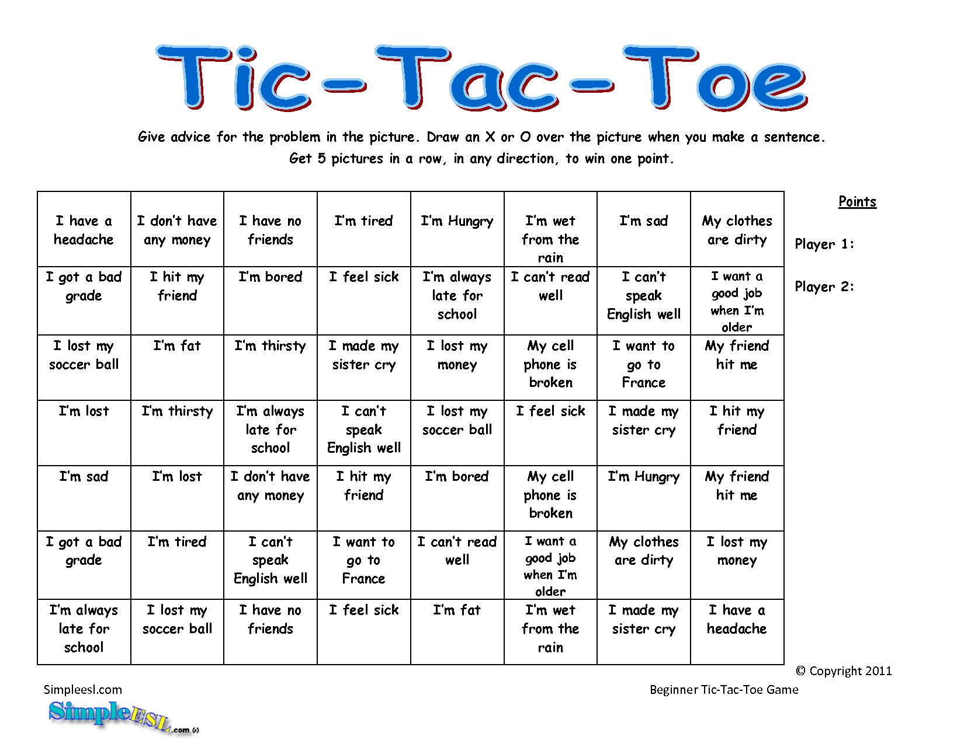
Father and Son by Cat Stevens

It’s not time to……………………, just relax and ……………………. settle down
You’re still young, ……………………….. take your time
………………… you have to know take it easy
Find a girl,……………. , if you want to, you can marry make a change
Look at me, I am old, but I’m happy that’s your fault
I was …………like you are now, and I know that ……………….. going on
To be calm, when you’ve found something……………. once
But, ………… think a lot, think of everything you’ve got There’s so much
For you will still be here tomorrow, but your dreams may not it’s not easy

How can I try to explain? When I do he ………………….again there’s a way
It’s always been the same, ………………….. have to go
………………….. I could talk I was ordered to listen same old story
Now………………. and I know I …………….away From the moment
And I know I have to go turns away

It’s not time to……………., just …………….and ………………… There’s so much
You’re still young, ……………….., All the times
……………….. you have to………………….. make a change
Find a girl, ……………, if you want to you can marry sit down
Look at me, I am old, but I’m happy they were right
……………. that I cried, keeping all the things I knew inside go through
It’s hard, but it’s harder to ignore it. take it slowly
If……………, I’d agree, but it’s them they know,……………. that’s your fault
Now………………, and I know that ……………. away. there’s a way
I know I have to go. settle down
not me
I have to go

INSTRUCTIONS FOR LIFE by DALAI LAMA

1. Take into account that great love and great achievements involve great risk.
2. Když prohrajete, nenechte si ujít ponaučení. (nepropásni tu lekci.)
3. Follow the three Rs:
Respect for self
Respect for others and
Responsibility for all your actions.
4. Pamatujte si, že když nedostanete to co chcete, je to někdy skvělý zásah štěstí. (a wonderful stroke of luck).
5. Naučte se pravidla, abyste věděli, jak je správně porušit.
6. Don't let a little dispute injure a great friendship.
7. When you realise you've made a mistake, take immediate steps to correct it.
8. Každý den stravte nějaký čas o samotě.
9. Open your arms to change, but don't let go of your values.
10. Pamatujte si, že mlčení je někdy ta nejlepší odpověď
11. Live a good, honorable life. Then when you get older and think back, you'll be able to enjoy it a second time.
12. Milující atmosféra ve vaší domácnosti je základem vašeho života.
13. In disagreements with loved ones, deal only with the current situation. Don't bring up the past.
14. Sdílejte svoje poznatky. Je to způsob, jak dosáhnout nesmrtelnosti.
15. Be gentle with the earth.
16. Jednou do roka se vypravte někam, kde jste nikdy před tím nebyli.
17. Pamatujte si, že nejlepší vztah je ten, in which your love for each other exceeds your need for each other.
18. Judge your success by what you had to give up in order to get it.
19. Approach love and cooking with reckless abandon.

