- Where is the woman going to go on holiday this year?

- What time was the man’s appointment?
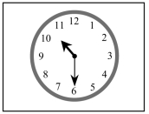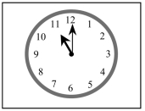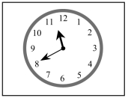
- What will the weather be like?
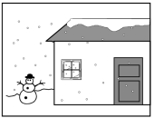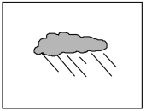
- How far is the nearest supermarket?
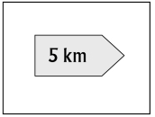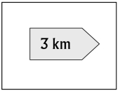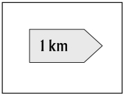
- Which table does Sally like?
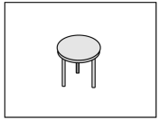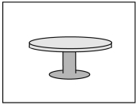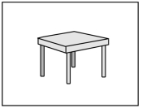
Listening Part 2
Listen to Tom talking to a friend about a sports afternoon.
What sport did each person do?

Listening Part 3
Listen to Jenny talking to Mark about buying a computer game.
1. The name of the computer game is ____________.
a) City 2010
b) City 2001
c) City 2100

2.The game is not good for people under ________
eight. ten. twelve.

3.Black's PC shop is in ________
Cambridge. London. Peterstown.
4.The address of the shop is ________
29 Hunter Road. 29 Marsden Street. 29 Walker Street.
5.The last day you can get a free game is ________
Friday. Monday. Thursday.
6.The computer game cost ________
£26. £30. £48.

Listening Part 4
You will hear a man asking for information about a train.
Train:__________________
Day of journey_______________________
Train leaves at:________________________
Return ticket costs: £___________________
Food on train: Drinks and ____________
Address of travel agency: 22____________Street

Listening Part 5
You will hear some information about a museum.
Manor House Museum
YOU CAN SEE:
Downstairs:

– Entrance hall: Old photos

– Ford room: Pictures of Italian___________________

Upstairs:

– Left: More than 150________________________

– Right:_________________________from films and TV

Price of guidebook: £______________________________

Museum closes at:____________________________________

