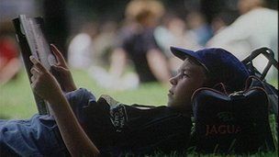LITERACY-

author-

fiction-

novelist-

librarian-

characters-

Why is reading good for you?

What are you reading at the moment? What is the book about?

How many books did you read this summer? Which one did you like best?

How do you choose books you want to read?

Why don’t people read books?

Do you like writing? If yes, what?

Have you ever written a diary?

Do you often write letters?

Is your handwriting legible?

Do you prefer typing to writing?

Do you know somebody who has problems with writing?

Would you like to have more written homework such as essays?

Do you write down new words to remember them better?

**Listening:**

Who is a bookworm?

Where does Finn read books?

What encourages us to read?

Which genres does Rob like?

Who is a literacy hero?

What is dyslexia?

Which books were read by Mike Tyson and where?

Why are books useful in prison?

How many words were there in the Marcel Proust’s book?

**Literacy conversation:**

What do you think about literacy?

How are literacy rates in your country?

Is literacy linked to one’s intelligence?

How does literacy affect your life?

Are you computer literate?

How do high levels of literacy help a country?

How would your life be different if you were illiterate?

What is the biggest barrier to literacy and how can we overcome it?

What are the consequences of illiteracy?

**Reading:**

What is the aim of the WORLD LITERACY FOUNDATION?

Is illiteracy expensive? Why?

What can you say about female illiteracy?

What is the connection of illiteracy and HIV?

What can help stop illiteracy?

