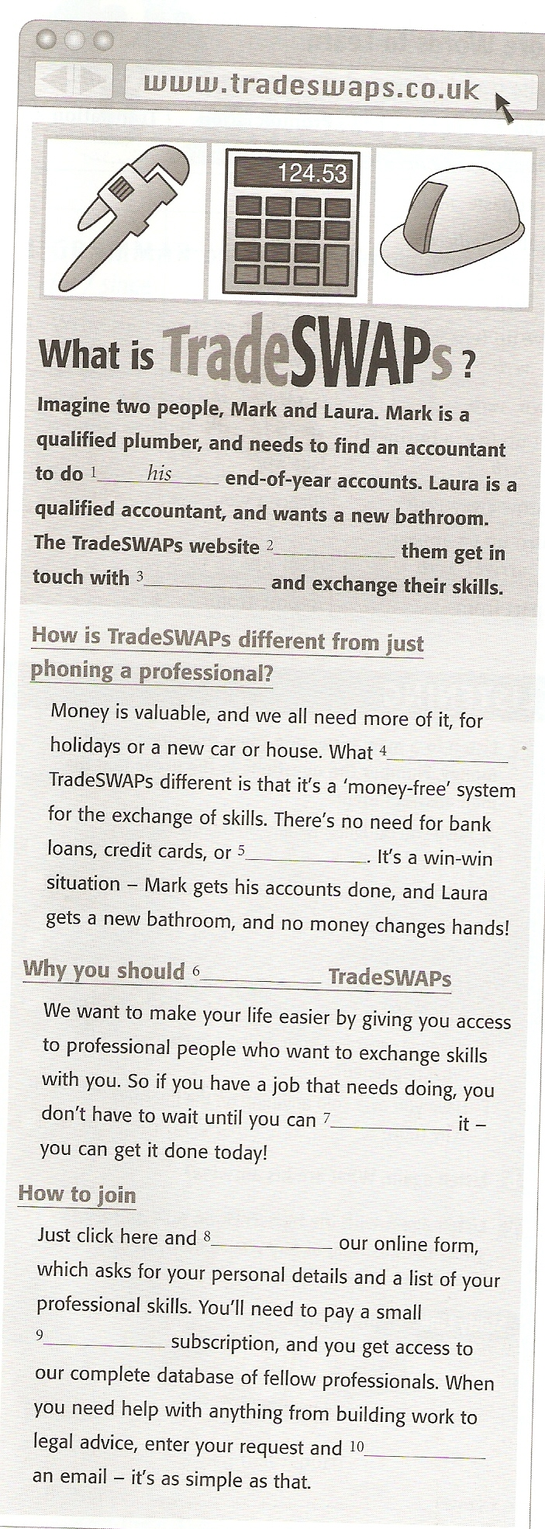

**Read the website and choose the best word for each space.**

1 her his their

2 asks makes lets

3 each other another themselves

4 makes does becomes

5 coin note cash

6 have join earn

7 afford pay buy

8 fill in fill up fill

9 month by month monthly

10 wait wait for waiting

**Tick the best summary**

1If you are a member of TradeSWAPs, you can get paid for your skills.

2 If you are a member of TradeSWAPs, you don’t have to pay as much for jobs as non-members.

3 If you are a member of TradeSWAPs, you can cooperate with other members.

**Living without money**

What would you do if you had to live one day without money? How would spend a day in your city/town/village without spending any money? What activities could you do? You’re not allowed to stay at home, you have to be out of the house for the whole day. You are allowed to drink water from city water fountains and eat any food that you find.

