**One-way ticket to MARS**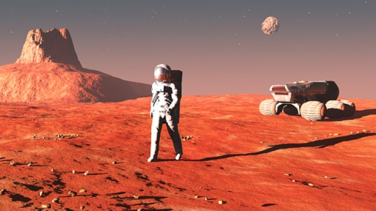

Do you like travelling? Why?

Where have you travelled to? Name the countries you have visited.

What was your longest vacation? Where did you go? How long were you there?

How much do you know about Mars?

***Mars*** *is the fourth* [*planet*](https://en.wikipedia.org/wiki/Planet) *from the* [*Sun*](https://en.wikipedia.org/wiki/Sun) *and the second smallest planet in the* [*Solar System*](https://en.wikipedia.org/wiki/Solar_System)*, after* [*Mercury*](https://en.wikipedia.org/wiki/Mercury_(planet))*. Named after the* [*Roman god of war*](https://en.wikipedia.org/wiki/Mars_(mythology))*, it is often referred to as the "Red Planet" because the* [*iron oxide*](https://en.wikipedia.org/wiki/Iron(III)_oxide) *prevalent on its surface gives it a reddish appearance.*

*Mars is approximately half the diameter of Earth, and its surface area is only slightly less than the total area of Earth's dry land. Mars is less dense than Earth, having about 15% of Earth's volume and 11% of Earth's* [*mass*](https://en.wikipedia.org/wiki/Mass)*, resulting in about 38% of Earth's surface gravity.*

Are you interested in astronomy and the science of space travel?

Do you think there is/was life on Mars?

Why are scientists so interested in Mars?

Do you have any memories of important achievements in space travel?

Have you heard of the Mars One project? What do you think it is?

**Mars One** is a non-profit organisation which wants to establish a permanent human settlement on Mars. To prepare for this settlement the first unmanned mission is scheduled to depart in 2020. Crews will depart for their one-way journey to Mars starting in 2026; next crews will depart every 26 months after the initial crew has left for Mars.

**Journey to Mars** - The flight will take between seven to eight months (depending on the relative positions of the Earth and Mars). The astronauts will spend those seven months together in a very small space—much smaller than the home base at the settlement on Mars—lacking luxury. This will not be easy. Showering with water will not be possible. Instead the astronauts will use wet towelettes (wet wipes) like astronauts on the International Space Station. Freeze dried and canned food is the only option. There will be constant noise from the ventilators, computers, and life support systems, and a strict routine of three hours of daily exercise in order to maintain muscle mass. If the astronauts are hit by a solar storm, they must hide in the even smaller, sheltered area of the rocket which provides the best protection, for up to several days. The journey will be demanding, pressing each of them to the very limits of their training and personal capacity.

**Life on Mars -** Once they arrive on Mars, the astronauts will begin making use of their relatively spacious living units; over 50 m2 per person, and a total of more than 200 m2 combined interior space. Within the settlement there are inflatable components which contain bedrooms, working areas, a living room and a 'plant production unit', where they will grow greenery. They will also be able to shower as normal, prepare fresh food (that they themselves grew and harvested) in the kitchen, wear regular clothes, and, in essence, lead typical day-to-day lives. If the astronauts leave the settlement, they have to wear a Mars suit. However, all living spaces are connected by passageways, in order for the astronauts to move freely from one end of the settlement to the other. As the rovers have done much of the heavy construction before astronauts’ arrival, it will not take them a long time to find routine in their new life, moving into carrying out valuable construction works and research.

What is Mars One?

How many people will go in 2026? How about in 2028?

What will happen to the travellers during their trip to Mars?

Can you describe the astronaut’s life on Mars?

What do you think of the project? Is it realistic?

The project is currently accepting applicants to be part of the 4 man crew that will leave in 2026. What kind of people do you think they are looking for?

Would you be interested in participating? Why? Why not?

What kind of people do you think would apply for the project?

If you were running the project what tests would you do on the applicants to check if they are suitable?

What are the biggest problems the people could encounter on the 7-month journey to Mars? And when they land?

How would you feel if a member of your family wanted to apply for the project?

Do you know anyone who you think would like to apply?

Why do you think people would apply to be part of the project?

Imagine you have been selected to be part of the first crew. You are allowed to take 1 item of hand luggage (standard budget airline size) of personal belongings. What would you take and why?

Are men really from Mars and women from Venus?