NATURE

nature (U), also Nature - everything in the physical world that is not controlled by humans, such as wild plants and animals, earth and rocks, and the weather.
countryside – a rural area, land that is far away from big towns and cities
country - rural as distinguished from urban areas
landscape - a section or expanse of natural scenery, that can be seen from a single viewpoint
scenery - the general appearance of a place; all the features that give character to a landscape.
outdoors - the open air, an area away from human settlements.
in the wild - in nature, animals and plants that are living in nature, rather than being kept "in captivity" by humans in a zoo, a garden, someone's home, etc.

You have a holiday home in the ____________ where you go to enjoy the ___________.
Scottish ________ is beautiful.
I love camping____________.
I am interested in _____________.
____________ lions rest for about 20 hours a day.

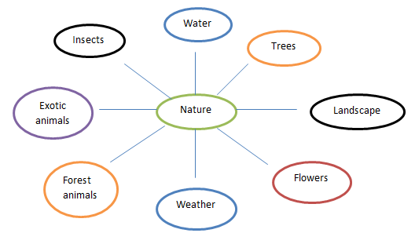

How important is nature to you? Why?
How much nature is there where you live?
What is the most beautiful thing in nature? Why?
How does being in the country make you feel? Why?
What is your favourite place in the countryside?
Why do people live in cities, where there is almost no nature?
What does "the power of nature" mean? How powerful is nature?
What would the trees say to humans (if they could talk)?
What would life be like without nature?
In 100 years from now, how different do you think the natural world will be?
How important is nature in your culture?
Are there any bad things about nature?
Is your country often affected by natural disasters?
How can we add more nature to cities?
Where is nature at its most beautiful – the mountains, oceans, deserts, beaches, space, or forests? Why do you think so?

Listening:
1. What does the girl do when painting pictures of trees?
A. She uses many different colours of paint.
B. She goes to the mountains to be surrounded by trees.
C. She climbs her grandfather's tree to concentrate on her work.

2. What aspect of trees is the girl referring to when she says that "it's" a glass of cool water on a hot day"?
A. the colour
B. the feel
C. the smell

3. What is one thing the girl does NOT mention about climbing her grandfather's tree?
A. She likes to think and relax in the tree.
B. She enjoys eating the apples.
C. She likes to play games in the branches.

4. According to the girl, how do trees make life possible?
A. They produce oxygen so we can breathe.
B. They provide food and shelter for countless animal species.
C. They serve as an important energy source.

5. How does the beauty of trees make the girl feel according to her closing statement?
A. Trees make her feel a greater interest in protecting the environment.
B. The beauty of trees makes her want to study plants in the future.
C. The girl believes that trees help her become a better person.

Conversation continues:
What are the three most famous natural wonders in your country?
Have you ever been to a natural wonder?
What makes something a natural “wonder”?
Should people be allowed to visit a natural wonder if the visitors hurt the natural wonder just by visiting it?
Would you rather visit natural wonders or man-made wonders?

