NATURE

nature (U), also Nature - everything in the physical world that is not controlled by humans, such as wild plants and animals, earth and rocks, and the weather.
countryside – a rural area, land that is far away from big towns and cities
country - rural as distinguished from urban areas
landscape - a section or expanse of natural scenery, that can be seen from a single viewpoint
scenery - the general appearance of a place; all the features that give character to a landscape.
outdoors - the open air, an area away from human settlements.
in the wild - in nature, animals and plants that are living in nature, rather than being kept "in captivity" by humans in a zoo, a garden, someone's home, etc.

You have a holiday home in the ____________ where you go to enjoy the ___________.
Scottish ________ is beautiful.
I love camping____________.
I am interested in _____________.
____________ lions rest for about 20 hours a day.

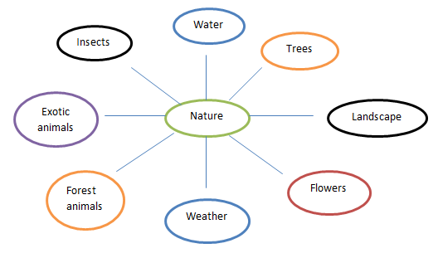

How important is nature to you? Why?
How much nature is there where you live?
What is the most beautiful thing in nature? Why?
How does being in the country make you feel? Why?
What is your favourite place in the countryside?
Why do people live in cities, where there is almost no nature?
What does "the power of nature" mean? How powerful is nature?
What would the trees say to humans (if they could talk)?
What would life be like without nature?
In 100 years from now, how different do you think the natural world will be?
How important is nature in your culture?
Are there any bad things about nature?
Is your country often affected by natural disasters?
How can we add more nature to cities?
Where is nature at its most beautiful – the mountains, oceans, deserts, beaches, space, or forests? Why do you think so?

Listening: I don’t know about you, but I __________________ natural disasters now than before. _________________ the news there’s some kind of disaster. There are bushfires in Australia and California, earthquakes in China, hurricanes in Mexico __________________ Africa. I’m sure global warming is creating more natural disasters. I’m lucky. Where I live, we __________________ natural disasters. I’ve never experienced anything __________________ TV. Japan has many natural disasters. They have earthquakes, typhoons, flooding, volcanoes, __________________. They are lucky they have the money __________________. There are countries in Africa that aren’t rich. When a natural disaster hits them, ___________________.
Conversation continues:
What are the three most famous natural wonders in your country?
Have you ever been to a natural wonder?
What makes something a natural “wonder”?
Should people be allowed to visit a natural wonder if the visitors hurt the natural wonder just by visiting it?
Would you rather visit natural wonders or man-made wonders?

