THE ACADEMY AWARDS

Word Cloud – How many films can you find? Have you seen any of the films? Would you like to see any? Can you identify the genre? Do you think any of the films has won the Oscar?

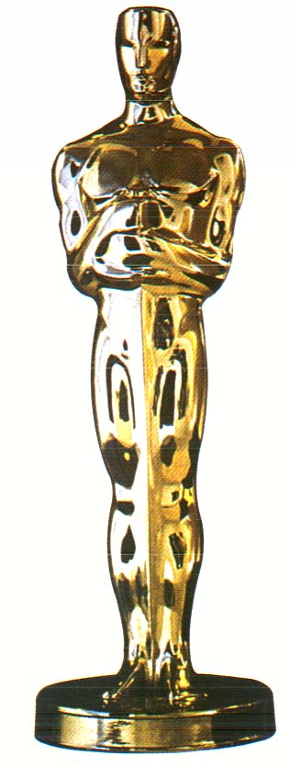
The Academy Awards, also known / knowing as the Oscars, is an annual presentation held by the U.S. movie industry. The event is running / run by the Academy of Motion Picture Arts and Sciences, which has to maintain strict / strictly security of who has won what until the winners are announced. It started in 1929 and has growth / grown into a worldwide extravaganza. Millions of people tune / tunes in each year to see whether their favourite movie, director or actor has picked down / up the top award. The gold statuette prize, called an Oscar, is the highest honour in the movie industry. It can twist / turn an actor into a legend or a movie into a classic. It also turns Hollywood into a party and paparazzi paradise. The stars turn in / out looking like a million dollars in their designer dresses and suits.
The voting for the Academy Awards is very strict and is conductor / conducted under the tightest secrets / secrecy. A top international accounting firm has counted the votes for the past / post seven decades. Only the most talented people in the movie industry can become a member of the Academy and votes / vote. Membership is by invitation only. This is to make surely / sure the top professionals in the business decide on the winners. There are up to 25 categories up for grabs, and up / as to five nominations can be made in each. The newest award is for Best Animated Feature, which started in 2001. Movie fans / fan in over 100 countries watch on television as the famous envelopes are opened with the word / words, “And the winner is…”.

What comes to your mind when you hear the word ‘movie’?
Would you like to work in the movie industry?
Why are movies called movies?
Which movie would you like to live in?
What’s the best movie you’ve ever seen?
Do you prefer watching movies at the cinema or on TV?
Why are made-for-TV movies so bad?
Which country makes the best movies?
What was the last movie you saw?
Who is your favourite movie star?
What’s the worst movie you’ve ever seen?
Are movies good for us?
Do you think movies have made society more violent?
What movie genre do you like best?
Who would you want to play you in a movie based on your life?
Would you like a job as a movie critic?
What makes a great movie for you?
What was the first movie you saw at the movie theater?
If you could make a movie, what would it be about?
Do you prefer to watch a good movie or a good game of sport?
Who do you like watching movies with best?

Video:
OSCAR HISTORY

