FEARS AND PHOBIAS

What is the difference between a fear or phobia?

be scared to death have goose bumps break into cold sweat
blood turned cold send chills down one‘s spine jump out of skin
shake like a leaf be as white as a ghost
be scared be afraid be terrified be horrified be frightened be petrified

Dictation:

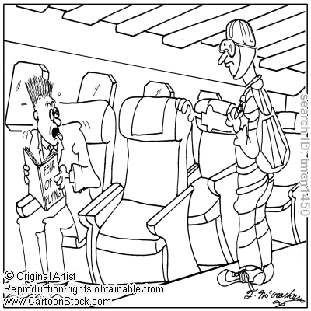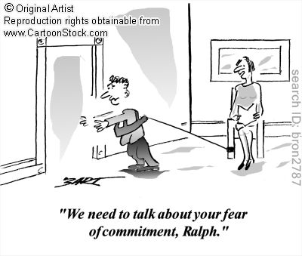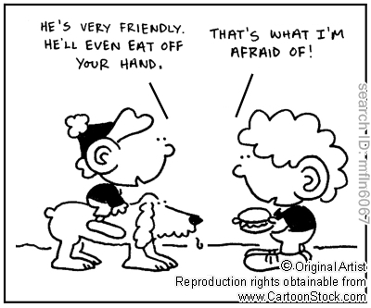
- What are the people in the pictures afraid of?
- Are you afraid of any of these things?
- Is fear a good thing? What would happen if we were completely fearless?

Fear is a defense mechanism that evolved over the years to protect us from dangerous situations. If you weren’t afraid of dangerous things, then you’d be more likely to engage in dangerous acts. Imagine you were on the top of a mountain and you weren’t even the least bit afraid of falling. You would walk around just as you normally would on the ground. If you made one false move, you’d be toast. The fear you feel is supposed to make you more careful and pay more attention to the situation.

- What is your biggest fear for the world?
- Do you have any form of phobia?
- How often do you feel afraid?
- How do you react to fear?
- How would you help someone to get over their fear?
- Have you ever panicked with fear?
- What were you afraid of as a child?
- Do you like putting yourself in situations where you can feel fear?
- Do you think society lives in fear?
- Are you ever afraid of other people?

Millie, 15
I have a phobia of the dark. It really freaks me out. If I wake up in the night and need the toilet, I will lie in bed until it gets light. Once I was sleeping in a tent in my garden and I needed the toilet, I had to phone my mum (at 2 or 3 in the morning) to turn on all the security lights so it wasn‘t dark. I also have a fear of deep water but it is kind of the same as my fear of the dark, as well as being scared of not being able to reach the bottom I get scared because I can‘t see what is beneath me.

Jade, 16
I have a fear of giving birth, I don‘t know why I have it but when I was in school we watched a film about it and I think it has made me scared. I hate the thought of giving birth, but I think I also have a fear of pain too. It makes me sick of the thought of giving birth but I really want to overcome it as I some day want a family.

Jodie, 23
I really have an unusual phobia. It began when I was a little girl. I was staying with my grandma and she asked me to get her cardigan. I opened the cupboard and saw this big, dark green cardigan with huge, black buttons hanging there – I was terrified. I started screaming. From then on it was a problem. All buttons make me feel uncomfortable. It is difficult for me to buy clothes. I try to find skirts and trousers with just belts and zips, but it’s not easy. About a year ago a button came off a colleague’s jacket and I had a panic attack. I’ve decided to see a psychotherapist, but I am embarrassed to say that I am scared of buttons. It sounds silly.
- How does their phobia affect their lives?
- Which of the people has the most difficult phobia to live with?
- Why do some people get phobias and others not?
- How do you think they can be cured?
1. I got scared to ___________when a stranger with his hands inside the pockets of his coat approached me.
2. I saw a white flying object hanging in the sky yesterday. It was neither a plane nor a bird. Could it have been a UFO (unidentified flying object)? I get goose _________every time I tell people about it.
3. Melanie broke into ___________when she realized she left her passport at home. Her plane was about to take off in an hour.
4. My blood ______________when I heard about a shooting in a local school.
5. Just the sound of the dental drill was enough to send chills ____________________.
6. Someone’s heavy breathing and loud footsteps made me jump out ______________________.
7. Jami is afraid of heights. She was shaking like __________________when she was crossing the bridge a hundred meters up from the river.
8. The accused turned as white as ____________and was really shaking when the witness was giving her testimony.
VIDEO : Are you nomophobic?
We use cellphones every day. But for a growing number of people, staying connected is an obsession.
According to a study by SecurEnvoy, a company that deals in mobile phone technology, the fear of being apart from your cellphone is on the rise.
It's called Nomophobia, as in "No mobile phone phobia," and 66 percent of the people surveyed said they have it.
That number is up from a similar study four years ago, where 53 percent of people admitted to a fear of losing their cellphones.
Dr. Mitch Spero, director of child and family psychologists in Broward County, said it was common to see problems arise because of cellphone use.
"Cellphones are tools that should be used to enhance our lives," he warned, "not to destroy our interpersonal communication skills with those that we love."
The study by SecurEnvoy shows that people check their cellphones an average of 34 times a day. But for Karla Campos from Pembroke Pines, that's nothing.
Campos estimates that she checks her phone closer to 50 times a day, and she even sleeps with it.
"Before I go to sleep, I put it under my pillow," said Campos, who owns a web services company called Gig Logo.
No matter what, 'it goes with me'
According to the study, 75 percent of people use their cellphones in the bathroom.
Scott Miller-Farrugia from Coral Springs admitted to being one of those people.
"I bring it into the bathroom instead of the newspaper," he said.
Scott's wife Shellie is such a cellphone addict, her nickname is "Celly."
"No matter where I am, it goes with me," she said.
Campos takes "everywhere" to the extreme, bringing her cellphone into the shower, "just in case it rings and somebody needs me."
For the record, Campos said she placed the phone on a ledge where it stays dry.
She also uses her cellphone to communicate with her 10-year-old son. But not necessarily when they're apart.
"He doesn't talk to me, I see him and pass by and he just says 'Hi Mom,'" Campos explained, "but when I have real conversation with him, it's on the phone, through Facebook."
Campos argued that any form of communication is better than none at all, and said she believes the cellphone connects her family.
Spero disagreed. "What I recommend is to keep your cellphone there for emergencies, but when you're with someone make them the priority in your life," he said.
The study showed that the younger you are, the more likely you are to be afflicted with Nomophobia. Women are also more likely to have it than men.
Wondering if you have Nomophobia?
The warning signs include: Obsessively checking your phone, constantly worrying about losing it even when it's in a safe place, and never turning it off.

