**Phones…**

Telephones are ____________________ lives these days. When I was growing up, I perhaps used the phone once a week. It was ____________________ when it rang. Everyone rushed into the living room to find out who was calling. Of course, ____________________ phone – the size of a football. And you had to leave it on the table because it ____________________ wall. Today, however, is a ____________________. Everyone has a phone. Some people I know have several. They change them every six months ____________________ come out. Today's phones aren't really phones. They are like personal ____________________ that have a phone. I'm waiting ____________________. I'm sure it'll be here soon.

Do you know anything about the invention of a telephone or a mobile phone?

**A FEW FACTS ABOUT MOBILE PHONES**

-The history of mobile phones goes back to 1908 when a US Patent was issued in Kentucky for a wireless telephone.

-Mobile phones were invented as early as the 1940s when engineers working at AT&T developed cells for mobile phone base stations.

-The first mobile phone invented for practical use was by a **Motorola** employee called Martin Cooper who is widely considered to be a key player in the history of mobile phones. Cooper made mobile phone history in April 1973 when he made the first ever call on a handheld mobile phone.

-Japan became the first country to have a city-wide commercial cellular mobile phone network in 1979.

-The Nordic Mobile Telephone (NMT) system launched in Denmark, Norway, Sweden and Finland in 1981.

-The next major step in mobile phone history was in the mid-eighties with the **First Generation (1G)** fully automatic cellular networks were introduced.

-The first ever mobile phone to be approved by the FCC (Federal Communications Commission) in the USA was the **Motorola DynaTac** in 1983.

Did you have a landline when you were a child?

When did you get your first mobile phone? What was it like?

Can you remember what life was like before mobile phones?

From what age do you think children should have a phone?

Should smart phones be banned at schools?

Are you happy with the phone you have now?

How often do you buy a phone?

What is your favourite function?

What is your ring tone and why did you choose it?

Do you like making phone calls? What about phone calls in other languages?

What kind of phone calls irritates you?

When did somebody make you happy over the phone?

Do you like texting? What are the advantages of texting over making a phone call?

Can a mobile phone be harmful?

How clean do you think your phone is?

Have you ever cleaned your phone?

“The phones contained more skin bacteria than the any other object; this could be due to the fact that this type of bacteria increases in high temperatures and our phones are perfect for breeding these germs as they’re kept warm and cozy in our pockets, handbags and brief cases. These bacteria are toxic to humans, and can cause infections if they have the opportunity to enter the body.”– Joanne Verran, Professor of Microbiology at Manchester Metropolitan University

Is the communication among people changing? How?

What do you think about the situations described in the pictures?

What would you do if your date spent more time on his/her phone than talking to you?

**Introduction / Making Contact** - If answering a business call, start by introducing yourself or if the caller fails to identify themselves, then you could ask them to state who they are by using the following phrases:

**Formal**

* ‘Hello’
* ‘Good Morning’
* ‘Good Afternoon’
* ‘This is ___ speaking’
* ‘Could I speak to ___ please?’
* ‘I would like to speak to ___’

**Informal**

* ‘Hello’
* ‘Hi, it’s ___ here’
* ‘I am trying to get in touch with ___’
* ‘Is ___ there please?’

**Giving more information** - This would probably be used in a business context mainly, but could sometimes be helpful in an informal conversation too. It is good to specify where you are calling from, if you feel it may be helpful to the person you are calling.

**Formal**

* ‘I am calling from ___
* I’m calling on behalf of ___’

**Informal**

* ‘I’m in the post office at the moment, and I just needed ___’

**Asking for more information / Making a request** - If you need to ask for a specific person, then phrase your request as a polite question, if you only have an extension number and no name, you can say so. If you’re calling for a specific reason, just explain briefly what it is.

**Formal**

* ‘May I ask who’s calling please?’
* ‘Can I ask whom I’m speaking to please?’
* ‘Could I speak to someone who ___?’
* ‘I would like to make a reservation please’
* ‘Could you put me through to extension number ___ please?

**Informal**

* ‘Who’s calling please?’
* ‘Who’s speaking?’
* ‘Who is it?’
* Who am I speaking to?

**Asking the caller to wait / Transferring a call** - If you are transferring a caller to someone else, you should let them know that you are doing so, just so they know what is happening, as the silent tone could be mistaken for a disconnected line! If you are the one being transferred, you will often hear the person use the following phrases:

**Formal**

* ‘Could you hold on a moment please’
* ‘Just a moment please’
* ‘Hold the line please’
* ‘I’ll just put you through’

**Informal**

* ‘Hold on a minute’
* ‘Just a minute’
* ‘Okay, wait a moment please

**Giving Negative Information** - If you are the one answering a call, you might not be able to help the caller. You can use some of the following phrases in these circumstances:

**Formal**

* ‘I’m afraid the line is busy at the moment’
* ‘That line is engaged at the moment, could you call back later please?’
* ‘I’m afraid ___’s busy at the moment, can I take a message?’
* ‘I’m sorry, he’s out of the office today’
* ‘You may have dialled the wrong number’

**Informal**

* ‘Sorry, ___’s not here’
* ‘___ is out at the moment’
* You’ve dialled the wrong number.

**Telephone Problems** - If you don’t understand everything the other person is saying, be honest. Tell the other person immediately, otherwise you might miss some important information! Most people will appreciate your honesty, and will be happy to repeat it for you.

**Formal**

* ‘I’m afraid I can’t hear you very well’
* ‘Could you speak up a bit please?’
* I’m afraid my English isn’t very good, could you speak slowly please?’
* ‘Could you repeat that please?

**Informal**

* ‘Sorry, I didn’t catch that’
* ‘Say that again please?’
* ‘I can’t hear you very well’
* ‘Sorry, this line is quite bad.

1. May I ask ________________ calling?  
a) Ms. Smith, please. b) I'll call tomorrow. c) This is Bob Hall.

2. I'm sorry, but she's out to ___________ right now.   
a) Okay. I'll call her right now. b) I'll call her after lunch. c) Okay. Lunch time is fine.

3. Could I have your ____________________?  
a) Yes. It's 532-9843. b) My name's Greg Rodgers. c) My zip code is 09783.

4. ___________________________________ message?   
a) No. I'll call later. b) Yes. Go ahead. c) Yes. Please give him the message.

5. Could ________________________________________ please?  
a) I work for Sony. b) It`s spelled T . . I . . M. c) That's correct.

6. _____________________________________________________.  
a) Here's the message. b) No. I'll call later. c) Thank you.

7. _____________________________________________________.  
a) Okay. Then, I'll meet him now. b) Do you know when it'll be over? c) Sorry. I can't meet him now.

8. _____________________________________________________.  
a) I'll call him Thursday morning. b) Alright. Please tell him Jeff called. c) Have him call me on Wednesday at 3:00.

9. _____________________________________________________.  
a) Next Wednesday would be fine. b) Sorry. I'm busy on Monday at 11:00. c) Sure. No problem.

10. _____________________________________________________?

a) Yes. I'll call her later. b) No. Just tell her I called. c) Yes. Tomorrow is fine.

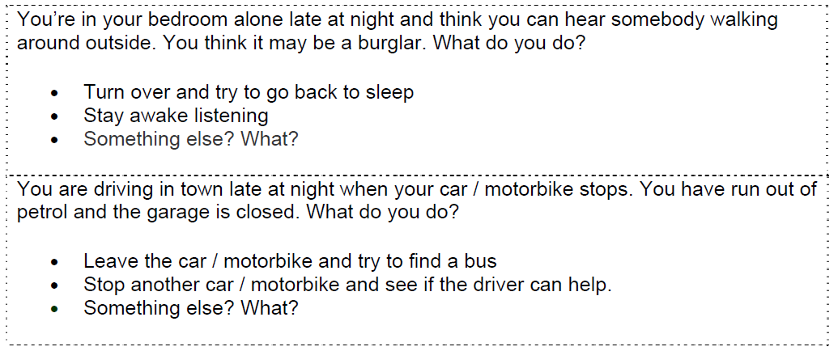

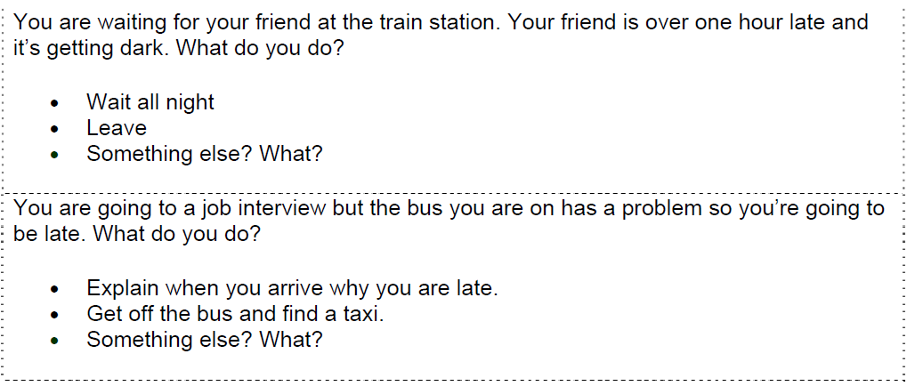

**Mobile Phones: Reading**

I’m in a bank and I’m opening a new bank account. The bank manager is asking me questions. She asks me my name, my age, my address, what I do, where I work, my phone number and then my mobile phone number.

‘I don’t have a mobile phone,’ I reply.

‘I’m sorry?’ asks the manager, shocked.

‘I don’t have a mobile phone.’

‘But everybody has a mobile!’

‘No, they don’t. I don’t.’

‘Are you serious?’

‘Of course I am!’

‘But how can you not have one? Everybody needs a mobile!’

‘No, they don’t. I don’t.’

‘Listen,’ I say to the bank manager, ‘this is a true story: A man is going parachuting – he has with him his parachute, his helmet and his mobile phone. The plane takes him higher and higher and further and further away from the town. But there is a very strong wind today and he lands on top of a hill very badly – he has two broken legs. He takes his mobile phone and calls his friend to come and rescue him. That’s strange – the phone is not working. He tries again. Nothing. Then he realizes that there is no mobile phone network on the hill. In great pain he pulls himself down the hill to the road and stops a car. The driver takes him to the hospital.

‘This is another true story: I am waiting for my friend Syrine at a railway station. Her train arrives but she’s not on it. I wait for the next train. No Syrine. I wait for an hour and begin to worry. Then I remember that she has a mobile phone. I go to a public telephone box and call her. Nothing. I try again – no answer. Another half an hour later Syrine arrives. I tell her about the phone call – she looks at her phone: the battery is flat.’

The bank manager tries to speak.

‘No, listen’ I say. ‘When I go to a restaurant, my friends put their mobile phones on the table. When the phones ring, they answer them and chat for ages. This is a true story: I am in a café with Syrine. Her mobile rings and she starts chatting to her friend, her friend is telling her a long, funny story about something. Syrine is laughing and listening. I eat my cake and drink my coffee. Syrine is still talking on her phone. I finish the cake and the coffee. Ha, ha, ha says Syrine. I pay for my cake and coffee and leave the café.

‘Now I’m in the cinema. I’m watching a film and it’s great. The hero of the story realizes he is in love with the girl, he’s walking towards her and talking softly. Then, and this is a true story, the person next to me has a phone call. She’s talking to her friend about what time the film ends and where they can meet. I can’t hear the film, I can only hear the person next to me.’

‘So,’ I say to the bank manager, ‘I don’t have a mobile phone, I don’t need a mobile phone and I don’t like mobile phones.’

The bank manager looks at me very strangely and opens the bank account.