**I am calling to say hallo…**

Do you know anything about the invention of a telephone or a mobile phone?

Reading: **The history of mobile phones**

Write down 3 questions you hope will be answered in the text:

1.

2.

3.

Mobile phones, particularly the smartphones that have become our inseparable companions today, are relatively new. However, the history of mobile phones goes back to 1908 when a US Patent was issued in Kentucky for a wireless telephone.

Mobile phones were invented as early as the 1940s when engineers working at AT&T developed cells for mobile phone base stations.

The very **first mobile phones** were not really mobile phones at all. They were two-way radios that allowed people like taxi drivers and the emergency services to communicate.

Instead of relying on base stations with separate cells (and the signal being passed from one cell to another), the first mobile phone networks involved one very powerful base station covering a much wider area.

These early mobile phones are often referred to as **0G** mobile phones, or **Zero Generation** mobile phones. Most phones today rely on **3G** or **4G** mobile technology.

The first mobile phone invented for practical use was by a **Motorola** employee called Martin Cooper who is widely considered to be a key player in the history of mobile phones.

Handsets that could be used in a vehicle had been developed prior to Martin Cooper’s phone, but his was the first usable truly portable mobile telephone.

Cooper made mobile phone history in April 1973 when he made the first ever call on a handheld mobile phone.

**Landmarks in early mobile phone history**

-Japan became the first country to have a city-wide commercial cellular mobile phone network in 1979.

-The Nordic Mobile Telephone (NMT) system launched in Denmark, Norway, Sweden and Finland in 1981.

-The next major step in mobile phone history was in the mid-eighties with the **First Generation (1G)** fully automatic cellular networks were introduced.

-The first ever mobile phone to be approved by the FCC (Federal Communications Commission) in the USA was the **Motorola DynaTac** in 1983.

Did you have a landline when you were a child?

When did you get your first mobile phone? What was it like?

Can you remember what life was like before mobile phones?

From what age do you think children should have a phone?

Should smart phones be banned at schools?

Are you happy with the phone you have now?

How often do you buy a phone?

What is your favourite function?

What is your ring tone and why did you choose it?

Do you like making phone calls? What about phone calls in other languages?

What kind of phone calls irritates you?

When did somebody make you happy over the phone?

Do you like texting? What are the advantages of texting over making a phone call?

Can a mobile phone be harmful?

How clean do you think your phone is?

Have you ever cleaned your phone?

“The phones contained more skin bacteria than the any other object; this could be due to the fact that this type of bacteria increases in high temperatures and our phones are perfect for breeding these germs as they’re kept warm and cozy in our pockets, handbags and brief cases. These bacteria are toxic to humans, and can cause infections if they have the opportunity to enter the body.”– Joanne Verran, Professor of Microbiology at Manchester Metropolitan University

Is the communication among people changing? How?

What do you think about the situations described in the pictures?

What would you do if your date spent more time on his/her phone than talking to you?

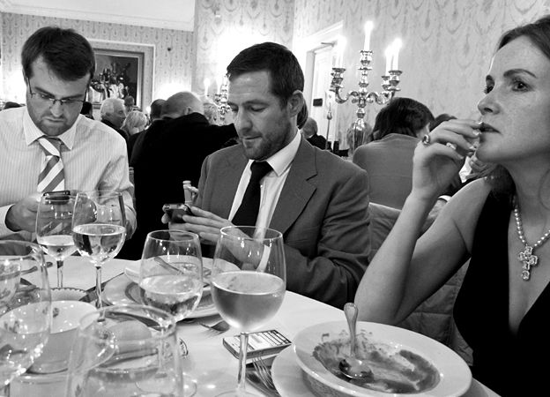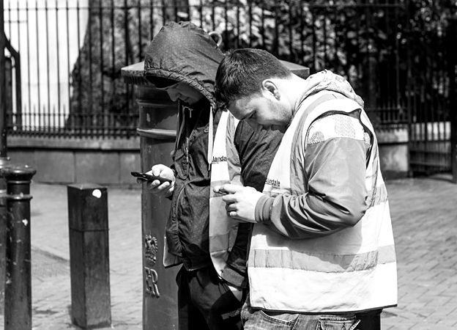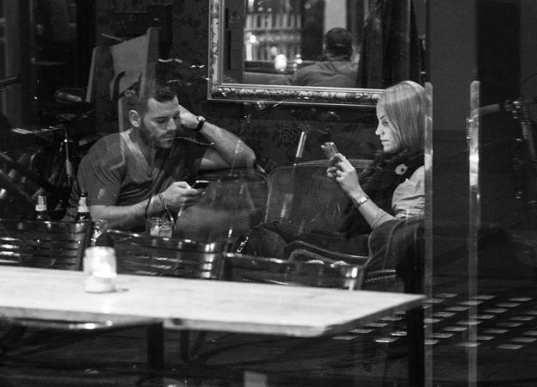

1. May I ask ________________ calling?  
a) Ms. Smith, please. b) I'll call tomorrow. c) This is Bob Hall.

2. I'm sorry, but she's out to ___________ right now.   
a) Okay. I'll call her right now. b) I'll call her after lunch. c) Okay. Lunch time is fine.

3. Could I have your ____________________?  
a) Yes. It's 532-9843. b) My name's Greg Rodgers. c) My zip code is 09783.

4. ___________________________________ message?   
a) No. I'll call later. b) Yes. Go ahead. c) Yes. Please give him the message.

5. Could ________________________________________ please?  
a) I work for Sony. b) It`s spelled T . . I . . M. c) That's correct.

6. _____________________________________________________.  
a) Here's the message. b) No. I'll call later. c) Thank you.

7. _____________________________________________________.  
a) Okay. Then, I'll meet him now. b) Do you know when it'll be over? c) Sorry. I can't meet him now.

8. _____________________________________________________.  
a) I'll call him Thursday morning. b) Alright. Please tell him Jeff called. c) Have him call me on Wednesday at 3:00.

9. _____________________________________________________.  
a) Next Wednesday would be fine. b) Sorry. I'm busy on Monday at 11:00. c) Sure. No problem.

10. _____________________________________________________?

a) Yes. I'll call her later. b) No. Just tell her I called. c) Yes. Tomorrow is fine.

Telephones are **these lives our of part major a** days. When I was growing up, **used phone a perhaps the once I** week. **it a rang big It event was when almost**. Everyone rushed **into find the out living who room was to** calling. **phone , an style course was - Of it old** – the size of a football. And **to had you table the on it leave** because it was plugged into the wall. Today, however, is a totally different matter. Everyone has a phone. Some people I know have several. change **They months six every them** when the latest models come out. Today’s phones aren’t really phones. They are like personal entertainment devices that have a phone. I’m waiting for the watch phone. **it’ll sure I’m soon here be**.

**Mobile Phones: Reading**

I don’t have one, and if I can help it, I won’t ever get one in the future. And I hate the assumption that I need one, or that I’m strange not having one. I opened a new bank account the other day and the woman who was helping me (and this is a true story) asked me if I was serious when she found out I didn’t have one. She simply couldn’t see how I could live my life without one. I don’t see why – I can be contacted at home, or work, so what’s the problem?

Yes, I have a laptop computer and instant access to the Internet; yes, I have a digital camera and yes I have a microwave oven and an i-Pod but I absolutely refuse to get a mobile phone!

Of course I can see how useful they *could* be, and that if there was a *real* emergency they could come in handy, but that’s not always the case. There was a story of a guy who had a parachuting accident and found himself on top of a cliff with two broken legs. He had his mobile with him but – guess what? He wasn’t able to use it because he was in a remote area! So, in great pain, he had to pull himself along the ground with his elbows until he got to a road and could stop a motorist. So not much help for him then, was it? And once when I very reluctantly rang a friend on her mobile (from a telephone box on the platform) because she was very late arriving at a train station she didn’t answer it. Why? Because, she said (when she eventually arrived) that the battery was flat! So what’s the point? (And calling mobiles is so expensive!)

Other times they create the emergency themselves. Remember that awful story of the Kenyan student? She dropped hers into a pit latrine while ‘answering a call of nature’. So she offered the equivalent of $13 to anyone who could get it for her and what happened? Three men died, intoxicated by the fumes because they were so desperate for the money. That’s awful. And don’t they cause cancer? Apparently, the general scientific opinion at the moment is that the benefits seem to outweigh any known dangers but it’s best to use a hands-free kit. I’m not sure about that. An independent report recommends that under-16s use theirs only for essential calls – ha! Try telling that to a teenager!

And no gentle burr burring either but we have to listen to the theme tune of a soap opera, or a national anthem, or ringing bells while the owner rummages in the bottom of their bag to find the offending item.

But these aren’t my main bugbears. No, what I hate is how my daily life is affected negatively by other people using theirs. Take a restaurant – I really, really hate it when friends arrive and the first thing they do is put their mobiles on the table so that, in the (likely) event of it going off they stop talking to you and start ignoring you. Are they doctors? Are they giving advice on open-heart surgery? Are they talking to long-lost friends? Sick relatives? NO! It’ll be their mother who they saw recently, or other friends they’re going to meet soon. For me it’s the height of rudeness. And of course I also have to put up with the same happening on the next-door table too. And how inept and pointless the conversations! ‘I’m with Jenny and we’re having Dim Sum.’ The person needs to know that? ‘Hi, I’m on the train now and will be there in about 10 minutes.’ So? Are they not expected? Can’t they just turn up in 10 minutes and say ‘I’m here.’? I don’t want to know what strangers did yesterday, what they plan to do tomorrow or what they’re doing now (I can see what they’re doing now!).

I’m also affected by the light – do the owners really not realize how bright they are? OK maybe the stupid thing is on vibration but when it’s opened in the cinema, or at a concert the owner is all lit up and then I can’t concentrate on what I’m watching. I was at a concert not long ago, up on the balcony, and looking down on the audience there were always at least five people using their mobiles. Why didn’t they switch them off? Why are they going tappety tap tap instead of watching the show? It drives me so mad! The mate of mine sitting next to me actually answered his and started whispering loudly – but when he saw the look on my face he instantly apologized. ‘Sorry – it’s my sister.’ So?

Finally, it’s an excuse to be late. If the waiting friend can be contacted ‘Just to let you know I’m going to be half an hour late’, then somehow being late is therefore OK. No! Just make an effort to arrive on time! Sometimes friends even blame *me* for sitting alone for twenty minutes when it was *they* who were late because, they insist, I couldn’t be contacted! No –I’m *never, ever* going to get one!