PLAYTIME

Do you like playing?

What can you play?

How often do you play?

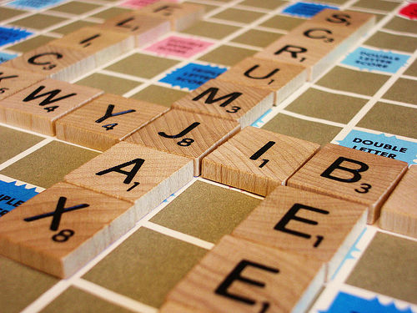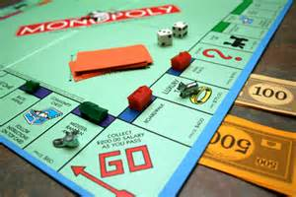Look at the pictures of two classic board games. Do you know these games? Have you ever played them? Which of the two games do you prefer?

What is the connection between the words in bold bellow and the article about the games?

**Great Depression architect by hand unemployed 750 million +**

In 1929 many people in the United States suddenly lost their jobs. This was the beginning of what Americans call the Great Depression, and it lasted for about four years. During the Great Depression, two of the most famous board games in the world were invented: Monopoly and Scrabble. While the games are very different, the story behind each one is similar…

Alfred Butts, the inventor of Scrabble and Charles Durrow the inventor of Monopoly, were both American. Neither inventor had a job. Butts had lost his job as an architect in 1929, and Durrow was an unemployed sales representative in 1933. At the beginning, the inventors made every edition of their game by hand. Neither game was accepted by toy companies at first. They said that Monopoly was too complicated and that nobody would be interested in Scrabble.

Both games are played on a board, and can be played by two or more people.

Both games have been extremely popular: according to its makers, more than 750 million people have played Monopoly, and two hundred million copies of Scrabble are sold every year.

Both of them are successful worldwide. They are published in over 25 languages today, and are available in more than 80 countries.

*Look at the text and say what these games have in common.*

*Complete the texts with the following words:*

board dice miss a turn money points square turn

Scrabble is played with letters. Different letters are worth different ________________.

Each player has seven letters per ____________________. You put the letters on the _____________ and make words. The object is to get as many points as possible. If you can’t make a word with your letters, you ______________.

In Monopoly, players roll a ______________ and move their counter around the board.

Each ___________________on the board represents a property. If you land on someone else’s property, you have to pay them. The object is to collect property and make __________.

*Useful vocabulary:*

roll the dice

it’s your turn

pick a card

miss a turn

whoever rolls higher goes first

which piece is yours

no cheating

What do you learn from playing?

Do you prefer playing alone, or with / against friends?

What is it about playing that makes people happy?

Do people play enough in our country?

How can play help you relax?

Do you like to watch people playing?

What would you say if your parents told you to go out and play?

Have you ever played in the rain?

When is playing a waste of time?

Can you remember the first games you played?

What will playtime be like in the future?

Is playing good for your health?

"You can discover more about a person in an hour of play than in a year of conversation." -  Plato.  What do you think of this?

How can you learn English through playing?

Have young people forgotten or don't know how to play?

Have you ever played dumb?

Do you know anybody who plays God?

Do you like playing with fire?

Did you play truant when you were at school?

Do you always play fair?

Who mostly plays on your nerves?

When did you last play something by ear?

**Can you replace the word make in the sentences with a more suitable word with a specific meaning?**

The traffic in the afternoon *makes* lots of problems.

They are *making* a new bank in the centre of town.

These cars are *made* in a Korean factory.

Alfred Butts *made* the game of Scrabble.

We’ve *made* a new computer program.

**Fill in the gaps with make or play in the correct form**

1. This company _____ **business** with big corporations.

2. The young children ______ a lot of **noise** in class.

3. I don’t want to _________**cards**. I want to ___________**something** more interesting.

4. You need to ______ **an effort**, if you’re going to pass the exam.

5. John _____ **well** in his exams.

6. I need to _____ **an appointment** to see the dentist.

7. My best friend _____ me **a favour** by helping me move house.

8. I had to ______ **a speech** in front of the whole school.

9. My Mum always ______ **the ironing**.

10. You need to ______ **a decision** about your holidays.

11. I have _____ **plans** for the weekend.

12. I have never _________**yoga** but I have always __________ **football and basketball**.

13. He _____ **a promise** to help his Mum with the housework.

14. He’s always _____ **excuses** to avoid doing his homework.