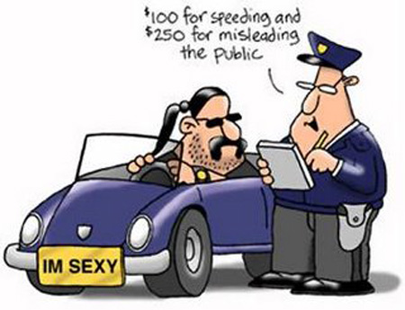
POLICE - singular or plural???
Police is a collective noun for a body of men and women employed to maintain law and order. When referring to individual members of the police in the UK, terms such as policeman/woman, police officer, P.C., and constable are commonly used.

STORY: New York cop's act of kindness goes viral VIDEO
Here's how a simple act of kindness can become a worldwide inspiration and a public relations bonanza for the New York Police Department.
In a case of being in the right place at the right time, a tourist from Arizona, who happens to work in law enforcement herself, was visiting New York City earlier this month when she noticed a man without shoes asking for change near Times Square.
Jennifer Foster, of Florence, Arizona, sent the following note, along with a picture she took, to the NYPD, which posted it on its Facebook page.
"Right when I was about to approach, one of your officers came up behind him. The officer said, 'I have these size 12 boots for you, they are all-weather. Let's put them on and take care of you.' The officer squatted down on the ground and proceeded to put socks and the new boots on this man. The officer expected NOTHING in return and did not know I was watching. I have been in law enforcement for 17 years. I was never so impressed in my life. I did not get the officer's name. It is important, I think, for all of us to remember the real reason we are in this line of work. The reminder this officer gave to our profession in his presentation of human kindness has not been lost on myself or any of the Arizona law enforcement officials with whom this story has been shared."
That Facebook post has gone viral since it went up Tuesday, with more than 77,000 shares, 322,000 likes and 20,000 comments. Most of those comments, which come from places as far away as Australia and Malaysia, praise the officer for his simple act.

STORY: No one reported shot, stabbed or slashed in New York City on Monday, police sources say
No news really is good news -- not a single person was reported shot, stabbed or slashed in New York City on Monday, police sources said.
The shutout seemingly caught the NYPD by suprise, as officials were almost at a loss to explain it."Nice way to start the week," said Deputy Commissioner Paul Browne, the NYPD's top spokesman. Neither Browne nor other officials could remember the last time a day ended with three zeros.
It likely didn't happen in 1990, when the city logged a record 2,245 murders, said Tom Reppetto, a NYPD historian and author of "American Police, 1945-2012.""We lived in a town where people were afraid to come out of their houses, where babies slept in bathtubs to avoid getting shot, where nursery schools ran drills - 'When you hear the shots, drop down.'"
Reppetto said that the lack of gun and knife violence on Monday may be rare, but not a complete surprise, given that the city is on pace to finish the year with just over 400 murders."They're going to come in with the fewest number of murders since about 1960,'' he said. "It's an almost impossible figure, but their programs have been fabulously successful in stopping crime."
The streak ended 11:20 a.m. Tuesday when a 27-year-old man was shot in Brooklyn at Ralph and Flatlands Ave.That was the first shooting since 10:25 p.m. Sunday, when a man in Bedford-Stuyvesant was shot in the head and badly wounded by a gunman wearing a red and black jacket and black hat.

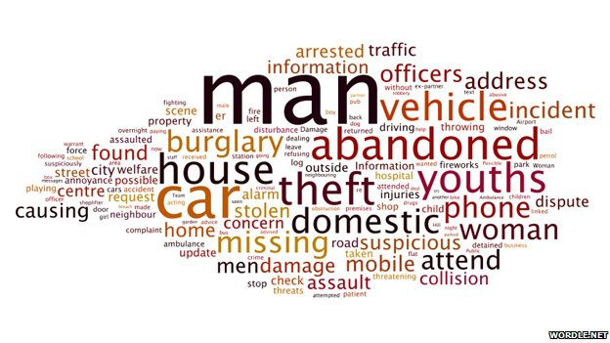
Listening: What _________________ without the police? They do a very valuable job. Without them, our society would be less safe. The police are _________________ when we are in danger or ___________________ happened. Even people who say they don’t like the police will call them for help. _________________ police officer is an interesting but risky job. Police officers must see lots of strange things every day. _________________ never a boring day in a police officer’s life. I wanted to be a police officer ___________________ would be too dangerous. I didn’t want to be in the middle _________________ people with guns. I think we must respect the police because they do a difficult job. It _________________ their job is getting more difficult.
Discussion:
How do the police help you?
Do you have any friends who are policemen?
Are you afraid of the police?
What are some situations when you would call the police?
Can you think of some situations when you wouldn't want to call the police?
Can you describe the police uniform of the policemen in your country?
What do you think about police in your country?
Would you like to be a police officer or did you want to be one when you were a child?
Do you think that it is a very dangerous job?
Do you think that a male police officer is required to do different or more difficult or dangerous jobs than a female police officer?
Have you ever called the police?
Have you ever been stopped by the police?
Have the police ever helped you? How?
What is the general feeling towards police in your country, is it positive or negative?
Do you think police are well paid in your country?
What do you think would happen if all police officers decide to go on a strike?
What are the qualities a good cop should have?
What question would you like to ask a police officer?

