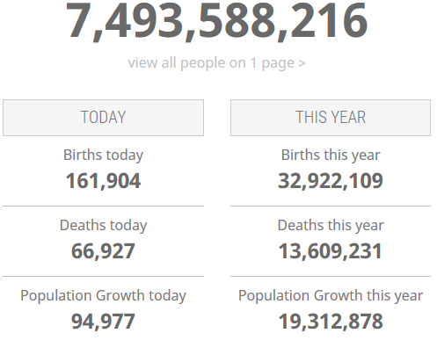
What comes to mind when you hear the word ‘population’?

How would you describe the population of your country?

How has your country’s population changed over the years?

The physicist Stephen Hawking said that if world population continues growing at its current rate, then “by 2600 we would all be standing literally shoulder to shoulder”. Will this happen?

Is population growth a concern in your country?

What will the impact of more people be on these things?
 | Positive impact | Negative impact
The environment
Travel
Water
Food
Animals
The future

Listening: The world’s population _______ bigger and bigger. There’s a population _________in some countries. I’m not sure if this is good or bad. The Earth can __________ a limited number of people. One day, the world’s population will be too big to _______________. When that happens, we’ll have food wars ________________. Many years ago, the population was controlled by ___________, a shorter lifespan, disease and other natural causes. We are richer now and so we can control _______________. This is already causing problems in some countries. Japan, for example, has almost more ___________________ working people. This means workers can’t make _________________________ look after old people

Population growth
At the dawn of agriculture, about 8000 B.C., the population of the world was approximately 5 million. Over the 8,000-year period up to 1 A.D. it grew to 200 million (some estimate 300 million or even 600, suggesting how imprecise population estimates of early historical periods can be), with a growth rate of under 0.05% per year.
A tremendous change occurred with the industrial revolution: whereas it had taken all of human history until around 1800 for world population to reach one billion, the second billion was achieved in only 130 years (1930), the third billion in less than 30 years (1959), the fourth billion in 15 years (1974), and the fifth billion in only 13 years (1987).
During the 20th century alone, the population in the world has grown from 1.65 billion to 6 billion.
In 1970, there were roughly half as many people in the world as there are now.
Because of declining growth rates, it will now take over 200 years to double again.
Population in the world is currently (2017) growing at a rate of around 1.11% per year (down from 1.13% in 2016). The current average population change is estimated at around 80 million per year.
Annual growth rate reached its peak in the late 1960s, when it was at 2% and above. The rate of increase has therefore almost halved since its peak of 2.19 percent, which was reached in 1963.
The annual growth rate is currently declining and is projected to continue to decline in the coming years. Currently, it is estimated that it will become less than 1% by 2020 and less than 0.5% by 2050.
This means that world population will continue to grow in the 21st century, but at a slower rate compared to the recent past. World population has doubled (100% increase) in 40 years from 1959 (3 billion) to 1999 (6 billion). It is now estimated that it will take a further 39 years to increase by another 50%, to become 9 billion by 2038.

In which century did the world population grow fastest?
What is the trend now?
What was the highest growth rate?

The current population of Czech Republic is 10,553,268 as of Monday, March 27, 2017, based on the latest United Nations estimates.
Czech Republic population is equivalent to 0.14% of the total world population.
Czech Republic ranks number 87 in the list of countries (and dependencies) by population.
The population density in Czech Republic is 137 per Km² (354 people per mi²).
The total land area is 77,219 Km2 (29,814 sq. miles)
75 % of the population is urban (7,913,956 people in 2017)
The median age in Czech Republic is 41.9 years. (Median age is the age that divides a population into two numerically equal groups - that is, half the people are younger than this age and half are older. It is a single index that summarizes the age distribution of a population)

What would happen in the world if there was a population explosion?
Is the population of your cities growing? How is this affecting the countryside?
Do you like looking at population surveys and statistics?
Is your society moving towards an ageing population? Is this a problem?
Is there any population control in your country?
What kind of ethnic and immigrant populations live in your town?
Do you think a diverse population is good for your country?
What is a population crisis?
What factors influence changing population patterns?
What do you think of ‘one child per family’ policies to slow down population growth?
What do you think of the idea of an international population tax?

NATIONAL GEOGRAPHIC QUIZ
1. On a planet of seven billion people, who is the most typical human?
a. Javanese Indonesian man, 62 b. Punjabi Indian woman, 34
c. Han Chinese man, 28 d. Zhuang Chinese girl, 10

2. If all seven billion people on Earth stood shoulder-to-shoulder, we would fill _________.
a. São Paulo, Brazil b. Tokyo, Japan c. Florida d. Los Angeles, California

3. Life expectancy in an industrialized nation is about ___ years long.
a. 55 b. 70 c. 80 d. 100

4. How many people have ever lived on Earth?
a. 15 billion b. 55 billion c. 108 billion d. 500 billion

5. What percent of all people who've ever been born are alive now?
a. 0.5% b. 2.0% c. 6.4% d. 15%

6. The most populous country today is China. What will it be in 2050?
a. China b. India c. Nigeria d. Indonesia

7. What percent of the world's population is literate?
a. 5% b. 16% c. 38% d. 82%

8. Do most people today live in urban or rural environments?
a. Urban b. Rural

9. How do most people make their livelihood?
a. Agriculture b. Services c. Industry
10. In 2011, there were _______ births per minute around the world.
a. 38 b. 127 c. 266

