Procrastination
Today, we have a lot of stuff to get done.

Video: Tales of Mere Existence
Write down words or expressions that you can see:

Order the parts of the text in the correct order:
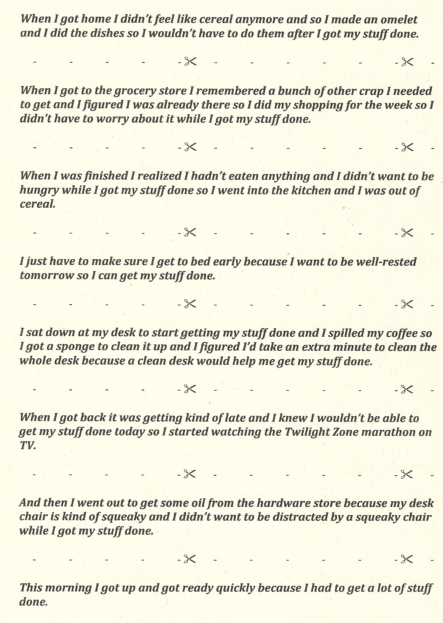
Do you understand the following expressions?
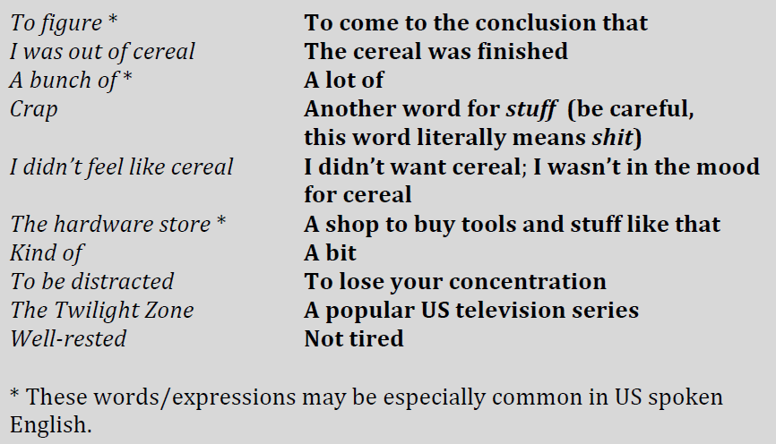
Translate:
This morning I got up and got ready quickly.
I spilled my coffee so I got a sponge to clean it up.
When I got to the grocery store I remembered some other stuff I needed to get.
When I got home I didn’t feel like cereal any more.
I went out to get some oil from the hardware store.
When I got back, it was getting late.
I just have to make sure I get to bed early.
I want to be well-rested tomoroww so I can get my stuff done.
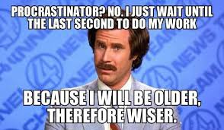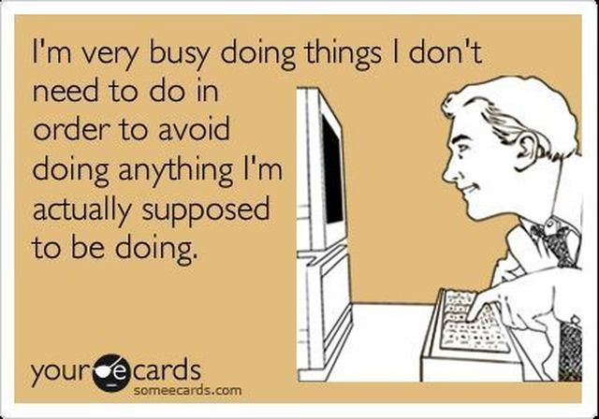

Why do people procrastinate?
Who do you know that always procrastinates?
When is it good to procrastinate?
When is it really bad to procrastinate?
What kinds of things do you put off doing?
How do you feel when other people put off something you want done soon?
Who is the most patient person you know?
What's the difference between patience and procrastination?
Do you usually procrastinate when you have homework?
What can procrastinators do to change their lives?
What kinds of things do people often forget?
Do you ever forget to pay your bills on time?
How do you feel about the late charges on most bills?
What do people often forget to do on time?
Have you ever forgotten an important date or event?
Do you become impatient when you have to wait in a long line?
Have you ever yelled at someone or been really angry because they didn't do something?
Are you always on time to class, late, or early?
Have you ever known someone who was always early to important things?
Do you know someone who is always busy?
Do you think people in some cultures are in too much of a rush?
Do you think people in other cultures are too relaxed?
Do you want to accomplish many things in your life or do you want to take it easy?

