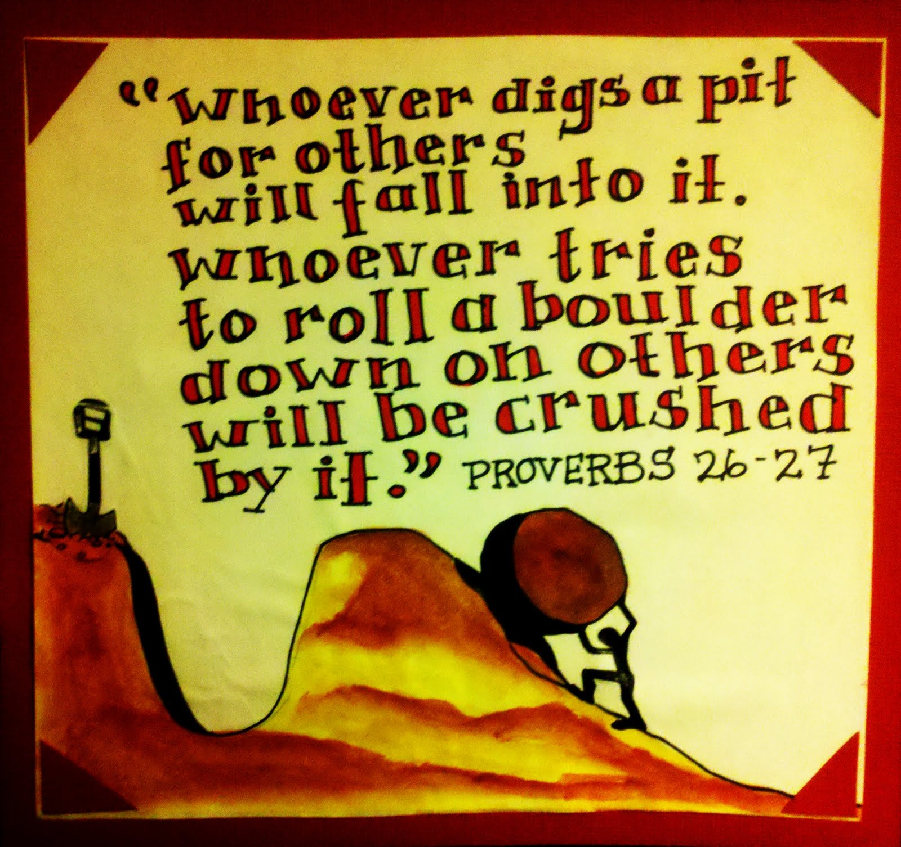
Proverbs

Proverbs are popular sayings which contain advice or state a generally accepted truth. Since most proverbs have their origins in oral tradition, they are generally worded in such a way as to be remembered easily and tend to change little from generation to generation, so much so that sometimes their specific meaning is no longer relevant.
My best was never good enough – Bruce Springsteen

"Every cloud has a silver lining,
every dog has his day."
She said "Now don't say nothin'
If you don't have something nice to say
The tough know they get going when the going gets tough."
But for you my best was never good enough
"Now don't try for a home run baby
If you can get the job done with a hit
Remember a quitter never wins
And a winner never quits
The sun don't shine on a sleepin' dog's ass."
And all the rest of that stuff
But for you my best was never good enough
"If God gives you nothin' but lemons
then make some lemonade
The early bird catches the fuckin' worm,
Rome wasn't built in a day
Now life's like a box of chocolates
You never know what you're going to get
Stupid is as stupid does"
and all the rest of that shit
Come on, pretty baby, call my bluff
Cause for you my best was never good enough

- You can not expect to do important things in a short period of time.

- You are what you do.

- You can anticipate when someone is not telling the truth.

- Everyone is successful during some period in their life.

- Life is full of surprises.

- You can turn something bad into something good

- When you do nothing, you can’t achieve anything

- If you want to be successful, you should do something immediately.

- If you give up, you will never be successful.

Translate:
- Bez peněz do hospody nelez.
- Bez práce nejsou koláče.
- Co je doma, to se počítá.
- Co můžeš udělat dnes, neodkládej na zítřek.
- Dobrá rada nad zlato.
- Dvakrát měř, jednou řež.
- Hněv je špatný rádce.
- Kdo hledá, najde.
- Kdo se moc ptá, moc se dozví.
- Když kocour není doma, myši mají pré.
- Líná huba, holé neštěstí.
- Mluviti stříbro, mlčeti zlato.
- Na každém šprochu pravdy trochu.
- Není kouře bez ohně.
- Opakování matka moudrosti.
- Ranní ptáče dál doskáče.
- Starého psa novým kouskům nenaučíš.
- Stokrát nic umořilo osla.
- Trpělivost růže přináší.

Explain:
- Where there's a will there's a way
- First come, first served
- A friend in need is a friend indeed
- A rolling stone gathers no moss
- As you sow, so you shall reap
- Barking dogs seldom bite
- A bird in hand is worth two in the bush
- Better late than never
- Birds of a feather flock together
- All that glitters is not gold
- Fire is a good servant but a bad master.
- Actions speak louder than words.
- It's never too late to mend.
- Still waters run deep.
- Look before you leap.
- Like father, like son, like mother, like daughter.
- There's no smoke without fire.
- When the cat is away the mice will play.
- A new broom sweeps clean.
- Blood is thicker than water.
- The last straw that broke the camel's back.
- Make hay while the sun shines.
- A leopard cannot change its spots.
- We never miss the water till the well runs dry.
- Too many cooks spoil the broth.
- Jump from the frying pan into the fire.
- Beggars can't be choosers.
- You can lead a horse to water but you can't make him drink.
- Love me, love my dog.
- A stitch in time saves nine.
- Time heals old wounds.
- Don’t cry over the spilt milk.
- Don’t judge a book by its cover.

