Real Beauty

What makes a person beautiful?
Vocabulary:
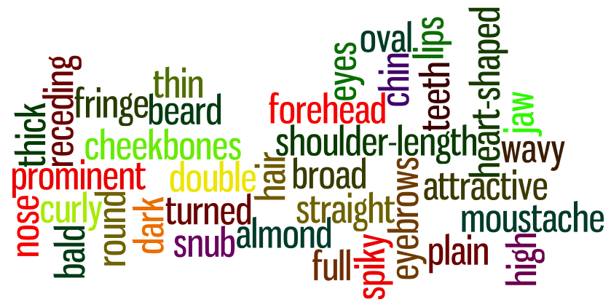
Pictures:
How would you describe these women?
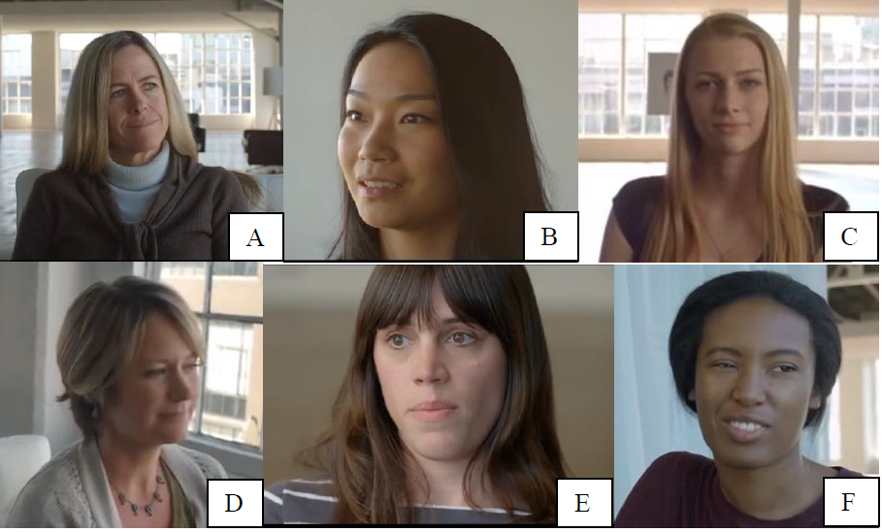

Video - Watch the video and answer the following questions.
1 What was Gil Zamorra’s previous job? What was he doing this time?
2 How did Gil get the information to make his drawings?
3 Which of the two pictures do you think looked most like the real people?
4 How does the video make you feel?
5 What is the message of the video?
6 The video is an advertisement. What do you think the advertisement is for?

DISCUSSION
Do you think it’s true that women tend to believe they are less attractive than they really are? Why/why not?
Do you agree with Florence that what we think about our looks has an impact on everything in our life? Why/why not?
Do you think that men are equally self-critical? Why/why not?
Do you think that an advertisement like this could have a positive effect on women’s self-esteem? Why/why not?
Do you think beautiful people have better lives? Why/not?
Do beautiful people intimidate you? Let's say you went to a party filled with models, would you feel uncomfortable? Why/not?
Do you think that models portray an unrealistic image of beauty? Why/not?
Which draws you to a person when you meet them for the first time, looks or personality? Why?
Studies suggest that beautiful people get better salaries and more frequent promotions than the average person. Why does this happen?
Some people say that the loneliest people are often beautiful people. What might this mean? Do you agree or disagree?
What are some disadvantages that the beautiful people of the world encounter on a regular basis? Why do you think so?
Why do people spend such a large amount of their discretionary income on products that promise beauty? Is it mere vanity?
If you could change one aspect of your appearance, which feature would you change? Why would you change it?
Is the quest for eternal beauty a pathological problem which affects everyone?
Assume an accident has left you horribly disfigured. How would it affect your life? Might you choose to have plastic surgery? Please explain.
What if you were voted the most beautiful person in the world? How would your life be different? Would your life be better or worse?
Who are some attractive celebrities? What makes them attractive?

Australia mayor seeks ‘ugly’ women
The mayor of a remote Australian town has caused outrage among women across Australia. John Molony, the mayor of Mt. Isa, a mining town in the Australian Outback, has offended women by making sexist comments. He called on women who were “ugly ducklings” to come to his town to make its male citizens happy. Mt. Isa has a population of almost 25,000 and men outnumber women by a ratio of five to one. Mr. Molony proposed making the numbers more equal by saying: “If there are five [men] to every girl, we should find out where there are beauty-disadvantaged women and ask them to proceed to Mount Isa.” He stated that “not so attractive” women were happy in his town because of a recent or upcoming date.
Many of Mt. Isa’s female residents are up in arms at their mayor’s comments. Patricia O’Callaghan from the Chamber of Commerce said Molony’s remarks were offensive and that "there are a lot of women who are furious”. Many women have hit back. Healthcare worker Catherine Willett said: "To be honest, there just aren't top quality men here….They are too busy drinking beer to notice the women and all they do is whistle or yell as you go past.” Anna Warrick, an occupational therapist, added: "The guys don't make much of an effort with the girls. There isn't much wining and dining going on.” Molony has refused to apologize, saying his comments were “twisted and warped” by the media. He insists he respects women.

