Regional variations in English language
- Do you know the term “lingua franca”? What does it mean?
- Can you guess the origin of following words (French, Dutch or German)
  - competition, landscape, cookie, dollar, mate, table, police, routine, smuggle, waffle, doppelganger, ennui
- Let’s have a look at the less speaking variations of English:
  - Listen to Irish and Australian English:
    - Irish (words come from Gaelic): https://www.youtube.com/watch?v=W2PHch4IPPQ
    - Australian (more relax and informal): https://www.youtube.com/watch?v=yDb_WsAt_Z0
  - Decide if the text is Irish or Australian:
    - Will the 2002 Fleadh be held here? The city and environs could be in for a multi-million pound boost next year.
    - Oz Snaps Up $100m US Gear. American sports clothing has become a meg-business of the decade.
    - Beaut Bangles – Diamond Fiesta. Drooling at diamonds is probably not a healthy pastime, unless you’re a born money bags.
    - He pointed out that all three men had apologized to the Gardai on the day following the incident.
  - Answer the questions:
    - What is the name for a kind of wild dog found in Australia?
    - Who or what is the Taoiseach?
    - When an Australian talks about the outback, what are they referring to?
    - What is an Irish person referring to when they talk of the craic?
    - Where would you find a boreen?
    - Where would you find a station without trains or buses?
    - What would you do with a didgeridoo?
    - Is an ocker a person or thing? Explain.
  - Listen to the Scottish accent: https://www.youtube.com/watch?v=mALkCGVA2BU
  - Watch funny video from Scottish elevator ☺ : https://www.youtube.com/watch?v=NMS2VnDveP8
  - Match the words with definitions:
- shroff  - jocker  - wee  - varsity  - bairn  - washroom  - macommere  - eejit  - veld | - Scottish word for small  - Scottish word for a child  - Malaysian word for university  - Australian word for person  - Caribbean word for godmother  - Hong Kong word for a payment office at a car park  - Irish word for idiot  - South African word for flat, open countryside with few trees  - Canadian word for a public toilet

- Let’s practice the most famous variants of English:
  - Is the sentence in British or American English?
    - I lost my way at the big intersection just south of the city.
    - Why are there always so many shopping trolleys left in the car park?
    - Cross the road at the pedestrian crossing and ten turn left.
    - You can’t drive any further; you’ll have to back up, the street is very narrow.
    - You’ll see a petrol station just round the corner.
    - The bookstore is kitty-corner to the Chinese restaurant.
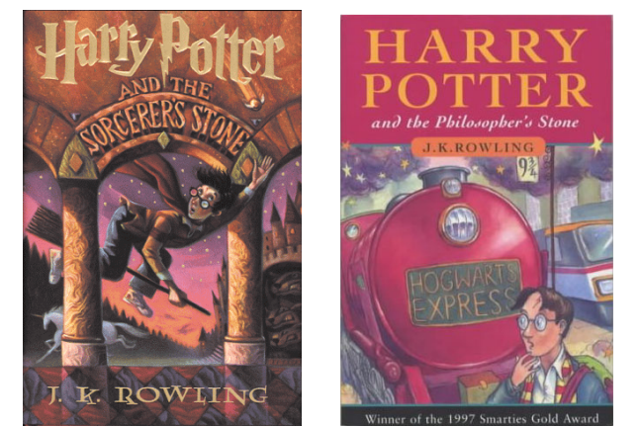
    - There is a creek at the end of the trail.
  - Which cover of Harry Potter is British and which American. Why do you think there is the change?
  - Imagine J.K.Rowling is going to write a more Americanized version of Harry Potter. How should she change the underlined words for the American audience?
    - “…the soles of his trainers were peeling away.”
    - “he’s going to jump out from behind a dustbin and try and do me in?”
    - “she got a bit shirty with me.”
    - “I fancy a cup of tea, too.”
    - “they reached the entrance hall, which was full of people queuing for dinner.”
  - Check these American phrases and words that are the most commonly used by American people. Do you know the meaning of all of them?
    - awesome
    - happy camper
    - jaw dropping
    - larger than life
    - What’s up? / Wassup? / ‘sup? (check this beer commercial, that made this phrase famous: https://www.youtube.com/watch?v=tauYnVE6ykU&feature=youtu.be)
    - Shut up!
    - Dude
    - To buy something
    - Off the hook / Off the chain / Off the hinge
    - To give props to someone
    - Bent out of shape
    - Bananas / Bonkers / Nuts
    - Bummer / Bummed
    - To hang tight
    - Plastered / sloshed / smashed / wasted
    - Whatever
    - to be amped
    - all ears
    - all around the clock
    - cheesy
    - hit the road
    - You bet!
    - You’re tellin‘ me!
    - You can say that again!

