**REGRETS**

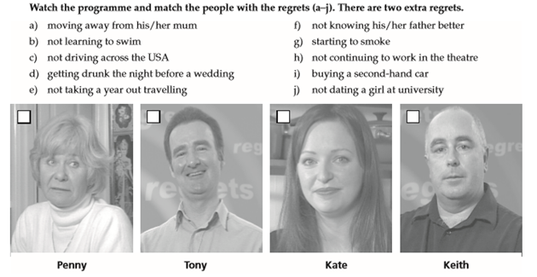

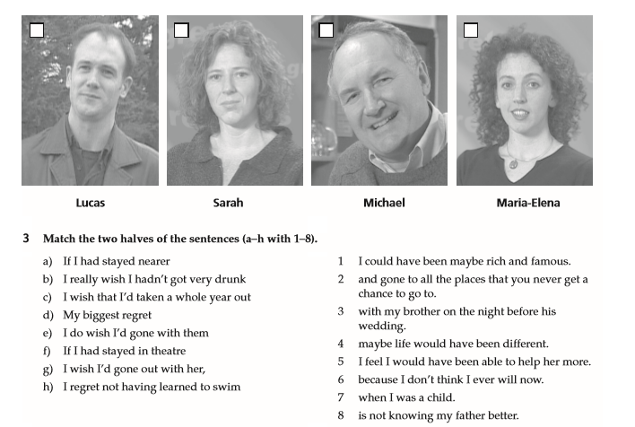

What are three wishes you have for your life?

If you could choose only one of these to come true, which would it be and why?

What would be some positive and negative consequences (results) if each of these wishes came true?

What other wishes do you have for yourself?

What wishes do your parents have for you? Are they the same?

How have your wishes changed since you were young?

When you were young, how did you answer this questions: "What do you want to be when you grow up?"

Have you ever had a wish come true? Was it what you always wanted?

Why do we wish for things we don't have?

If you have a wish but your family doesn't agree with you, what should you do?

Do you have any strange wishes?

Why are wishes very important to people?

Do you really want all your wishes to come true?

What would be one thing you would wish for your spouse?

What in your life would you not change?

What are you thankful for? Who are you thankful for?

1. What a pity we didn't meet them last night!

I wish________________________________________________________________________

2. You should have driven more carefully.

I wish________________________________________________________________________

3.You should not have brought Jennifer along to the funeral, she was so upset.

I wish________________________________________________________________________

4. I wish I had written down their telephone number.

What a pity____________________________________________________________________

5. I wish I hadn't come so late.

I do regret_____________________________________________________________________

6. You shouldn't have done it.

I wish_________________________________________________________________________

7. If only John hadn't lied to me!

I_____________________________________________________________________________

8. I regret selling my old Jaguar.

I wish_________________________________________________________________________

9. "Bob, leave your sister alone!

" I wish________________________________________________________________________

10. I'd really like you to pay more attention.

I wish_________________________________________________________________________

11. I'm sorry I didn't phone you.

I wish_________________________________________________________________________

12. You didn't speak to me at the party, I regret it.

I wish_________________________________________________________________________

13. Why didn't I check the petrol before leaving.

I wish_________________________________________________________________________

14. It's such a pity I lost his address

I wish_________________________________________________________________________

15. What a pity you left your book in the taxi!

I wish_________________________________________________________________________

16. What a pity we didn’t meet them last week!

I wish________________________________________________________________________

17. It would be so nice to have a house in the mountains.

I wish_________________________________________________________________________

18. Why didn't I meet them? Now, it's too late.

I wish_________________________________________________________________________

19. I'd like you to take better care of your visitors in the future.

I wish ________________________________________________________________________

20. He didn't help her. He feels ever so sorry now!

He wishes_____________________________________________________________________

21. Why on earth did I buy such a big car?

I wish_________________________________________________________________________

22. What a pity I didn't invest in a good education for Brian.

I wish_________________________________________________________________________

23. What a pity you didn't join us: it was a wonderful party.

I wish_________________________________________________________________________

24. What a shame she didn't leave her address!

I wish________________________________________________________________________

25. I regret having left so early.

I wish_________________________________________________________________________

**STEVE JOBS (founder of Apple) - last words before he died**

"I reached the pinnacle of success in the business world. In others' eyes, my life is an epitome of success. … However, aside from work, I have little joy. In the end, wealth is only a fact of life that I am accustomed to. At this moment, lying on the sick bed and recalling my whole life, I realize that all the recognition and wealth that I took so much pride in, have paled and become meaningless in the face of impending death. In the darkness, I look at the green lights from the life supporting machines and hear the humming mechanical sounds, I can feel the breath of God and of death drawing closer…

Now I know, when we have accumulated sufficient wealth to last our lifetime, we should pursue other matters that are unrelated to wealth…something that is more important: Perhaps relationships, perhaps art, perhaps a dream from younger days … Non-stop pursuing of wealth will only turn a person into a twisted being, just like me.

God gave us the senses to let us feel the love in everyone's heart, not the illusions brought about by wealth. The wealth I have won in my life I cannot bring with me. What I can bring is only the memories precipitated by love. That's the true riches which will follow you, accompany you, giving you strength and light to go on. Love can travel a thousand miles. Life has no limit. Go where you want to go. Reach the height you want to reach. It is all in your heart and in your hands.

What is the most expensive bed in the world? - "Sick bed" … You can employ someone to drive the car for you, make money for you but you cannot have someone to bear the sickness for you. Material things lost can be found. But there is one thing that can never be found when it is lost - "Life". When a person goes into the operating room, he will realize that there is one book that he has yet to finish reading - "Book of Healthy Life". Whichever stage in life we are at right now, with time, we will face the day when the curtain comes down.

Treasure Love for your family, love for your spouse, love for your friends… Treat yourself well. Cherish others."

Listening: https://deepenglish.com/2012/01/top-5-regrets-of-the-dying/