REVISION
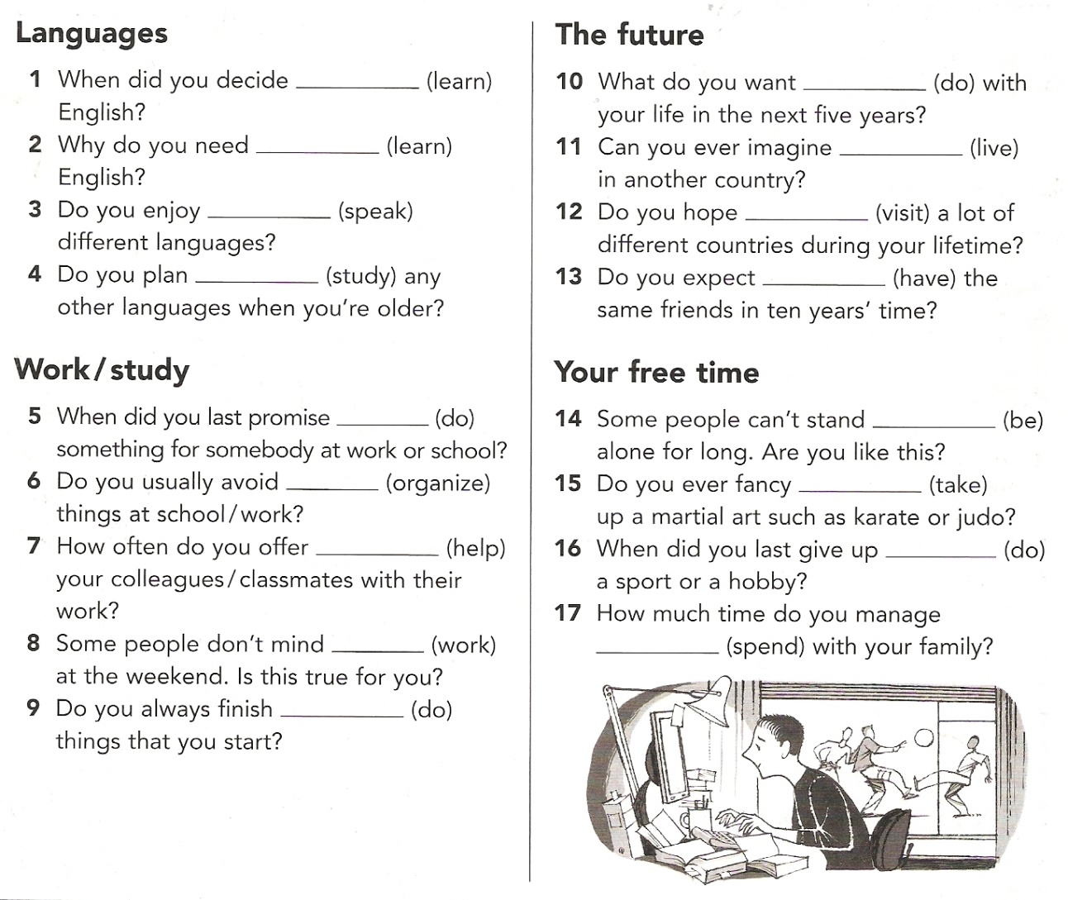
Use the present simple or continuous tenses and future forms to complete this text.
I ..................... (not do) housework on Sundays normally. But tomorrow I ................................. (tidy) my room, because my boyfriend Jim ...................... (come). The bus ......................... (arrive) at 10. I think Jim ...................... (come) on time as usual, because he .................... (like) to be punctual. I ...................................... (look) forward to him. We .................... (have) a date every Sunday and I ..................... (always look) forward to him. Tomorrow we .......................... (have) a special date. We ........................... (go) to see his parents. We ........................... (have) a good time, I hope.
Make questions to match the answers.
What time ....................................................... ? The meeting starts at 8.30 tonight.
......................................................................... ? No, I don't watch TV every day.
What ............................................ after school? I don't know what I'll do.
........................................................................ ? Yes, she is going to try it.
When .............................................................. ? He is leaving next month.
How often ....................................................... ? She helps me twice a week.
......................................................................... ? No, no. Marion won't study at university.

Match these sentences.
1. He's getting married a. sooner or later. 2. He'll get married b. on Saturday.
1. It snows here. a. This is a cold place. 2. It is snowing here. b. Look at that.
1. I'm writing a story. a. I'm not a novelist. 2. I write short stories. b. I'm going to finish it soon.
1. This bag is so heavy! a Are you going to take it? 2. The final exam is on Monday. b Will you take it, please?
1. My laptop doesn't work. a What are you going to do? 2. I can see you! b What will you do?
Use modal verbs can, may, must in a positive or negative form to complete the following sentences.
You ................ give me a lift. I can go by train.
Don't talk. You ................ be quiet.
I want a computer at home. I ............ buy one.
I don't understand. .............. you repeat it?
Where is it? I ................. see it.
You ....................... drive fast. We have enough time.
We ......................... stop here. It is not allowed.
How can I get there? - You .............. take a taxi if you want.
I failed the English test. But I ................. try again! I want to pass it.

Put the words in the correct order to make imperative sentences.
over/seat/a/there/take ............................................................................
eat/something/to/have ............................................................................
so/bags/have/many/don't ............................................................................
not/sit/do/down ............................................................................
quiet/do/be ............................................................................
it/me/for/let/you/do ............................................................................
let/worried/not/us/be ............................................................................
now/the/let/pay/customers ............................................................................
explain/it/let/her ............................................................................
Make questions to match the answers.
......................................................................... ? No, they needn't help her.
......................................................................... ? No, you mustn't park here.
......................................................................... ? Yes, you can tell him.
How many exercises ...................................... ? You must do three exercises.
Match these sentences.
1. I must eat less. a. I am so thin. 2. I can't eat less. b. I'm getting fat.
1. Hurry up! a The train is coming. 2. We needn't worry. b The train comes on time.
1. He may take it. a. I don't need it. 2. He can take it. b. Who knows?
1. I must study hard. a. I want to be good. 2. I mustn't study hard. b. I am ill.
1. You needn't water the flowers. a. They are dry. 2. You must water the flowers. b. But you could wash the dishes.
1. You mustn't work. a. You don't feel well. 2. You needn't work. b. You can relax.
1. We must clear the table. a Let's do it now. 2. He must clear the table. b Let him do it now.
Complete the sentence:
We needn't ________ (watch)TV all night.
Did she ask you_____________ (fetch) her bag?
You shouldn't _________ (risk) to get sunburnt.
I don't think he'll give up ______________(drink) coffee.
I tried ___________(drive) his car. I liked it.
Please, go on ___________ (read).
I'm sorry _____________(ask) you the following question.
I am looking forward to ______________(have) lunch with you.

Choose the correct tenses. past, present perfect, past perfect
He had a break after he ..................................... for two hours. a) was walking b) had been walking c) has walked
I ......................................... her for a long time. a) know b) have known c) have been knowing
We ............................ the windows and the car on Saturday morning. a) were cleaning b) cleaned c) have been cleaning
I ............................ in York for a week in 1998. a) worked b) have been working c) have worked
How many cupboards .............................. since yesterday? a) did they move b) have they moved c) have they been moving
As he ................... a bike, a dog ................ him. a) was riding - bit b) rode - bit c) was riding - has bitten
When the dog ................ him, he ...................... his bike. a) was biting - fell off b) bit - was falling off c) bit - fell off
I didn't notice that you .................................... . a) had come b) came c) have been coming
................................................... the dishes yet? a) Has he washed b) Has he been washing c) Did he wash
I can't find Todd. Where is he? - He ..................................................................... in the garage. a) 's been working b) worked c) was working
She .................................. books on the shelves all day. That's why she is so exhausted. a) was putting b) has put c) has been putting
The sun ........................ and we ........................ on the white sand. a) shone - were lying b) was shining - were lying c) shined - lay
You ............................. at last! Where ................................................................... so long? a) arrived - have you been b) have arrived - have you been c) arrived - were you
What's your teaching experience? .................................................................... anyone? a) Have you ever taught b) Did you ever teach c) Have you ever been teaching
She's hurt her arm. - When ........................... it? a) has she hurt b) has she hurted c) did she hurt
Where is Mum? - She ................................. the shopping all the morning. a) has done b) has been doing c) was doing
At 9.30 I ....................... a documentary on TV. It ........................................................... at 9.20. a) was watching - had started b) watched - has started c) watched - started

Use past tenses, present perfect or past perfect tenses to complete these sentences.
We ............................... in Bristol from January to March. (stay)
Where is my wine? Someone ............................ my wine! (drink)
When you .......................... , ...................... you............................................. fast? (crash, drive)
I'm sorry. Dad isn't here. He ............................. our neighbour's flat since the morning. (decorate)
What a nice coat! Where .......... you ............ it? (buy)
At 6 o'clock he ......................................... there for three hours! (sit)
I want to learn French. But I ............................. yet. (not start)
What ................ you ....................................... ? You are so dirty! (do)
Oh, no! I .................................... my way. What shall I do? (lose)
Jim ............................... the dishes after dinner. The kitchen sink is full of plates. (not wash)
She ....................................... three clients since the morning. (contact)
I couldn't help you. I ..................................your problems. (not understand)
Does he know about it? ............. you ................ him yet? (tell)
As soon as I ................................. the message, I ..................................... my house. (get, leave)
While Maggie ............................ a new jumper, Jill and I ........................................ . (knit, read)
...................... you in your room at 5.30? - Yes, I think I ........................ my suitcase. (be, pack)
Nice to meet you! I ............................ you for 10 years. What ............ you .......................... all this time? (not see, do)
He ............................... , but he'll be back home today. The doctors ................................. to cure him. (die, manage)
After we ........................................ to the top of the hill we had a great view of the bay. (climb)
The pigeon finally delivered the news after it ..................................... for the whole day. (fly)

