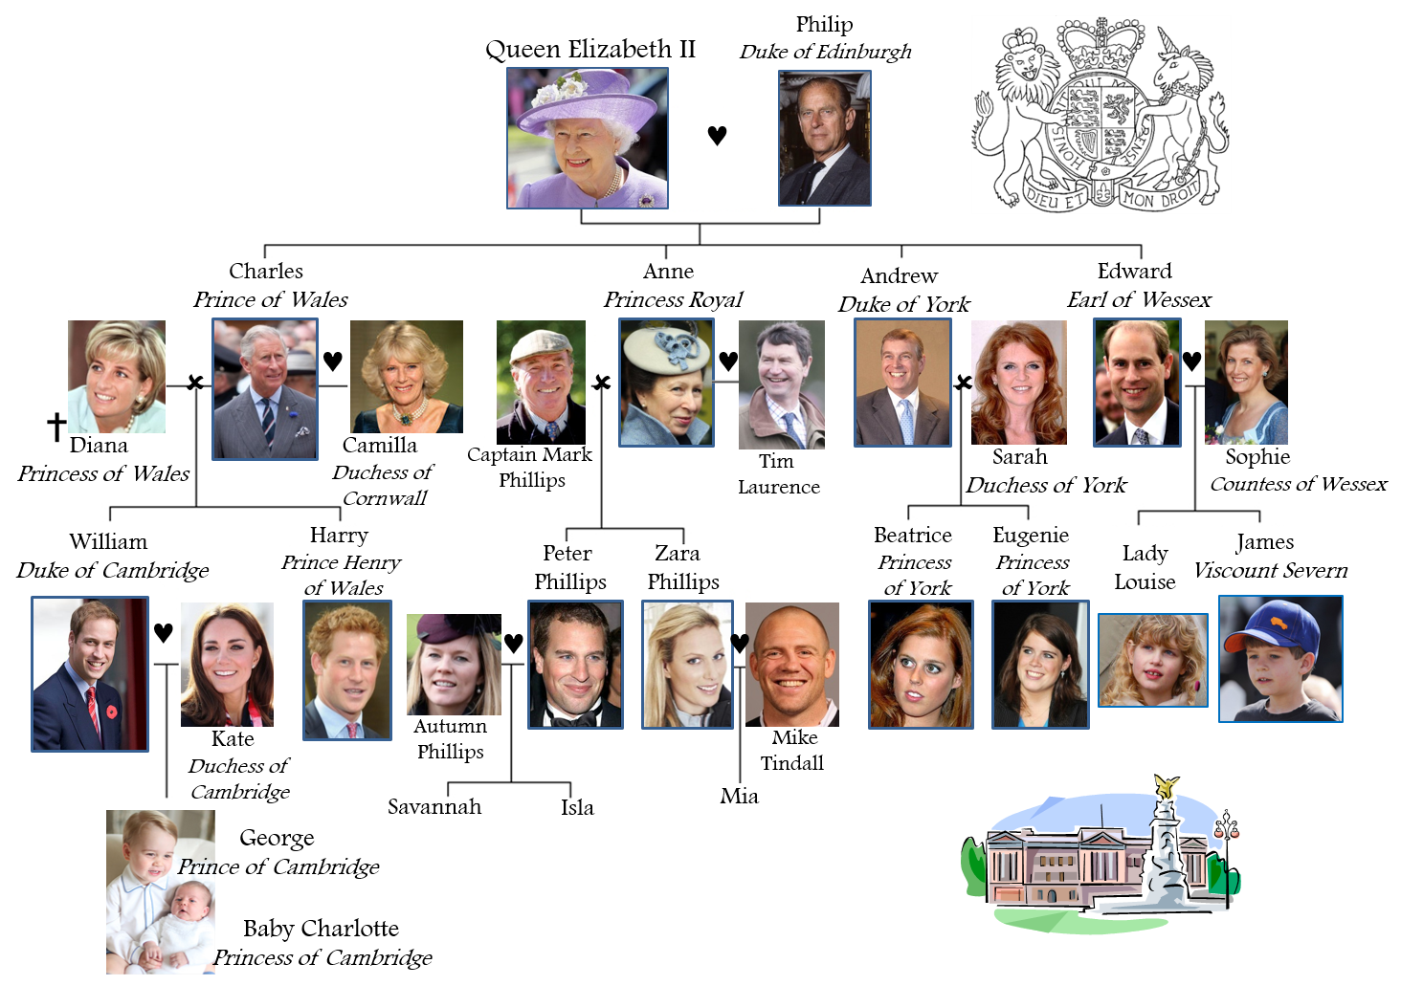
The British
Royal Family

- What is the surname of the Royal Family?
- Buckingham
- Windsor
- Kensington
- Which member of the Royal Family is next to the throne?
- Prince Charles
- Prince William
- Prince Andrew
- What’s the name of the Queen’s official residence in London?
- The Tower of London
- Buckingham Palace
- Westminster House
- How many people work full time in the Royal Household?
- 245
- 445
- 645
- Which member of the Royal Family died on 31st August 1997?
- Lady Diana
- The Queen Mother
- Princess Margaret
- Which sport do Prince Charles and his sons like playing?
- Water polo
- Golf
- Polo
- What is Prince Charles’ wife official title?
- Princess of Cornwall
- Queen of Cornwall
- Duchess of Cornwall
- Which of the following things does the Queen not have?
- Number plates on her cars
- Money in her handbag
- A vote at general elections
- Which member of the Royal Family was born on 2nd May 2015?
- Princess Eugenie
- Princess Charlotte
- Prince George

Royal opinions :
- The main reason to have a Royal Family is to attract more tourists to a country.
- I would hate to be a member of a Royal Family.
- Countries that have Royal Families should be proud of them.
- Royal families are an important part of a country’s history.
- Royal families spend too much public money.

Henry VIII.
The king with six wives
Henry was the King of England who had six wives. But Henry did lots of other things besides marrying six times. He wanted to make England strong. Most of all, he wanted a son to be king after him.
When did he live?
Henry was born in 1491. In English history, the time when he and his family lived is known as the Tudor age. Tudor was Henry's family name. Henry lived at a time of changes. People had new ideas in art, science and religion. They sailed off to explore new lands. Henry died in 1547. Three of his children ruled England after him.
Why do people remember Henry?
Paintings of Henry VIII show a big, fierce-looking man in fine clothes. He looks scary, and many people were scared of him. If the King did not get his way, he got cross. People who made him cross risked having their heads chopped off! As a young man, Henry was handsome and clever. He was good at sport, music and dancing. He wanted to be a soldier and a famous king.

Elizabeth I.
Elizabeth was Queen of England, Ireland and Wales from 1558 to 1603. She gave her name to the 'Elizabethan Age'. It was an exciting time in English history. This was the age of William Shakespeare's plays, Francis Drake's voyages, and the sea battles against the Spanish Armada.
When did she live?
Elizabeth was the daughter of King Henry VIII. She was born in 1533. Her grandfather Henry VII was the first Tudor king of England. Elizabeth became Queen of England in 1558. She died in 1603.
Why is Elizabeth famous?
Elizabeth I ruled England alone. She did not marry. So although she was queen, England had no king. This was unusual at the time. The Elizabethan Age was an exciting part of English history. There were new ideas, and arguments about religion. There were wars with Spain. English explorers sailed to new lands.

Mary Queen of Scots
Mary was known as Queen of Scots because she was Queen of Scotland. For a short time she was also Queen of France. She might have become Queen of England too. Mary's life was full of romance but sadness too. She became famous across Europe, especially after her execution in 1587, for plotting (it was said) against England's Queen Elizabeth I.
When did she live?
Mary was born in 1542, when Henry VIII was King of England. Her father was King James V of Scotland. Mary became Queen of Scotland as a baby. She was Queen until 1567, when she gave up the crown and left Scotland. She spent many years a prisoner in England, where she was put to death on 8 February 1587.
A sad life
Mary never knew her father, who died soon after her birth. As a little girl, she was sent away from her mother to France. Her first husband died two years after their wedding. Her second husband was murdered. Her third husband ran off with her, then deserted her. The Scots rejected her, and the English locked her up. Mary Queen of Scots' sad life ended when she was beheaded in 1587.

Queen Victoria
People all over the world know the name of Queen Victoria. She is probably the most famous queen in history. She was Queen of a vast empire, as well as of Britain. A long period of history is named after her - the Victorian Age.
What does 'Victorian' mean?
It means 'to do with Victoria'. It's an adjective used to describe people and things from her time. Victoria was Queen for over 60 years. Many things happened during her life. We talk about 'Victorian' buildings or 'Victorian' furniture. This doesn't mean that Queen Victoria made them herself! It usually means something dates from the 1800s.
When did she live?
Victoria was born in 1819. She became Queen in 1837 when she was 18. Her reign lasted for more than 60 years. Queen Victoria was born early in the 19th century. She lived to see the start of the 20th century, dying in January 1901.

Her Majesty the Queen Elizabeth II
Elizabeth II became queen of the United Kingdom of Great Britain and Northern Ireland in 1952. Elizabeth I was Queen of England and Ireland from 1558 to 1603. Through her parents and grandparents, Elizabeth II can trace her ancestors back long before Elizabeth I!
Queen Elizabeth's father was King George VI. When he died in February 1952 Elizabeth became Queen. Her coronation was on 2 June 1953.
The Queen spends part of most days at her desk. She has a staff of people to help with her work. She gets 300 or more letters every day. And she is sent boxes of official papers to read. Queen Elizabeth II has less power than kings and queens in the past. But she does give advice to the government and has regular meetings with the Prime Minister. Because she has been Queen for so long, she has much more experience of governing than any of her ministers, or any other ruler around the world.

New ambassadors from foreign countries call at the palace. Other people come to receive medals and awards. It is a special honour to be made a Knight or Dame, when the Queen touches people on the shoulders with a sword. The Queen meets lots of people. If you meet her, you start a conversation by calling her 'Your Majesty', and then, 'Ma'am'.
The Queen welcomes world leaders to the United Kingdom. She gives banquets at Buckingham Palace. Sometimes she drives through London in an open carriage with visitors. Every year the Queen travels thousands of miles. She visits all parts of the United Kingdom. She makes 'walkabouts' so she can chat to people. She makes many trips abroad, and has visited more than 116 countries!
The Queen has two birthdays. Her real birthday is on 21 April. Her official birthday as Queen is in June. To mark it, she attends a parade on Horse Guards in London. It's called Trooping the Colour. The 'colour' is a flag belonging to one of the regiments of Guards. Bands play and crowds line the streets to see the Queen and her soldiers pass by.
The Queen is used to parades in big cities. Yet she enjoys being in the country. She likes horses. Her favourite sports are horse riding, horse shows and horse racing. She owns some race horses herself. The Queen also owns a number of dogs. And she has royal racing pigeons! In the 1880s the King of Belgium gave Queen Victoria some pigeons. The royal family has kept pigeons ever since.
Buckingham Palace is the Queen's office as well as her London home. The part most tourists see is the East Front. Here is the balcony where the royal family appears sometimes. The gardens are used for summer garden parties.
The Queen has a country house at Sandringham in Norfolk. In Scotland, her official residence is Holyroodhouse, in Edinburgh. In summer the Queen holidays in Scotland, at Balmoral Castle in Aberdeenshire. While she is away, the state rooms at Buckingham Palace are open to visitors.
Windsor Castle in Berkshire is a favourite royal home. It is the oldest and biggest castle still used as a home. Windsor Castle was begun in 1070 by William the Conqueror. In 1992 fire burned down parts of Windsor Castle. The Queen was sad, and helped to pay for repairs that have made the castle as splendid as ever.

- Would you like to have a king or a queen in our country?
- What would be the advantages and the disadvantages of being a member of a Royal family?
- Do you think Kings and Queens do real work?
- Do you think it is unfair for taxpayers to pay for Royal Families? Why?
- Do you think Royal Families benefit society?
- Do you think the public has the right to know their earnings?
- What would you do if you were King/Queen for a day?
- Do you think Monarchies are old fashioned?
- Do you think members of a Royal Family live a privileged life?
- How do you think monarchies started?
- Do you think monarchs should have the power to change governments and constitutions?
- What do you think monarchs think about their people?
Listening:
Do ________________ monarchy in the 21st Century? It’s such a strange idea. ________________ a democratic idea. No one votes for someone to be king or queen. When a prince or princess is born, he or she automatically has ________________. This is not fair. I had to study and work very hard just ________________ job, with not much money. Those in a monarchy are ________________. They never really have to lift a finger. The strange ________________ people ________________ monarchy like their king and queen. Take the United Kingdom, for example. Around 80 per cent of British people support their monarchy. I suppose it’s good for tourism. I wouldn’t ________________ part of a royal family.

