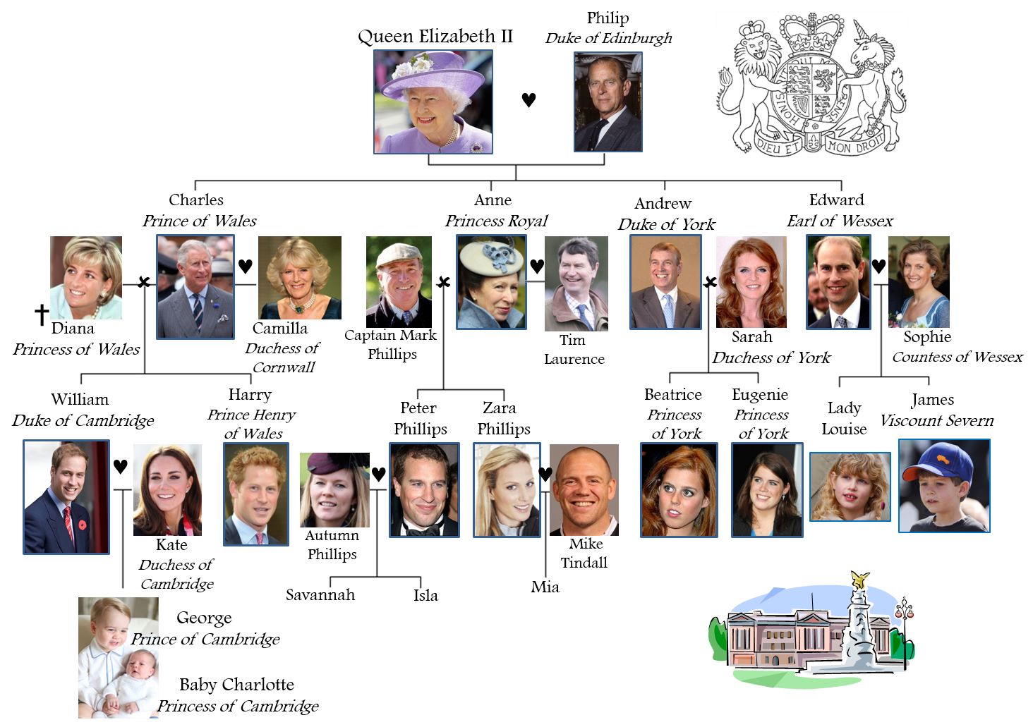

The British

Royal Family

**Vocabulary:**

a palace a robe a throne a crown a crest jewels

abdicate accede reign rule succeed a monarch

the heir to the throne a beefeater an aristocrat a chauffeur a footman

1. What is the surname of the Royal Family?
2. Buckingham
3. Windsor
4. Kensington
5. Which member of the Royal Family is next to the throne?
6. Prince Charles
7. Prince William
8. Prince Andrew
9. What’s the name of the Queen’s official residence in London?
10. The Tower of London
11. Buckingham Palace
12. Westminster House
13. How many people work full time in the Royal Household?
14. 245
15. 445
16. 645
17. Which member of the Royal Family died on 31st August 1997?
18. Lady Diana
19. The Queen Mother
20. Princess Margaret
21. Which sport do Prince Charles and his sons like playing?
22. Water polo
23. Golf
24. Polo
25. What is Prince Charles’ wife official title?
26. Princess of Cornwall
27. Queen of Cornwall
28. Duchess of Cornwall
29. Which of the following things does the Queen not have?
30. Number plates on her cars
31. Money in her handbag
32. A vote at general elections
33. Which member of the Royal Family was born on 2nd May 2015?
34. Princess Eugenie
35. Princess Charlotte
36. Prince George

**Do you think these statements are TRUE or FALSE?**

She became the Queen when she was 21.

The Queen has two birthdays.

She has met 15 Prime Ministers of the UK in her life.

She doesn’t need a passport.

She speaks French fluently and doesn’t need an interpreter.

The Queen has joined Twitter and Facebook.

The Queen did her own make-up for her wedding.

**Her Majesty the Queen** **Elizabeth II**  
Elizabeth II became queen of the United Kingdom of Great Britain and Northern Ireland in 1952. Elizabeth I was Queen of England and Ireland from 1558 to 1603. Through her parents and grandparents, Elizabeth II can trace her ancestors back long before Elizabeth I!  
Queen Elizabeth's father was King George VI. When he died in February 1952 Elizabeth became Queen. Her coronation was on 2 June 1953.  
The Queen spends part of most days at her desk. She has a staff of people to help with her work. She gets 300 or more letters every day. And she is sent boxes of official papers to read. Queen Elizabeth II has less power than kings and queens in the past. But she does give advice to the government and has regular meetings with the Prime Minister. Because she has been Queen for so long, she has much more experience of governing than any of her ministers, or any other ruler around the world.

New ambassadors from foreign countries call at the palace. Other people come to receive medals and awards. It is a special honour to be made a Knight or Dame, when the Queen touches people on the shoulders with a sword.

The Queen meets lots of people. If you meet her, you start a conversation by calling her 'Your Majesty', and then, 'Ma'am'.

The Queen welcomes world leaders to the United Kingdom. She gives banquets at Buckingham Palace. Sometimes she drives through London in an open carriage with visitors. Every year the Queen travels thousands of miles. She visits all parts of the United Kingdom. She makes 'walkabouts' so she can chat to people. She makes many trips abroad, and has visited more than 116 countries!

The Queen has two birthdays. Her real birthday is on 21 April. Her official birthday as Queen is in June. To mark it, she attends a parade on Horse Guards in London. It's called Trooping the Colour. The 'colour' is a flag belonging to one of the regiments of Guards. Bands play and crowds line the streets to see the Queen and her soldiers pass by.  
The Queen is used to parades in big cities. Yet she enjoys being in the country. She likes horses. Her favourite sports are horse riding, horse shows and horse racing. She owns some race horses herself. The Queen also owns a number of dogs. And she has royal racing pigeons! In the 1880s the King of Belgium gave Queen Victoria some pigeons. The royal family has kept pigeons ever since.

Buckingham Palace is the Queen's office as well as her London home. The part most tourists see is the East Front. Here is the balcony where the royal family appears sometimes. The gardens are used for summer garden parties.

The Queen has a country house at Sandringham in Norfolk. In Scotland, her official residence is Holyroodhouse, in Edinburgh. In summer the Queen holidays in Scotland, at Balmoral Castle in Aberdeenshire. While she is away, the state rooms at Buckingham Palace are open to visitors.

Windsor Castle in Berkshire is a favourite royal home. It is the oldest and biggest castle still used as a home. Windsor Castle was begun in 1070 by William the Conqueror. In 1992 fire burned down parts of Windsor Castle. The Queen was sad, and helped to pay for repairs that have made the castle as splendid as ever.

What does the Queen do on most days?

How can she influence politics?

At which occasions does she meet people?

What does ‘Trooping the colour’ mean?

What is the Queen’s relationship to animals?

When can you visit Buckingham Palace?

What happened to her favourite castle?

**Listening:**

Do ________________ monarchy in the 21st Century? It’s such a strange idea. ________________ a democratic idea. No one votes for someone to be king or queen. When a prince or princess is born, he or she automatically has ________________. This is not fair. I had to study and work very hard just ________________ job, with not much money. Those in a monarchy are ________________. They never really have to lift a finger. The strange ________________ people ________________ monarchy like their king and queen. Take the United Kingdom, for example. Around 80 per cent of British people support their monarchy. I suppose it’s good for tourism. I wouldn’t ________________ part of a royal family.

* Would you like to have a king or a queen in our country?
* What would be the advantages and the disadvantages of being a member of a Royal family?
* Do you think Kings and Queens do real work?
* Do you think it is unfair for taxpayers to pay for Royal Families? Why?
* Do you think Royal Families benefit society?
* Do you think the public has the right to know their earnings?
* What would you do if you were King/Queen for a day?
* Do you think Monarchies are old fashioned?
* Do you think members of a Royal Family live a privileged life?
* How do you think monarchies started?
* Do you think monarchs should have the power to change governments and constitutions?
* What do you think monarchs think about their people?

**Put the correct verbs in the right form into the sentences below:**

1. When a king or queen decides that they don’t want to be the monarch anymore, they_______.
2. Queen Victoria _______ for over 63 years. Only Queen Elizabeth II has been a monarch longer.
3. The young prince will soon _______ to the throne. Many think he is not old enough to be king.
4. The country was _______ by a very unpopular king. The people wanted to get rid of him.
5. The king was ______ by his brother when he died, as he had no heir.
6. They will ______ her queen as soon as possible. The coronation will be at the cathedral.

**Match the verbs on the left to the words on the right to make collocations:**

1. rule a) a battle
2. wear b) a kingdom
3. fight c) a title
4. abolish d) to the crowd
5. wave e) the coronation
6. inherit f) the crown
7. watch g) the monarchy

**Match the idioms to their definitions:**

1. All our guests get royal treatment. You will have access to the 24hr pool, sauna, and spa.
2. Pierre was the king of the castle. He had managed to beat everyone in the competition.
3. He often dreams that he will live like a king one day. He wants his own private jet.
4. His wife is really the power behind the throne. She makes all the decisions.
5. The house was fit for a king. It had three bathrooms and five bedrooms.
6. The lakes are the area’s crown jewels. They attract thousands of visitors.
7. good enough for royalty.
8. have a luxurious lifestyle.
9. receive a lot of attention and care.
10. the most successful or powerful person in a group.
11. the most valuable or important thing in a place that you own.
12. the person who controls someone who has a more important position.